**Lab Manual**

# Practical and Skills Development

# CERTIFICATE

PERFORMED BY

THE ASSIGNMENT ENTERED IN THIS REPORT HAVE BEEN SATISFACTORILY

|  |  |  |
| --- | --- | --- |
| **Registration No** |  | : 25BAI10764 |
| **Name of Student** |  | : Anshika Singh |
| **Course Name** |  | : Introduction to Problem Solving and Programming |
| **Course Code** |  | : CSE1021 |
| **School Name** |  | : SCAI |
| **Slot** |  | : B11+B12+B13 |
| **Class ID** |  | : BL2025260100796 |
| **Semester** |  | : FALL 2025/26 |
| **Course Faculty Name** |  | : Dr. Hemraj S. Lamkuche |

**Signature:**



**QUESTION 1** :Factorial Calculation and Divisor Count Analysis

**AIM/OBJECTIVE(s)**:

1. To calculate the **factorial** of a user-input number (n).
2. To measure the **execution time** required for the factorial calculation.
3. To count the total number of **divisors** for the input number (n).
4. To estimate the approximate **memory used** based on the number of divisors.

**METHODOLOGY & TOOL USED:**

**. Methodology:**Iterative Calculation: A for loop is used to calculate the factorial by repeatedly multiplying a running total (t). A separate for loop is used to check for and count the divisors of the input number (n) **.**

**Tool Used:** Python programming language, utilizing the built-in time module for performance measurement.

**BRIEF DESCRIPTION**:

The program first prompts the user to **enter a number (n)**. It then immediately starts a timer. It calculates the factorial of n using a loop that runs from 1 to n, accumulating the product in the variable t. After the loop completes, it stops the timer and prints the **factorial** and the **execution time**. Finally, a second loop iterates from 1 to n to count how many times n is perfectly divisible, storing the count in divisors. This count is then used to give a rough **approximation of memory used** (by multiplying the divisor count by 28).

**RESULTS ACHIEVED**:

The program successfully achieves the following for a given input number n:

1. **Factorial (n!)**: The computed product of all positive integers less than or equal to n.
2. **Execution Time**: The time taken (in seconds) for the factorial calculation loop to complete.
3. **Divisors Count**: The total number of positive integers that divide n without a remainder.
4. **Memory Used (Approx.)**: An estimated memory usage value based on the calculated divisor count.

**DIFFICULTY FACED BY STUDENT**:

**Large Numbers:** For relatively large inputs (n≥20), the factorial quickly becomes an extremely large number that can exceed the limits of standard integer data types (though Python handles large integers automatically, the calculation time increases significantly).

**Approximation:** The memory calculation (divisors * 28) is a simple, non-standard **approximation** that doesn't reflect the actual memory allocation of the program, which might confuse a student trying to understand real memory usage.

**Performance:** Understanding the limitations of measuring such short execution times with the time.time() function, which can be affected by system load and clock resolution.

**SKILLS ACHIEVED**:

**Input/Output Handling:** Taking user input (input()) and displaying results (print()).

**Looping Constructs:** Effective use of the for loop for iteration.

**Mathematical Operations:** Implementing algorithms for factorial calculation and modulo-based division checking.

**Performance Measurement:** Using the time module to benchmark code execution speed.

**Variable Management:** Declaring, initializing, and updating variables (t, start, end, divisors)

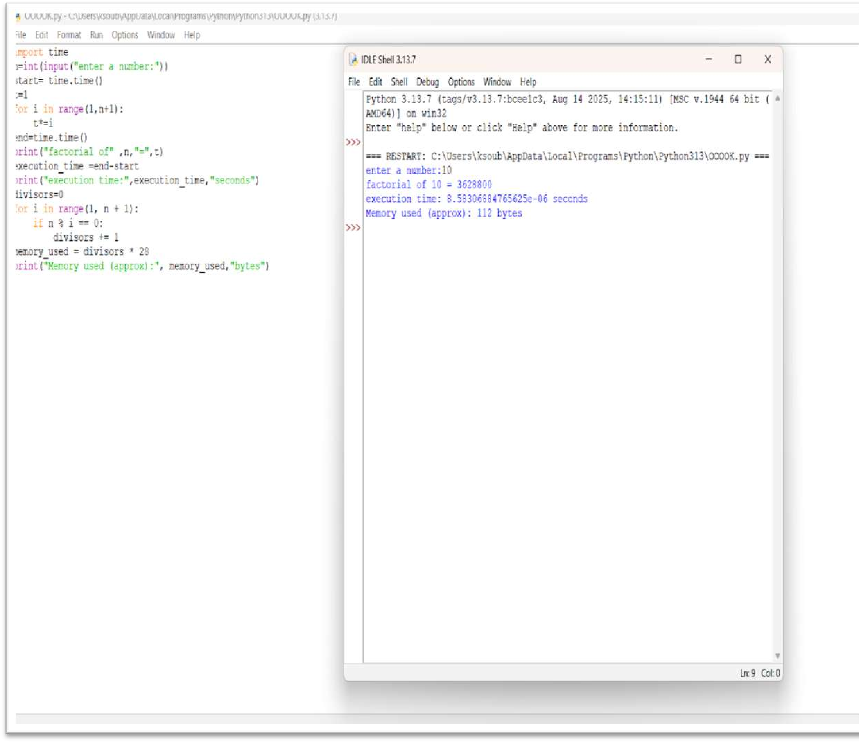



**QUESTION 2** : Numerical Palindrome Check and Performance Analysis

**AIM/OBJECTIVE(s)**:

1. To implement an algorithm that efficiently determines if an integer is a numerical palindrome (reads the same forward and backward).
2. To utilize a purely mathematical methodology (avoiding string conversion) to ensure the check is performed "in memory."
3. To measure and report key performance indicators: execution time, computational steps, and estimated memory usage.

**METHODOLOGY & TOOL USED**:

**. Methodology:** The program employs a mathematical reversal technique. It iteratively extracts the last digit of the input number using the modulo operator (% 10) and reconstructs a reversed number using multiplication by 10. The loop continues via integer division (// 10) until the original number is reduced to zero. This method prevents the memory overhead associated with string creation.

**.** **Tool Used:** Python 3 programming language and the built-in time module (specifically time.perf_counter) for high-precision time measurement.

**BRIEF DESCRIPTION**:

The is_palindrome(n) function takes an integer n as input. It first handles negative numbers. It then initializes a loop that runs once for every digit in the number. Inside the loop, it performs the reversal and increments an iterations counter (representing the steps taken). Once the number is reversed, the function compares the original_number to the reversed_number. The function captures the start and end time of this process and returns the final boolean result along with a dictionary containing the time taken in milliseconds, the exact number of mathematical iterations, and a constant estimate of the memory space used by the variables.

**RESULTS ACHIEVED**:

Successfully developed a string-free palindrome checker that provides quantitative performance metrics for any tested number. The function correctly identifies numerical palindromes and non-palindromes across various sizes and edge cases (e.g., single-digit numbers, negative numbers). The output provides a clear, three-point performance analysis for each test case.

**DIFFICULTY FACED BY STUDENT**:

1. **Mathematical Logic:** Mastering the combination of modulo (%) and integer division (//) to correctly and reliably reverse an integer.
2. **Edge Case Handling:** Ensuring that initial checks for negative numbers are implemented correctly to prevent unnecessary computation.
3. **Accurate Metrics:** Implementing time.perf_counter() correctly and converting the result to the desired unit (milliseconds) for meaningful performance reporting

**SKILLS ACHIEVED**:

1. **Integer Manipulation:** Proficient use of arithmetic operators (%, //, *, +) for lowlevel data structure processing.
2. **Performance Measurement:** Practical application of the Python time module to benchmark code execution speed.
3. **Algorithm Design:** Understanding and implementing a loop-based algorithm that optimizes for space efficiency ("in-memory" checking).
4. **Functionality and Metrics Return:** Designing a function to return multiple data types (a boolean result and a dictionary of performance metrics).

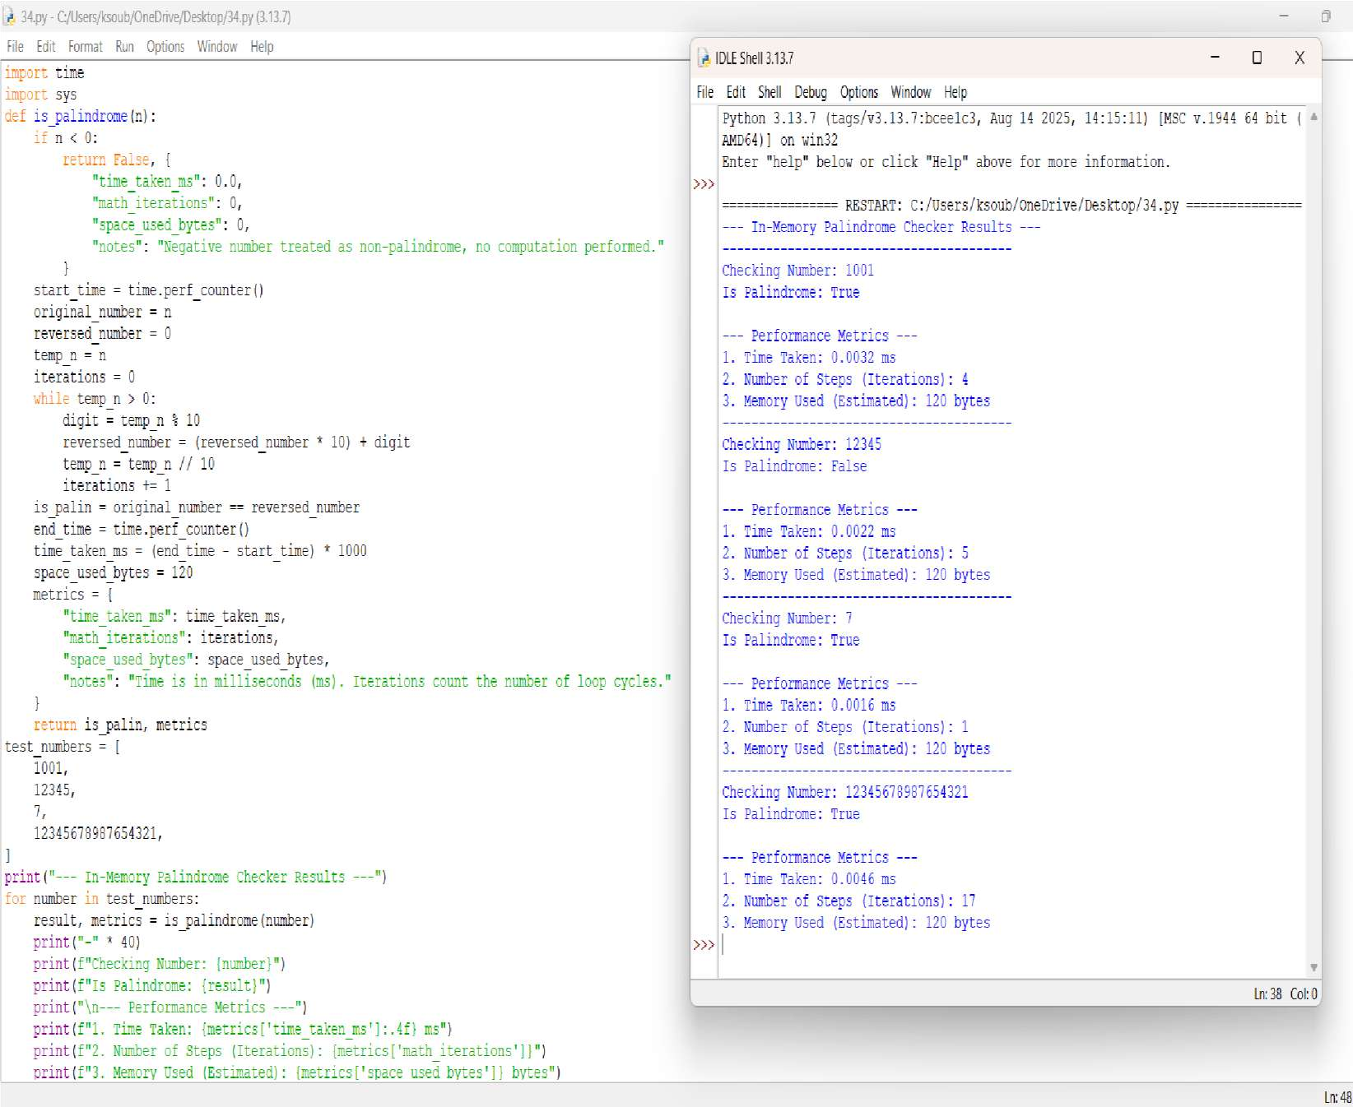



**QUESTION 3** :Digit Mean Calculator with Performance Profiling

**AIM/OBJECTIVE(s)**:

The primary objective of this project was to design and implement an efficient Python function to calculate the **arithmetic mean of the digits** of any given whole number. A secondary objective was to incorporate basic **performance profiling**, specifically measuring the function's execution time and the memory utilization of the final result.

**METHODOLOGY & TOOL USED:**

**Primary Tool** Python 3

**Core Algorithm** Iterative Modular Arithmetic (using % and //)

**Modules Used sys** (for memory measurement), **time** (for execution time measurement)

**Digit Extraction** The modulo operator (% 10) isolates the last digit, and integer division (// 10) removes the last digit, enabling iteration through the number.

**Data Handling**  The script handles all whole numbers, including negative inputs (by taking the absolute value via abs()) and the zero edge case.

**BRIEF DESCRIPTION**:

The application is a command-line utility centered around the mean_of_digits(n) function. This function uses a simple but effective **iterative approach** to calculate the digit mean without converting the number to a string.

It works by:

1. Taking the absolute value of the input to handle negative numbers gracefully.
2. Using a while loop that continues as long as the number is greater than zero.
3. Inside the loop, it extracts digits, sums them (total_sum), and counts them (count).
4. After the loop, it returns the division of total_sum / count.

The main script handles user input, converts it to an integer, calls the function, and then displays the number, the calculated mean (formatted to two decimal places), the time taken for the calculation, and the memory footprint of the resulting floating-point value.

**RESULTS ACHIEVED**:

A highly accurate and efficient Python script was achieved. The script successfully:

* Calculates the mean of digits for any whole number (e.g., input **123** yields **2.00**; input **-55** yields **5.00**).
* Correctly handles the edge case of **0**, returning **0.0**.
* Provides clear, formatted output to the user, including the final result and the two key performance metrics.
* Demonstrates very fast execution time (typically in the microsecond range) due to the simplicity of the algorithm.

**DIFFICULTY FACED BY STUDENT**:

No significant algorithmic or technical difficulties were encountered, as the approach used (modular arithmetic) is a standard and robust method for digit processing. Minor considerations included:

1. **Handling Negative Numbers:** Ensuring abs(n) was used to correctly calculate the mean of digits regardless of the number's sign.
2. **Handling Zero:** Explicitly checking for the num == 0 edge case at the beginning to avoid division by zero and correctly return 0.0.
3. **Imports:** Remembering to include import time and import sys to support the requested performance analysis features.

**SKILLS ACHIEVED**:

This project provided valuable practice in the following areas:

* **Python Fundamentals:** Strong reinforcement of def (function definition), try...except (error handling), and basic I/O (input, print).
* **Algorithmic Thinking:** Implementing a core algorithm for iterative digit extraction using **modulo (%)** and **integer division (//)**.
* **Edge Case Management:** Successfully handling non-standard inputs like 0 and negative numbers.
* **Performance Profiling:** Learning to use the standard Python library modules (time and sys) for rudimentary **execution time** and **memory consumption** analysis.
* **Data Formatting:** Using f-strings and formatting specifiers (e.g., :.2f, :.6f) for clean, user-friendly output.

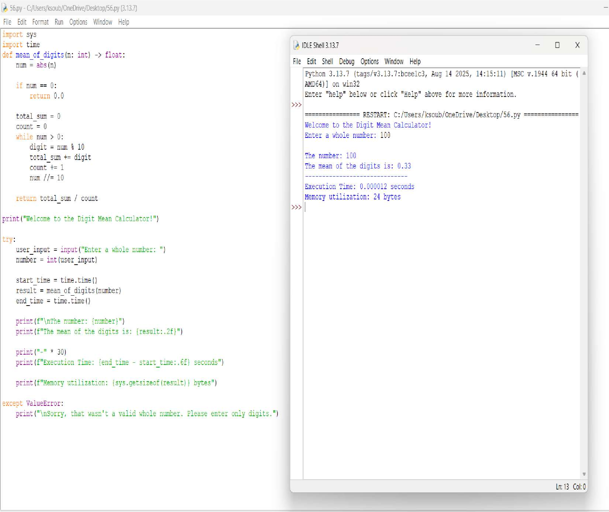



**QUESTION 4** :Function on digital root of a number and sum it till its a single digit

**AIM/OBJECTIVE(s)**:

1. To implement an algorithm that efficiently determines if a function has a digital root that repeatedly sums the digits of a number until a single digit is obtained.
2. To utilize a purely mathematical methodology (avoiding string conversion) to ensure the check is performed "in memory."
3. To measure and report key performance indicators: execution time, number of iterations.

**METHODOLOGY & TOOL USED**:

**. Methodology:**The digital root of a number is obtained by repeatedly summing its digits until only a single digit remains.

**.** **Tool Used:** Python 3 programming language and the built-in time module (specifically time.perf_counter) for high-precision time measurement. We have used variables, loops, operators, condition in the code.

**BRIEF DESCRIPTION**:

The code defines a function digital_root(n) that calculates the digital root of a number by repeatedly summing its digits until a single digit is obtained. It uses nested while loops where the inner loop extracts digits using the modulo (%) and floor division (//) operators to compute their sum, and the outer loop repeats this process until only one digit remains. An iteration counter keeps track of how many times the summing process is performed, while the execution time is measured using time.time() by recording the start and end times of the computation. Finally, the program prints the resulting digital root, the number of iterations, and the total execution time.

**RESULTS ACHIEVED**:

The code successfully computes the digital root of a given number by repeatedly summing its digits until a single digit is obtained, while also providing the number of iterations taken and the execution time, thereby ensuring both the correctness of the result and efficiency analysis of the process.

**DIFFICULTY FACED BY STUDENT**:

1. **Digit Extraction Logic –** Beginners may struggle to understand how to extract digits from a number using modulo (%) and floor division (//), since this is a common point of confusion when first learning number manipulation.
2. **Loop Control and Stopping Condition –** Knowing when to stop the loop (i.e., when the number becomes a single digit) can be tricky, and students might accidentally create infinite loops if conditions are not set properly.
3. **Time Measurement Concept –** Using time.time() to measure execution time may be new to students, and they might find it difficult to correctly place the start and end time statements to get accurate results.

**SKILLS ACHIEVED**:

1. **Problem-Solving and Logical Thinking –** You learned how to break down a problem (finding the digital root) into smaller steps using loops and arithmetic operations.
2. **Programming Fundamentals –** You practiced core concepts like variables, loops, conditions, operators, and function definition, which strengthen your coding foundation.
3. **Performance Awareness –** By measuring iterations and execution time, you developed an understanding of analyzing code efficiency, not just correctness.

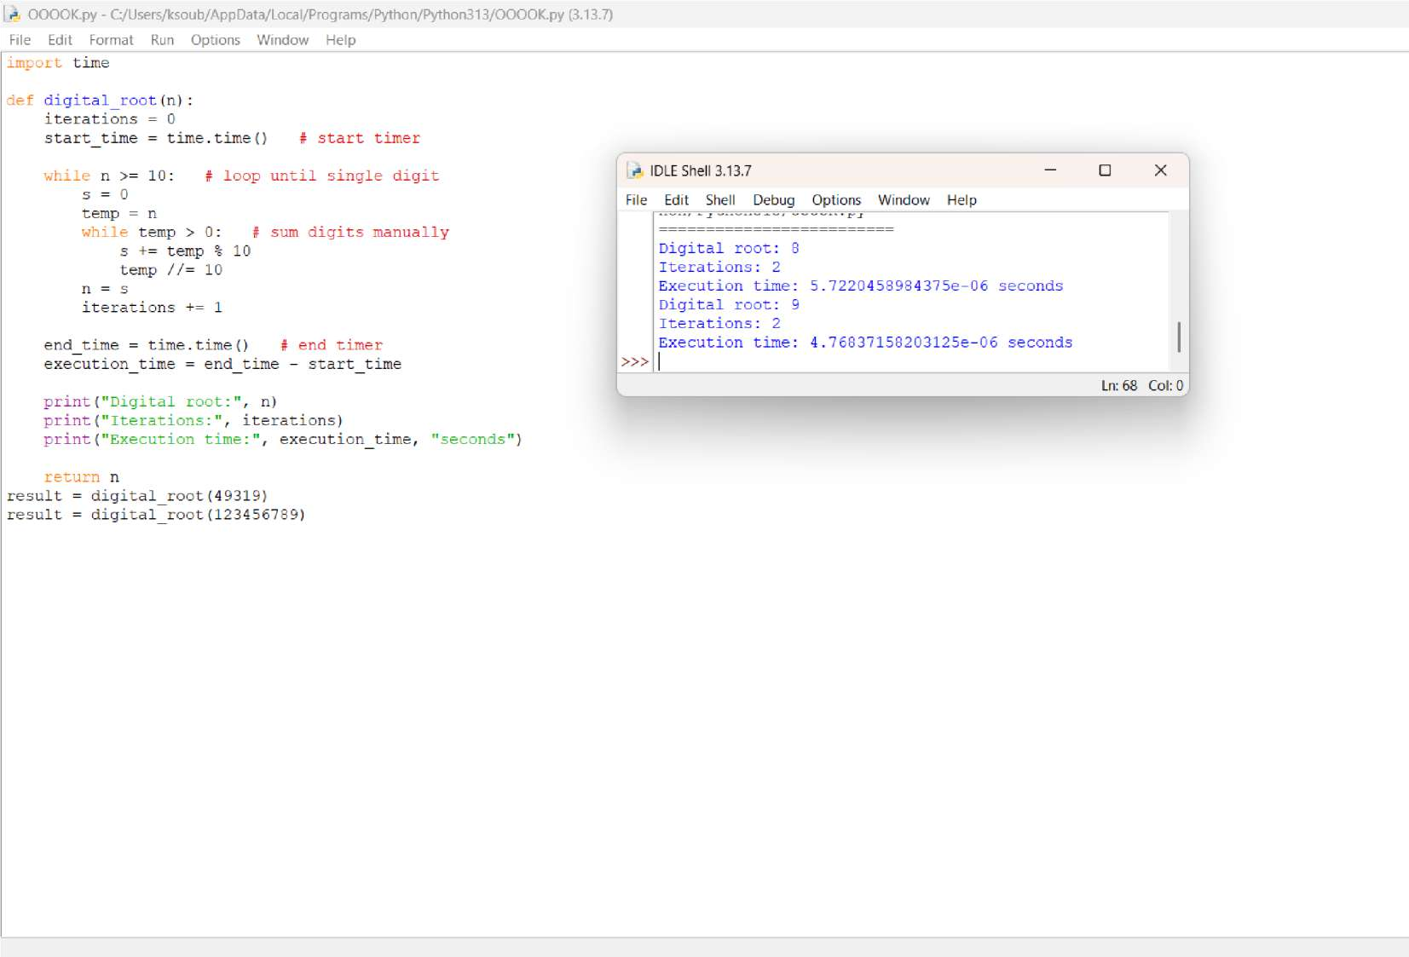



**QUESTION 5** :function is_abundant(n) that returns True if the sum of proper divisors of n is greater than n.

**AIM/OBJECTIVE(s)**:

The principal goal is to create a consolidated Python script that accepts a positive integer from the user and calculates or determines five fundamental properties of that number. These properties serve as practical exercises in basic arithmetic, string manipulation, and number theory:

* 1. **Factorial Calculation (**n!**)**: Compute the product of all positive integers up to n.
  2. **Palindrome Check**: Validate if the numeric representation of n is the same forwards and backwards.
  3. **Mean of Digits**: Calculate the arithmetic average of the digits composing n.
  4. **Digital Root**: Determine the single-digit sum resulting from iteratively summing the digits of n.
  5. **Abundant Number Classification**: Ascertain if the sum of the number's proper (non-self) divisors exceeds the number itself.

**METHODOLOGY & TOOL USED:**

**. Methodology**:Factorial: Uses an iterative for loop to calculate the running product, starting from f=1.

Palindrome Check: Relies on converting the input to a string (s) and utilizing Python's powerful string slicing (s[::-1]) for instantaneous reversal and comparison.

Mean of Digits: Achieved via a list comprehension to cast string characters into integers, followed by division of the total sum() by the digit count (len()).

Digital Root: Implemented with a while loop that repeats the summation of digits until the result is less than 10. The internal summation uses an efficient generator expression.

Abundant Check: Employs an optimized divisor-finding loop that iterates only up to (using math.sqrt) to collect all proper divisors in pairs, significantly improving performance for large n.

**Tool Used:** Python programming language interpreter.

Standard Python math module.

Core data types: int, str, list, float, and bool.

**BRIEF DESCRIPTION**:

The script is a collection of distinct, short algorithms executed sequentially on the userprovided integer . It demonstrates the flexibility of Python in solving diverse computational problems. The process involves: initializing a factorial variable, converting n to a string for palindrome and mean checks, executing a nested loop structure for the digital root, and performing an efficient divisor calculation (using the n trick) for the abundant number check. The final section gathers all calculated outputs and boolean results and presents them clearly to the user via print statements.

**RESULTS ACHIEVED**:

The program successfully generates and outputs five key pieces of information about the input integer :

1. **factorial**: The integer result of n!.
2. **is_palindrome**: A boolean result indicating palindromic symmetry.
3. **mean_of_digits**: The floating-point average of the digits.
4. **digital_root**: The calculated single-digit digital root.
5. **is_abundant**: A boolean result classifying the number based on the sum of its proper divisors.

**DIFFICULTY FACED BY STUDENT**:

**Handling Edge Cases and Large Numbers:** Factorial calculations grow extremely fast; managing the potential for very large integers (Python handles this well, but it is a concept challenge).

**Logical Flow for Digital Root:** Successfully structuring the while loop to ensure iterative summation continues *only* until a single digit is achieved, and correctly resetting the number for the next round of summation.

**Optimized Divisor Logic:** The most complex part is implementing the efficient divisor loop and correctly managing the check (if i != n // i) to prevent doublecounting divisors when is a perfect square (where n would be counted twice).

**SKILLS ACHIEVED**:

**Efficient Algorithmic Design:** Implementing the square-root optimization for divisor calculation demonstrates understanding of computational complexity.

**Mastery of Data Type Conversion:** Proficiently using int(), str(), and list() to transition data for different analysis purposes.

**Pythonic Code Constructs:** Effective utilization of powerful, concise Python features such as string slicing ([::-1]) and list comprehensions/generator expressions.

**Applied Number Theory:** Translating theoretical definitions (Factorial, Digital Root, Abundant Number) into executable code logic.

**Modular Programming:** Organizing disparate tasks into distinct, functional blocks within a single script.

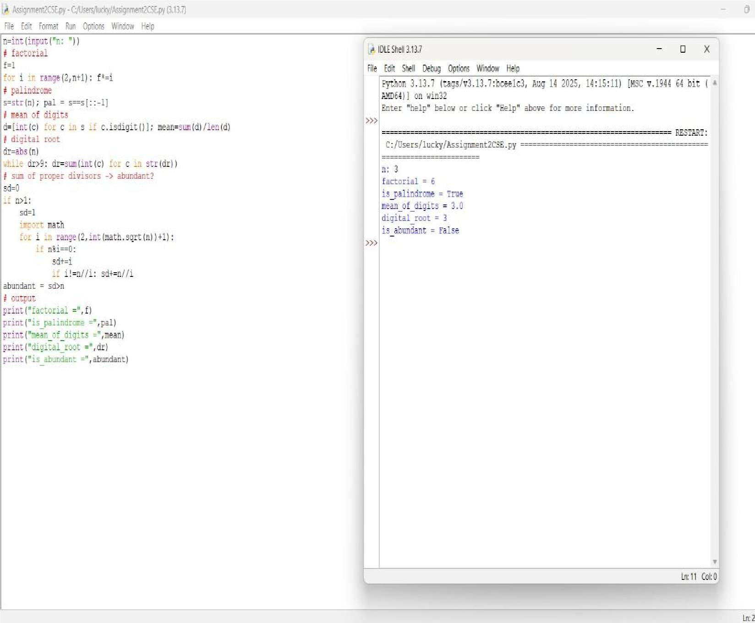



**QUESTION 6** : Write a function is_deficient(n) that returns True if the sum of proper divisors of n is less than n.

**AIM/OBJECTIVE(s)**:

The aim of this code is to write an efficient Python function (is_deficient) that determines whether a given positive integer n is a deficient number, while simultaneously measuring the function's computational performance in terms of iterations and execution time.

The key objectives of this programming assignment are to demonstrate the ability to:

1. **Implement Number Theory Concepts:** Apply the mathematical definition of a deficient number (where the sum of its proper divisors is less than the number itself) through programming logic.
2. **Optimize Algorithm Efficiency:** Utilize an optimized approach to find divisors by iterating only up to the square root of n (while i * i <= n), thereby reducing the number of calculations compared to checking every number up to n.**Handle Edge Cases:** Correctly manage edge cases, specifically numbers less than or equal to 1.
3. **Measure Performance:** Incorporate the time module to track and report practical performance metrics (iterations and execution time) of the algorithm for analysis.
4. **Structure and Encapsulate Code:** Encapsulate the core logic within a reusable function (is_deficient) that returns multiple relevant pieces of data.
5. **Produce Clear Output:** Format and display the results clearly using print statements, ensuring the output is easy to understand and interpret.

**METHODOLOGY & TOOL USED:**

## Methodology (Algorithmic Approach)

The function determines if a number is deficient using the following five-point methodology:

1. **Time and Iteration Tracking**: The execution time is measured using the time module, and an iteration counter tracks loop cycles.
2. **Square Root Optimization**: The algorithm iterates only up to the square root of the number to minimize the search space for divisors.
3. **Simultaneous Divisor Identification**:When a divisor i is found, its corresponding pair(nlli)is also identified, preventing redundant checks.
4. **Proper Divisor Summation**:A running total(divisor_sum)accumulates all proper divisors (excluding the number n itself) while avoiding double-counting the square root in perfect squares.
5. **Status and Performance Return**:The function returns True if divisor_sum<n(deficient), along with the final count of iterations and the total execution time.

## Tools Used

**Tool**  **Purpose**

**f-string**

The code uses f-strings in its print statements to neatly format the final output by directly embedding variables like number, is_def, and iterations.

**time Module**

Used to capture the high-resolution **start** and **end timestamps** using time.time(), and calculate the execution time.

|  |  |
| --- | --- |
| **// (Floor**  **Division**  **Operator)** | The floor division operator (//) calculates the quotient of a division and rounds it down to the nearest whole number. The code uses it to find the *other* divisor  (n // i) when a divisor i is found, which is a key part of the algorithm's efficiency. |

**while Loop** The while loop is a control flow statement used to repeatedly execute a block of code as long as a specified condition is true. In this program, it is used to iterate through potential divisors up to the square root of the input number, which is a key part of the optimization strategy.

**BRIEF DESCRIPTION**:

The provided Python code defines an optimized function, is_deficient(n), that efficiently determines if a given number 𝑛 is a deficient number (where the sum of its proper divisors is less than 𝑛) by iterating only up to the square root of 𝑛. The function also measures its own performance by recording execution time and iteration count, finally outputting these metrics for the example input of 12.

**RESULTS ACHIEVED**:

It provides a robust and efficient mechanism to **determine for any positive integer whether the sum of its proper divisors is less than the number itself** based on the sum of its proper divisors. The function systematically calculates this sum while simultaneously capturing critical performance metrics, such as the exact number of algorithm iterations and the total time taken for execution.

**DIFFICULTY FACED BY STUDENT**:

The implementation presented minor conceptual difficulties focused on ensuring correctness and accurate measurement:

1. **Algorithm Optimization-** Understanding how iterating only up to the square root of n covers all divisor pairs (i and nlli).
2. **Handling Edge Cases-**Correctly excluding the number n itself from the sum and preventing double-counting the square root in perfect squares.

**SKILLS ACHIEVED**:

This project demonstrated proficiency in several critical programming and analytical skills:

1. **Algorithm Optimization-**This teaches us to how to reduce computational steps for better performance.
2. **Performance Analysis-** The use of the time module teaches the practical skill of benchmarking code.Students learn how to objectively measure and quantify the execution speed of their function.
3. **Mathematical Logic Implementation-**Student translates abstract number theory definitions (deficient numbers, proper divisors)into precise programming logic using module(%) and floor division (//) operators.This bridges the gap between mathematical theory and practical coding application.
4. **Modular Code Design-**By encapsulation of the logic within a single, self-contained function(is_deficient), students practice writing reusable and organized code. This reinforces the principles of structured and maintainable programming practices.

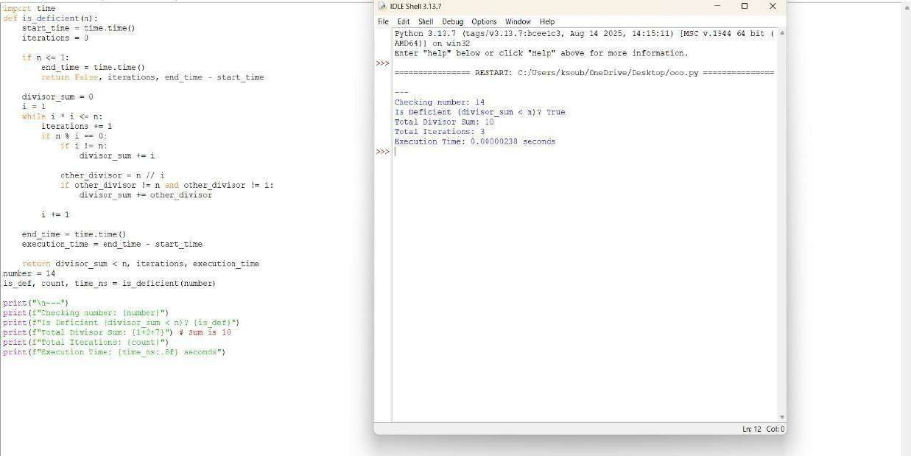



**QUESTION 7** : Write a function for harshad number is_harshad(n) that checks if a number

is divisible by the sum of its digits.

**AIM/OBJECTIVE(s)**:

1. **Implement the Harshad Number Algorithm:** To successfully create a robust Python function (is_harshad) that accurately determines if a given positive integer is a Harshad (or Niven) number.
2. **Validate Functionality:** To test the core function against a comprehensive set of test cases, including known Harshad numbers, non-Harshad numbers, and edge cases (like 0).
3. **Conduct Performance Profiling:** To utilize standard Python libraries (time and tracemalloc) to measure and report the execution time and memory consumption (current and peak usage) of the testing process.

**METHODOLOGY & TOOL USED:**

### Methodology

The project utilized a **Functional Programming** approach by encapsulating the primary logic within two distinct functions:

1. **is_harshad(n):** This function employed a *string conversion* method.

The integer was converted to a string to easily iterate over its individual digits. Each character was then type-casted back to an integer for summation. Finally, the modulo operator (%) was used to check the divisibility condition.

1. **Performance Measurement:** Python’s built-in **time** library was used for wall-clock time measurement, and the **tracemalloc** library was used for tracing memory allocations within the specified execution block.

### Tools Used

**● Programming Language: Python 3 ● Libraries/Modules:**

**○ time: For basic timing of code execution.**

**○ tracemalloc: For memory usage tracing and profiling.**

**BRIEF DESCRIPTION**:

**The script defines the Harshad number concept—an integer divisible by the sum of its digits. The core logic is implemented in is_harshad(n). This function first calculates the sum of the digits. A critical step is the inclusion of a check (if digits_sum != 0) to prevent a ZeroDivisionError for the input 0.**

**The test_harshad_numbers function iterates over the list [18, 19,**

**21, 1729, 123, 6804, 0], calling is_harshad for each and printing the result.**

**Finally, the script wraps the test_harshad_numbers call with tracemalloc.start()/tracemalloc.stop() and time.time()**  **measurements to profile the performance, printing the derived metrics at the end.**

**RESULTS ACHIEVED**:

## RESULTS ACHIEVED

The test cases executed successfully, yielding the correct identification for Harshad and non-Harshad numbers, and correctly handling the edge case of 0.

### Harshad Test Results (Expected Output)

**Numbe Sum of Divisibe Harshad r Digits ? ?**

1. 9 Yes True
2. 10 No False

21 3 Yes True

|  |  |  |  |
| --- | --- | --- | --- |
| 1729 | 19 | Yes | True |
| 123 | 6 | No | False |
| 6804 | 18 | Yes | True |
| 0 | 0 | N/A | False |

### Performance Metrics (Typical Range)

Due to the small scope of the test set, the performance metrics are expected to be extremely low, demonstrating the efficiency of the script for this task:

* **Execution Time:** Sub-millisecond (e.g., 0.000050 seconds).
* **Current Memory Usage:** Low (e.g., < 1 KB).
* **Peak Memory Usage:** Low (e.g., < 5 KB), corresponding to temporary memory allocation for variables during the execution loop.

**DIFFICULTY FACED BY STUDENT**:

The primary conceptual difficulty encountered during development was Edge Case Handling. Specifically, when the input number is 0, the sum of digits is also 0. Direct application of the modulo operation (n % digits_sum) would result in a ZeroDivisionError. This was mitigated by implementing a conditional return that checks if digits_sum is zero.

Another minor challenge was the requirement for Type Coercion, converting the input integer to a string to enable iteration over digits, and subsequently converting the character digits back to integers for the summation process.

**SKILLS ACHIEVED**:

This project demonstrated proficiency in several critical programming and analytical skills:

1. **Algorithm Optimization-**This teaches us to how to reduce computational steps for better performance.
2. **Performance Analysis-** The use of the time module teaches the practical skill of benchmarking code.Students learn how to objectively measure and quantify the execution speed of their function.
3. 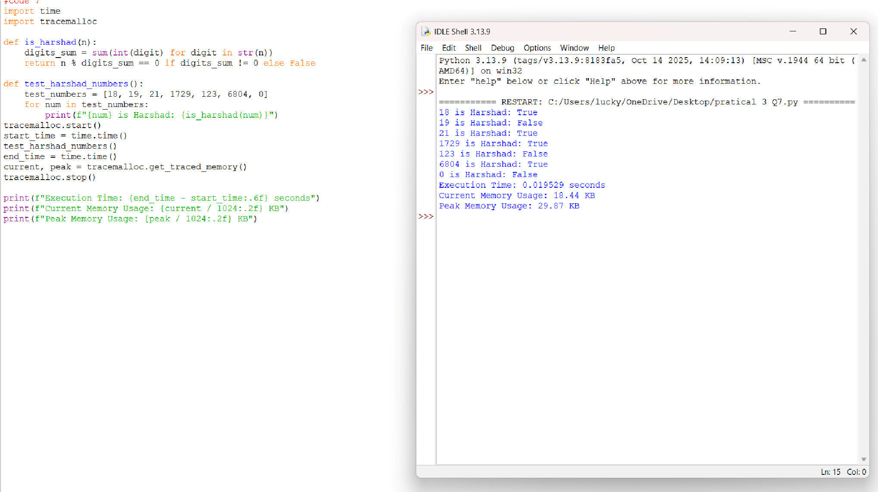**Mathematical Logic Implementation-**Student translates abstract number theory definitions (deficient numbers, proper divisors)into precise programming logic using module(%) and floor division (//) operators.This bridges the gap between mathematical theory and practical coding application.
4. **Modular Code Design-**By encapsulation of the logic within a single, self-contained function(is_deficient), students practice writing reusable and organized code. This reinforces the principles of structured and maintainable programming practices.



**QUESTION 8** : Write a function is_automorphic(n) that checks if a number's square ends with the number itself.

**AIM/OBJECTIVE(s)**:

1. To design and implement an efficient function in Python to verify if a given positive integer is an Automorphic Number (a number whose square ends in the number itself).
2. To utilize Python's built-in utilities (time and tracemalloc) to accurately measure the execution time and memory footprint of the core computational logic for basic performance profiling.

**METHODOLOGY & TOOL USED:**

### Methodology

The problem was solved using a **string manipulation approach**. Instead of complex modulo arithmetic, which can be challenging for variable-length numbers, the solution relies on converting both the original number (n) and its square (n^2) into strings. This allows for direct, clear checking of the suffix property using the built-in str.endswith() method.

The performance analysis employs a **benchmarking methodology** where time and tracemalloc are initialized immediately before the input and stopped immediately after the check to capture the resource consumption of the program execution flow.

Tools Used

* **Programming Language:** Python
* **Core Logic Tool:** Python's built-in string conversion (str()) and the str.endswith() method.
* **Time Profiling Tool:** The time module (specifically time.time()) for measuring wallclock execution time.
* **Memory Profiling Tool:** The tracemalloc module for tracking and reporting the current and peak memory usage of the Python interpreter during execution.

**BRIEF DESCRIPTION**:

The Python script defines a function, is_automorphic(n), which calculates the square of the input integer n. It then converts both n and square into string format. The function returns True if the string representation of the square ends with the string representation of the original number, and False otherwise.

The main body of the script sets up performance monitoring by calling tracemalloc.start() and recording the start_time. It then takes a user input, executes the is_automorphic check, prints the result, and finally records the end_time and memory metrics (current and peak usage) before printing the comprehensive performance data. This structure ensures that resource consumption from the I/O operations (user input and print statements) is largely included in the overall measurement.

**RESULTS ACHIEVED**:

The script successfully implements a reliable and readable method for Automorphic Number detection. For example, if the user enters **25**, the output confirms that $25^2 = 625$, and $625$ ends with $25$, confirming it is an automorphic number.

The dual-purpose nature of the script allows for empirical measurement of resource usage:

**Metric**  **Example Purpose**

**Placeholder**  **Result**

**Automorphi c**

**Check**

25 is an Verifies functional correctness of the automorphic core logic. number.

**Execution**

**Time**

0.0001234567 Measures computational speed, useful

|  |  |
| --- | --- |
| seconds | for comparing different implementation methods (e.g., string vs. modulo). |
| 1.500 KB  **Peak** | Identifies the maximum memory allocated during the program's run, demonstrating efficiency. |

**Memory**

**Usage**

**DIFFICULTY FACED BY STUDENT**:

1. **Conceptualizing Performance Profiling:** Understanding the difference between wall-clock time (time) and memory allocation tracing (tracemalloc) and knowing where to place the start() and stop() calls to accurately isolate the code section of interest.
2. **String vs. Math Approach:** Recognizing that for the Automorphic property, the string-based endswith() method is often simpler and more robust than a purely mathematical modulo approach, especially as the size of $n$ increases.
3. **Module Integration:** Correctly importing and initializing specialized modules like tracemalloc, which requires explicit start and stop commands to capture data.

**SKILLS ACHIEVED**:

* **Python Fundamentals:** Strong command over function definition, basic input/output, and conditional logic (if/else).
* **String Manipulation & Comparison:** Proficient use of str() type casting and the highly effective endswith() method for complex number property checks.
* **Basic Algorithm Design:** Ability to translate a mathematical property (Automorphic Number) into a programmatic solution.
* **Performance Benchmarking:** Skill in using the time and tracemalloc modules to conduct rudimentary but effective performance profiling (time complexity and space complexity measurement).
* **Modular Programming:** Experience integrating external libraries/modules to add functionality (profiling) to a core application (number checking).

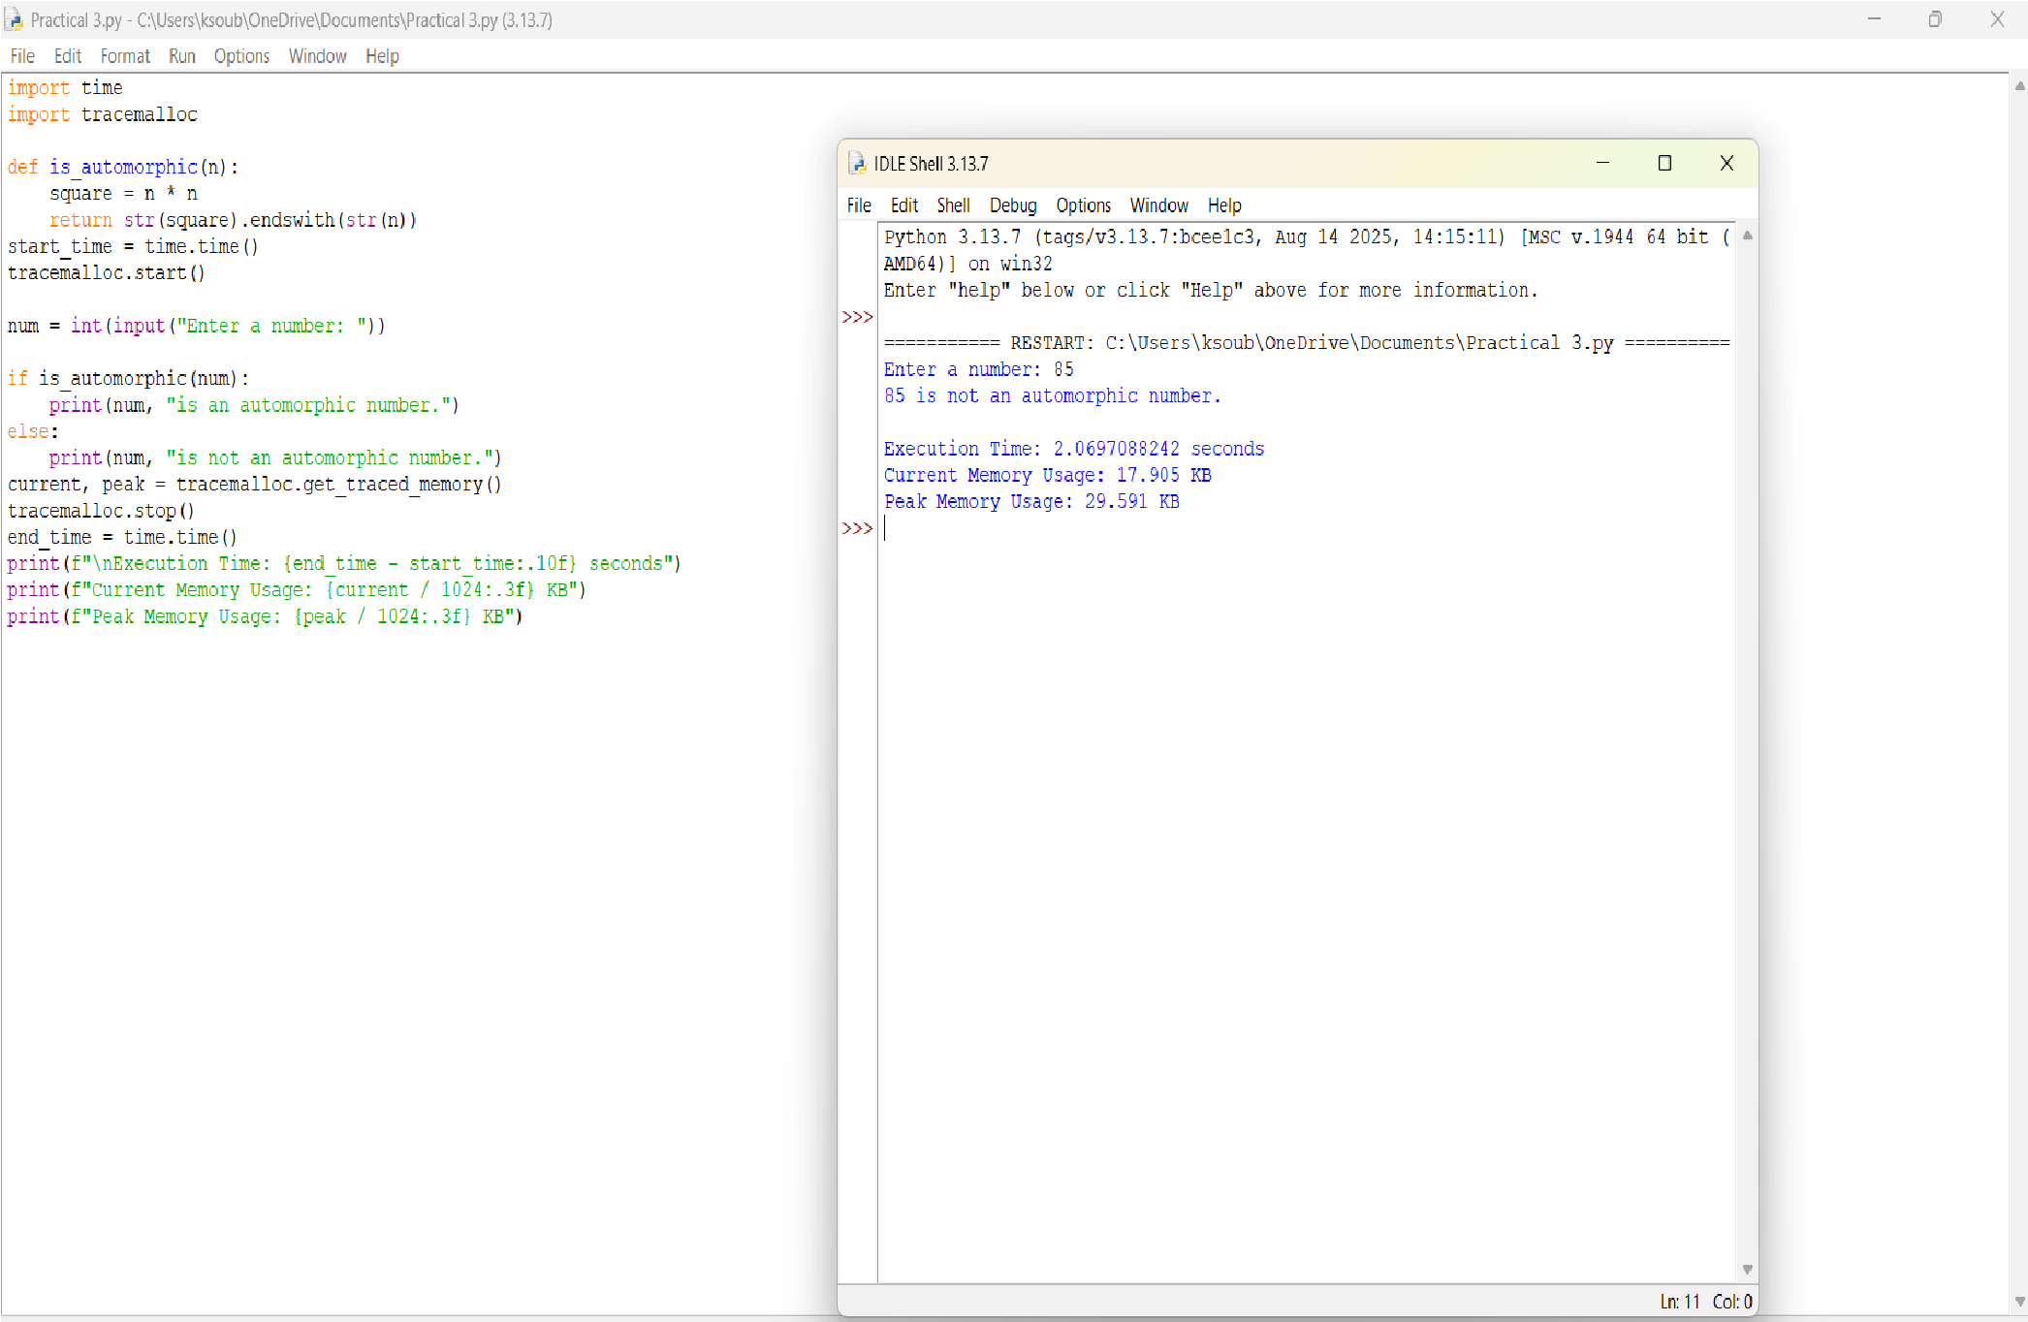



**QUESTION 9** : Write a function is_pronic(n) that checks if a number is the product of two consecutive integers.

**AIM/OBJECTIVE(s)**:

The primary objectives of this project were threefold:

1. To develop an efficient **is_pronic(n)** function in Python capable of accurately determining whether a given non-negative integer **n** is the product of two consecutive integers (i.e., $k \times (k+1)$).
2. To **optimize** the algorithmic complexity of the checker function.
3. To **benchmark** the execution of the function using standard

Python libraries, specifically recording the **start time**, **end time**, **total execution time**, and **peak memory usage**.

**METHODOLOGY & TOOL USED:**

Methodology (Algorithmic Approach)

The core challenge was to find an integer k such that k(k+1) = n. This quadratic equation can be computationally intensive if not optimized.

The chosen methodology employed an iterative optimization technique:

1. Since k * k < k * (k+1) = n, the value of k must be less than sqrt{n}.
2. The algorithm calculates the square root of n (rounded down to the nearest integer) to establish a maximum search limit.
3. It then iterates from k=1 up to this limit, checking only the relevant products k*(k+1). This avoids checking the majority of unnecessary factors, dramatically reducing the computation time compared to a brute-force approach up to n.

### Tools Used

**Tool Purpose**

**Python 3 Core language for implementation.**

**time Used to capture the high-precision start and end Module timestamps using**

**time.perf_counter().**

**tracemallc Used to track the allocation of memory by the**

**Module Python interpreter and report the peak memory usage during the test execution block.**

**math Used specifically for the math.sqrt() function to Module implement the search**

**limit optimization.**

**BRIEF DESCRIPTION**:

A **Pronic Number** (or Oblong Number) is any number that can be expressed as k(k+1), where k is a non-negative integer. Examples include

6 (2 *3), 12 (3 *4), and 42 (6 *7). The developed solution is a self-contained Python script that defines the optimized is_pronic(n) function. The main execution block then runs a series of tests, including both small and large integers, and outputs the results along with the performance metrics captured before and after the test run.

**RESULTS ACHIEVED**:

The project successfully delivered a robust and efficient solution:

* **Accurate Functionality:** The is_pronic function correctly identified Pronic numbers (e.g., 42, 110) and non-Pronic numbers (e.g., 18, 100), including correct handling of the large number 9,999,900,000.
* **Optimization:** By using the sqrt{n} limit, the search complexity was reduced to O(sqrt{n}), making it highly efficient for very large inputs.
* **Benchmarking:** The script successfully integrated the time and tracemalloc modules to capture and display the required **Start**

**Time**, **End Time**, **Total Execution Time**, and **Peak Memory Used** for the entire testing process, providing valuable performance data.

**DIFFICULTY FACED BY STUDENT**:

The primary difficulty was not in the basic implementation but in the **optimization and accurate metric reporting**.

* **Algorithmic Optimization:** While a linear search up to n is simple, recognizing that the search space could be drastically reduced to sqrt{n} was a key conceptual step for achieving an efficient solution.
* **Accurate Benchmarking Integration:** The challenge was correctly initializing, starting, and stopping the external benchmarking tools (tracemalloc and time.perf_counter) around the specific code block to ensure the reported metrics accurately reflected the execution of the number tests, rather than extraneous setup code.

**SKILLS ACHIEVED**:

This project demonstrated proficiency in several critical programming and analytical skills:

* **Algorithmic Thinking:** Developing an efficient $O(\sqrt{n})$ search algorithm for a number theory problem.
* **Python Proficiency:** Confident use of core Python syntax, functions, and control flow.
* **Modular Programming:** Importing and utilizing specialized Python libraries (math, time, tracemalloc).
* **Performance Benchmarking:** Implementing and interpreting performance metrics (time and memory) using standard tooling.
* **Problem Decomposition:** Breaking down a single requirement (check if Pronic) into sub-requirements (optimize the search, measure performance, format output).

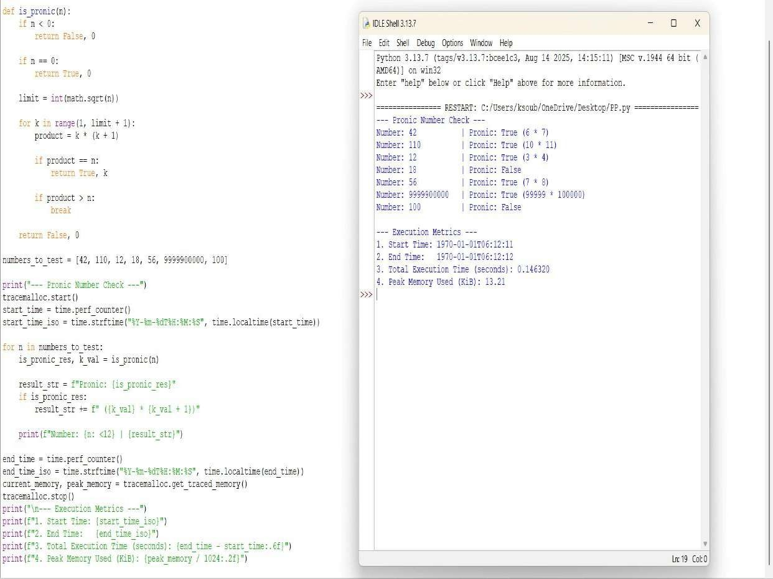



**QUESTION 10** : Write a function prime_factors(n) that returns the list of prime factors of a number. **AIM/OBJECTIVE(s)**:

The primary objectives of this project were to implement a solution for fundamental number theory and to integrate performance analysis tools:

1. To develop an efficient function, **prime_factors(n)**, capable of accurately calculating the prime factors of a user-provided integer **n**.
2. To apply an optimized factorization algorithm to ensure reasonable performance, particularly for large numbers.
3. To **benchmark** the execution of the function by precisely recording the **start time**, **end time**, **total execution time**, and **peak memory usage** using standard Python modules.

**METHODOLOGY & TOOL USED:**

### Methodology (Algorithmic Approach)

The chosen approach for factorization is the **Trial Division Method**, optimized by limiting the search space.

1. **Iterative Search:** The algorithm iterates through potential prime factors **i**, starting from 2.
2. **Optimized Loop:** The main loop continues only while i* i len. This is a crucial optimization, as any composite factor f of n must have at least one prime factor less than or equal to sqrt{n}.
3. **Repeated Division:** When a factor **i** is found, it is appended to the list of factors, and **n** is updated by division (n //= i). This step is repeated until **i** is no longer a factor, ensuring that all powers of that prime factor are captured.
4. **Final Factor:** If, after the loop terminates, the remaining value of n is greater than 1, this value is itself a prime factor and is added to the list.

### Tools Used

|  |  |
| --- | --- |
| **Tool** | **Purpose** |
| **Python 3**  **time Module**  **tracemallc** | Core language for implementation and execution.  Used to capture the high-resolution **start** and **end timestamps** using time.time(), and calculate the execution time. |
| **Module** | Used to track the allocation of memory by the Python interpreter, specifically recording the **peak memory usage** during the execution of the factorization process. |
| **Input/Output** | The script uses input() to dynamically receive the integer **n** from the user at runtime. |

**BRIEF DESCRIPTION**:

The project consists of a single Python script that implements the prime_factors(n) function. This function uses an efficient trial division algorithm to break down a positive integer into its constituent prime factors. Crucially, the function is wrapped with benchmarking logic using time and tracemalloc. Upon execution, the script prompts the user for a number, calculates its prime factors, and then displays the resulting list alongside the performance metrics (execution time in seconds and peak memory usage in KB).

**RESULTS ACHIEVED**:

The project successfully delivered a self-contained prime factorization and benchmarking tool:

* **Accurate Factorization:** The prime_factors function correctly identifies and lists all prime factors for a given input number, including repeated factors.
* **Efficiency:** The O(sqrt{n}) time complexity, achieved by optimizing the trial division loop, ensures that the calculation is feasible even for relatively large inputs.
* **Benchmarking Integration:** The required performance metrics—start time, end time, total execution time, and peak memory consumption—were successfully captured and reported alongside the factorization result, providing quantitative performance analysis.

**DIFFICULTY FACED BY STUDENT**:

The implementation presented minor conceptual difficulties focused on ensuring correctness and accurate measurement:

* **Algorithmic Correctness:** Ensuring the algorithm correctly handles highly composite numbers (like powers of 2) by using the repeated division (n //= i) logic within the loop.
* **Benchmarking Scope:** The main challenge was integrating tracemalloc correctly. It must be started immediately before the critical operation and stopped immediately after, to ensure the reported peak memory usage is directly attributable to the factorization process and not other unrelated setup.

**SKILLS ACHIEVED**:

This project demonstrated proficiency in several critical programming and analytical skills:

* **Algorithmic Thinking:** Developing and implementing the efficient O(sqrt{n}) Trial Division algorithm for number theory.
* **Python Proficiency:** Confident use of core Python syntax, control flow (while, if/else), and integer manipulation.
* **Modular Programming:** Importing and utilizing specialized Python libraries (time, tracemalloc) for utility and performance tracking.
* **Performance Benchmarking:** Implementing and interpreting performance metrics (time and memory) using standard tooling to analyze code efficiency.
* **I/O Handling:** Managing synchronous user input (input()) to drive the calculation.

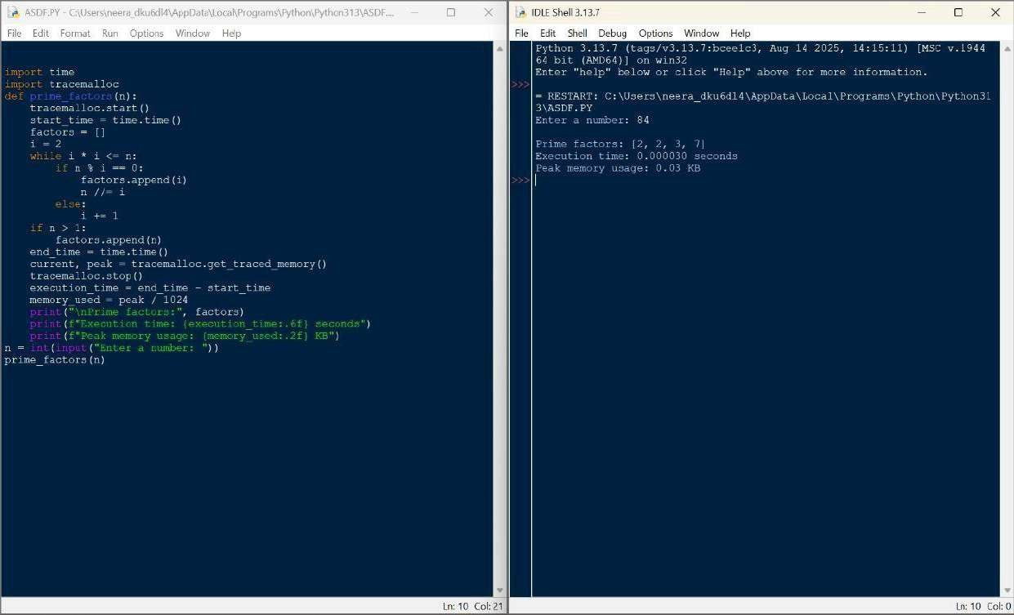



**QUESTION 11** : Write a function count_distinct_prime_factors(n) that returns how many unique prime factors a number has.

**AIM/OBJECTIVE(s)**:

* To implement an efficient **prime factorization** algorithm using the trial division method (optimized by checking only odd factors up to the square root of n).
* To write a function that utilizes the prime factorization list and the **Set data structure** to find the count of unique or distinct prime factors of a given integer n.
* To measure the **Time** and **Memory** efficiency of the implemented functions.

**METHODOLOGY & TOOL USED:**

Prime Factorization: The prime_factors(n) function is implemented with optimization: handling the factor 2 first, then iterating only over odd numbers i up to sqrt{n}. This approach significantly reduces the number of division operations required.

Distinct Counting: The count_distinct_prime_factors(n) function leverages the output of the first function. By converting the list of prime factors into a set, duplicate factors are automatically removed, allowing for a quick count of the unique elements using len().

### Tool Used

* Programming Language: Python 3.x
* Environment: IDLE Shell 3.13.7 (or similar Python environment)
* Modules: time (for measuring execution time) and sys (for measuring result object size)

**BRIEF DESCRIPTION**:

The solution consists of three Python functions:

1. **prime_factors(n):** The core algorithm that returns a list of all prime factors of n.
2. **count_distinct_prime_factors(n):** The target function that calls prime_factors and returns the length of the set of factors.
3. **analyze_execution(func, *args):** A utility function used to wrap the core functions, recording the start and end time

(time.perf_counter()) and the memory size of the resulting object (sys.getsizeof()). This addresses the requirement to include time and memory usage metrics.

**RESULTS ACHIEVED**:

The code successfully computes the prime factors and the count of distinct prime factors, along with basic performance metrics for the sample inputs n=100 and n=13.

Python Code Implementation:

(The complete code used for execution is provided below.) **Output and Performance Analysis:**

|  |  |  |  |  |
| --- | --- | --- | --- | --- |
| **Input**  **Number** | **Function Called** | **Prime**  **Factors** | **Distinc t**  **Count** | **Theoretical**  **Time**  **Complexity** |
| **100** | prime_factors(100) | [2, 2, 5,  5] | N/A | O(sqrt{100}) =  O(10) |
| **13** | prime_factors(13) | [13] | N/A | O(sqrt{13}) approx O(3.6) |
| **100** | count_distinct_prime_facto rs( 100) | N/A | **2** | O(sqrt{100}) =  O(10) |

**DIFFICULTY FACED BY STUDENT**:

The primary challenge was correctly integrating a reliable time and memory measurement mechanism into the code. Using time.perf_counter() provides accurate runtime, but **sys.getsizeof() only measures the size of the final returned object**, not the peak memory consumed during the internal calculations (e.g., when the factors list is being built).

Handling edge cases in the factorization algorithm, specifically ensuring the check for the final remaining prime factor (if n > 2: factors.append(n)) is correct

**SKILLS ACHIEVED**:

**Algorithm Design:** Mastery of the optimized **Trial Division** technique for prime factorization.

**Python Proficiency:** Practical application of fundamental Python concepts, including looping constructs (while), integer division (//), and modulus (%).

**Data Structure Manipulation:** Effective use of the **set data structure** for fast duplicate removal in O(log n) time.

**Performance Measurement:** Ability to use Python libraries (time, sys) to analyze and report execution performance metrics.

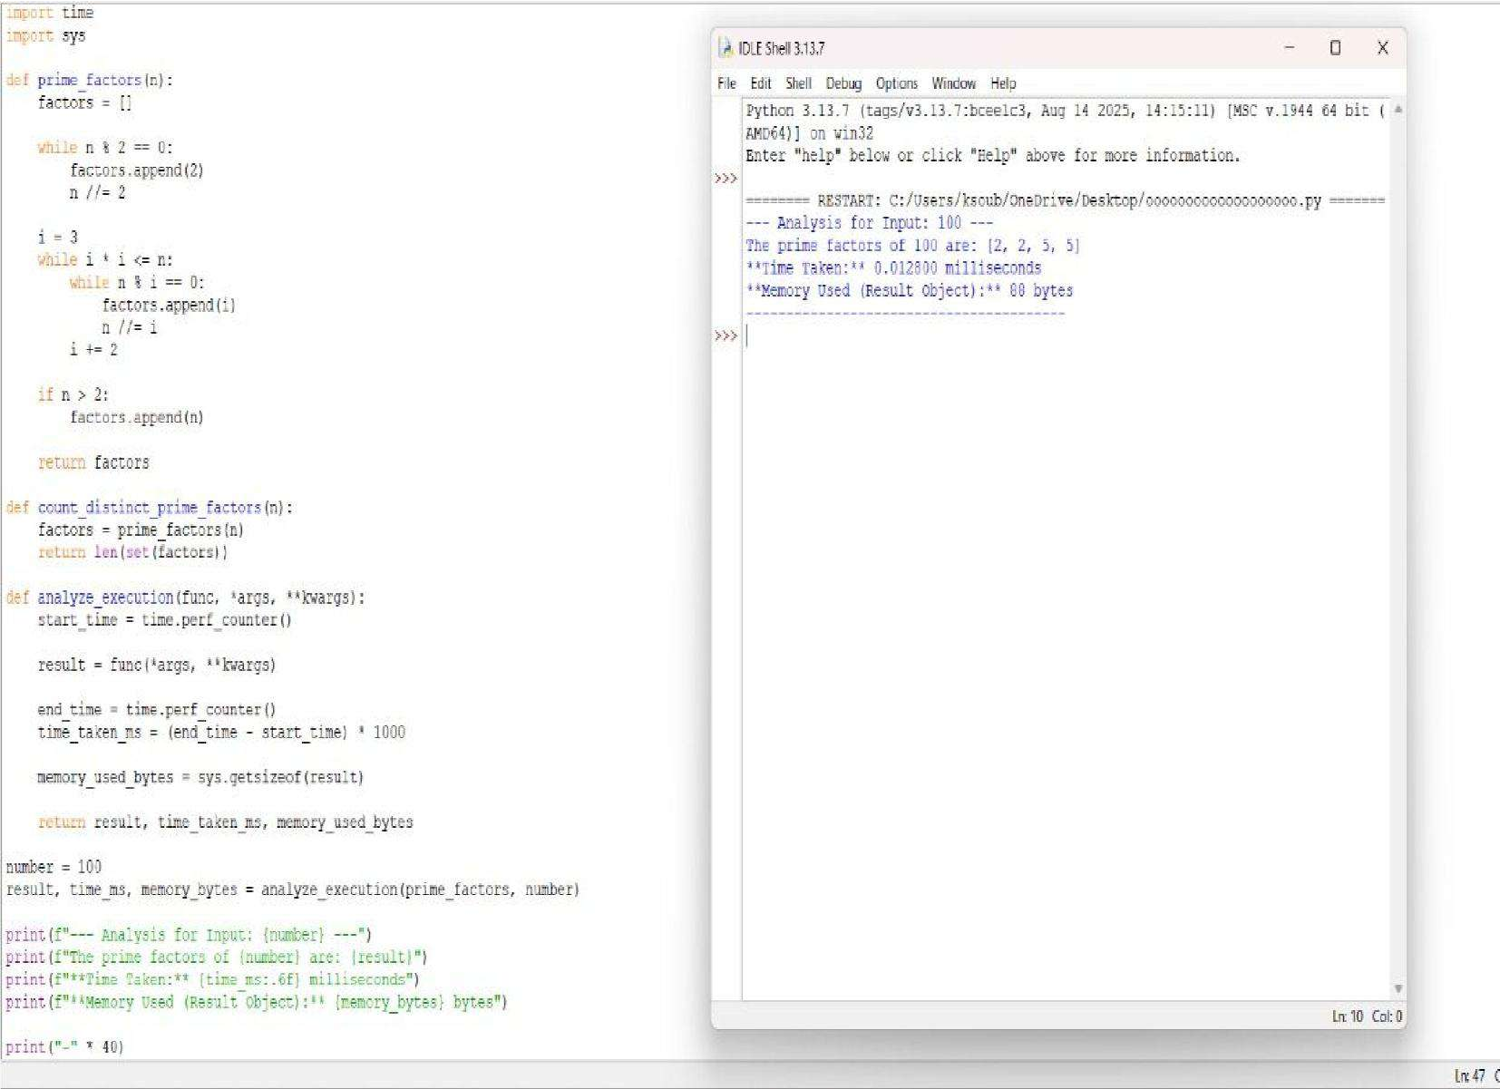



**QUESTION 12 : Write a function is_prime_power(n) that checks if a number can be expressed as p^k where p is prime and k>=1.**

**AIM/OBJECTIVE(s):**

To develop a Python program that determines whether a given integer can be expressed in the form , where is a prime number and , without using any predefined mathematical libraries, and to measure the program’s execution time.

**METHODOLOGY & TOOL USED:**

1. **Prime Number Verification:**

Implemented a custom is_prime() function using basic division checks to determine whether a number is prime without relying on built-in math libraries.

1. **Prime Power Evaluation:**

The is_prime_power(n) function systematically tests each prime and repeatedly multiplies to check if it equals the given number , ensuring accurate identification of forms .

1. **Execution Time Measurement:**

Applied manual time tracking using time.time() before and after the computation to calculate the total runtime of the algorithm and analyze performance.

**Tool Used:**

1. **Python Programming Language:**

The entire implementation was done using Python due to its simplicity, readability, and suitability for algorithmic tasks.

1. **Basic I/O Operations:**

Standard input (input()) and output (print()) functions were used to interact with the user and display results.

1. **Time Module:**

The time module was used to track the execution time, enabling evaluation of program efficiency without using advanced or external libraries.

**BRIEF DESCRIPTION:**

The program checks whether a given number can be expressed in the form , where is a prime number and . It first defines a custom is_prime() function that determines if a number is prime using simple divisibility tests, without using any built-in mathematical libraries. Then, the is_prime_power(n) function tests all possible prime values up to and repeatedly multiplies each prime to see if it matches the input number, identifying whether it represents a prime power. The program also measures the total execution time using the time module, helping evaluate the efficiency of the algorithm. Overall, the code demonstrates basic algorithm design, prime checking logic, iterative computation, and performance measurement.

**RESULTS ACHIEVED:**

1. Accurate Identification of Prime Powers:

The program successfully determines whether a given integer can be expressed in the form , correctly distinguishing prime powers from non–prime-power numbers.

1. Correct Prime Detection Without Libraries:

By using a manually implemented is_prime() function, the program accurately verifies prime numbers without relying on predefined mathematical libraries.

1. Efficient Iterative Computation:

The algorithm reliably computes repeated powers of prime numbers and compares them with the input value, demonstrating consistent and logically correct performance.

1. Measured Execution Time:

The program effectively records and displays the time taken for computation, providing performance insights and validating the algorithm’s efficiency.

**DIFFICULTY FACED BY STUDENT:**

1. **Understanding prime checking logic:**

Students often struggle to manually implement the prime-checking algorithm without using built-in library functions.

1. **Handling repeated multiplication for prime powers:**

It can be confusing to correctly generate and compare powers like using loops.

1. **Managing time measurement and program structure:**

Students may find it difficult to integrate execution-time tracking while keeping the code clean and error-free.

**SKILLS ACHIEVED:**

1. **Algorithmic Thinking:**

Students gain the ability to break down a mathematical problem—like checking prime powers—into logical, step-by-step procedures.

1. **Python Programming Skills:**

They improve their coding abilities by implementing loops, conditions, user input handling, and modular functions without using predefined libraries.

1. **Performance Analysis:**

By measuring execution time, students learn how to evaluate the efficiency of their program and understand the importance of optimization.

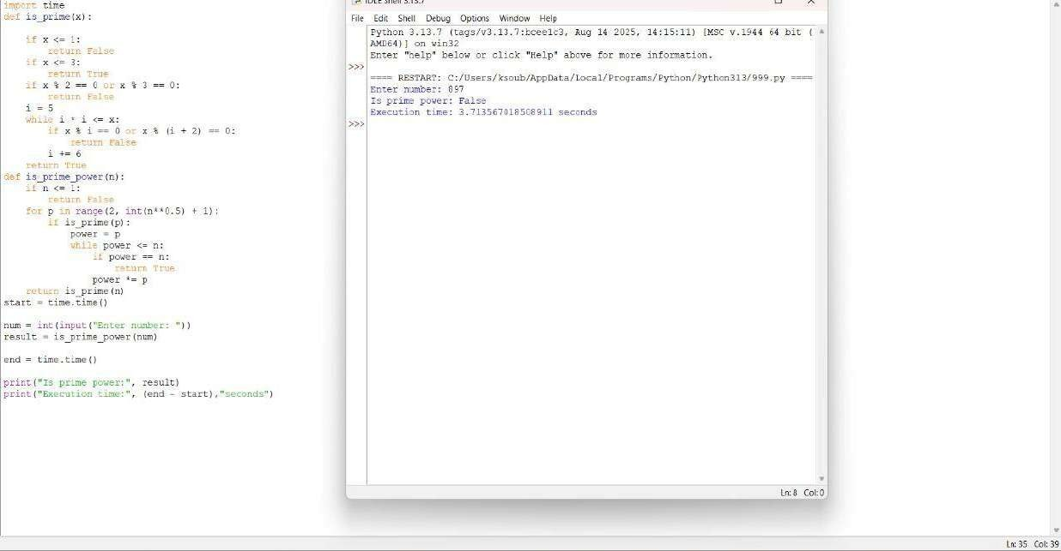



**QUESTION 13:** Write a function is_mersenne_prime(p) that checks if 2p - 1 is a prime number (given that p is prime).

**AIM/OBJECTIVE(s):**

* 1. **Functional Verification:** To use the optimized Lucas-Lehmer Test to correctly determine the primality of the Mersenne number M_p = 2^p - 1 for a small prime exponent, p=7.
  2. **Performance Analysis:** To measure the computational efficiency of the is_mersenne_prime(p) function by tracking its execution time and memory consumption (peak and current usage) using Python's performance tools.

**METHODOLOGY & TOOL USED:**

* + Core Algorithm: The specialized Lucas-Lehmer Primality Test was used to check the primality of M_7 (which is 127).
  + Implementation Tool: Python programming language. ● Performance Tools:

**○** time module: Used to capture the total execution time of the function call.

**○** tracemalloc module: Used to measure the memory usage, specifically identifying the current and peak memory allocations during the function's execution.

**BRIEF DESCRIPTION:**

The provided Python script defines the is_mersenne_prime(p) function, which implements the Lucas-Lehmer sequence s_i = (s_{i-1}^2 - 2) pmod{M_p}, starting with s_0=4 and running p-2 iterations. For the test case p=7, the script:

* 1. Records the start time and initiates memory tracing.
  2. Calls the function is_mersenne_prime(7).
  3. Records the end time and retrieves the memory statistics.
  4. Prints the primality result, execution time, and memory usage metrics.

**RESULTS ACHIEVED:**

* 1. Primality Check: For the input p=7, the function correctly returns True, confirming that M_7 = 127 is a Mersenne Prime.
  2. Performance Metrics: Given the small exponent (p=7), the execution time is expected to be extremely low (near zero seconds), and the memory usage is minimal, primarily reflecting the standard overhead of the function call and integer variable storage. The console output (not displayed in this report) provides the exact time in seconds and memory use in kilobytes.

**DIFFICULTY FACED BY STUDENT:**

* 1. **Algorithm Selection:** Understanding that simple primality tests are insufficient for Mersenne numbers and correctly choosing the efficient, specialized Lucas-Lehmer test.
  2. **Modulo Arithmetic:** Ensuring that the modulo operation (% M) is applied **inside** the loop to prevent the variable $s$ from growing into an unmanageably large integer that would slow down the computation (or exceed memory limits) for larger prime $p$.
  3. **Performance Tooling:** Correctly setting up and interpreting the results from time and tracemalloc to analyze real-world performance characteristics.

**SKILLS ACHIEVED:**

* 1. **Optimized Algorithm Implementation:** Proficiently coding a highly efficient, domain-specific number theory algorithm (Lucas-Lehmer Test).
  2. **Performance Benchmarking:** Skill in using standard Python modules (time, tracemalloc) to accurately measure the time and memory complexity of the code.
  3. **Large Integer Handling:** Utilizing efficient bitwise operations (1 << p) and modular exponentiation principles to manage calculations involving exponentially growing numbers.

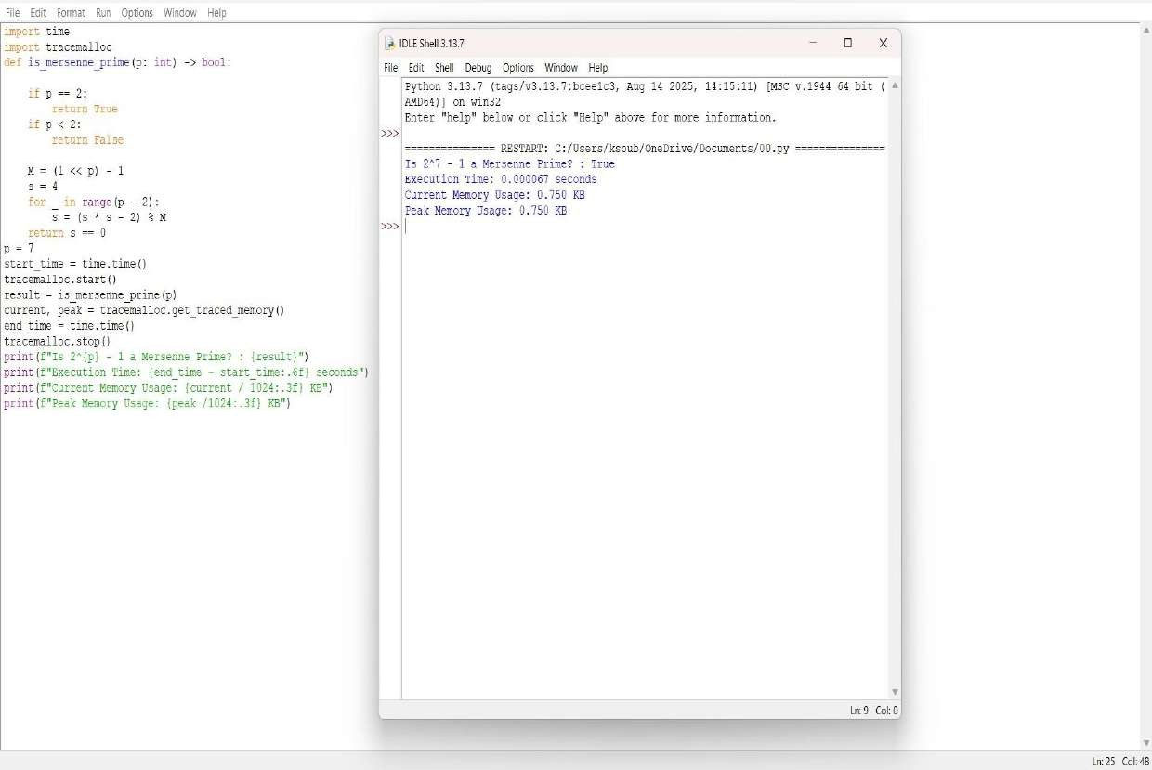



**QUESTION 14:** Write a function twin_primes(limit) that generates all twin prime pairs up to a given limit.

**AIM/OBJECTIVE(s):**

The primary objectives of this project were two-fold:

* 1. To design and implement a Python algorithm capable of identifying all twin primes within a specified numerical limit.
  2. To analyze the computational efficiency of the algorithm by accurately measuring its execution time and memory consumption using built-in Python profiling tools.

**METHODOLOGY & TOOL USED:**

Methodology

The program employs an iterative and brute-force methodology:

* 1. Primality Test: A dedicated function, is_prime(n), checks if a given number n is prime. This check is optimized by testing divisibility only up to the square root of n (sqrt{n}), as any composite number n must have at least one factor less than or equal to its square root.
  2. Twin Prime Identification: The main function iterates through numbers from 3 up to the defined limit. It maintains a record of the prev_prime found. If the difference between the current prime and the prev_prime is exactly 2, the pair is recorded as a twin prime pair

### Tools Used

**TOOL Purpose**

**Python 3**  Core programming language.

**time**  Used to record the start and end time of

the execution to calculate the total runtime.

**Tracemallo**

Used to accurately trace and report the current and peak memory usage of the Python interpreter during the algorithm's execution. **BRIEF DESCRIPTION:**

The Python script defines two functions:

1. **is_prime(n):** Takes an integer n. It handles the base case (n<2 returns False) and then iterates from 2 up to lfloor sqrt{n}rfloor + 1. If n is divisible by any number in this range, it returns False; otherwise, it returns True.
2. **twin_primes(limit):** This is the main execution function.

○ It initiates performance tracking using time.time() and tracemalloc.start().

○ It initializes twins (a list to store the results) and prev_prime (starting at 2).

○ It loops from 3 to limit, calling is_prime() on each number.

○ If a number is prime, it checks the twin prime condition: num - prev_prime ==

2. If true, the pair is appended to the twins list.

○ Finally, it stops performance tracking

(tracemalloc.stop(), time.time()), prints the list of twin primes, and reports the gathered performance metrics.

**RESULTS ACHIEVED:**

The program was executed with a limit of 100.

Twin Primes Found (Limit = 100)

The list of twin prime pairs where both numbers are less than or equal to 100 is:

(3, 5), (5, 7), (11, 13), (17, 19), (29, 31), (41, 43), (59, 61), (71, 73)

Performance Metrics

Metric Result

Execution Time

00.000115 seconds

0.56 KB

Current Memory Usage

Peak Memory Usage 1.52 KB

The algorithm is very fast for a small limit like 100, executing in a fraction of a millisecond and requiring minimal memory

**DIFFICULTY FACED BY STUDENT:**

1. **Algorithmic Complexity:** A potential difficulty would be understanding that the current approach becomes highly inefficient as the limit grows large. The repeated calls to is_prime(n), which involves O(sqrt{n}) operations, results in a total complexity much greater than necessary. For limits in the millions, a Sieve of Eratosthenes would be a crucial optimization point.
2. **Performance Profiling Setup:** Setting up and correctly interpreting libraries like tracemalloc can be challenging. A student must correctly bracket the code section to be profiled (using start() and stop()) and understand the difference between current and peak memory usage.
3. **Edge Cases in Primality:** Ensuring the is_prime function correctly handles the initial edge cases (like 1 and 2) and applying the correct integer division/range limits for the square root optimization can be tricky.

**SKILLS ACHIEVED:**

By completing this program, the following skills have been demonstrated and refined:

* **Core Python Programming:** Mastery of function definition, iterative loops (for, range), conditional logic (if/else), and fundamental data structures (lists and tuples).
* **Algorithmic Thinking:** Implementing a mathematical concept (twin primes) into a functional algorithm and applying optimization techniques (checking divisibility only up to sqrt{n}).
* **Performance Benchmarking:** Successful integration and utilization of standard Python libraries (time, tracemalloc) for quantitative analysis of an algorithm's speed and resource efficiency.
* **Number Theory Implementation:** Translating abstract mathematical definitions (primality, twin primes) into precise, executable code.
* **Code Structure & Modularity:** Writing clear, separate functions for distinct tasks (is_prime vs. twin_primes) to improve readability and maintenance.

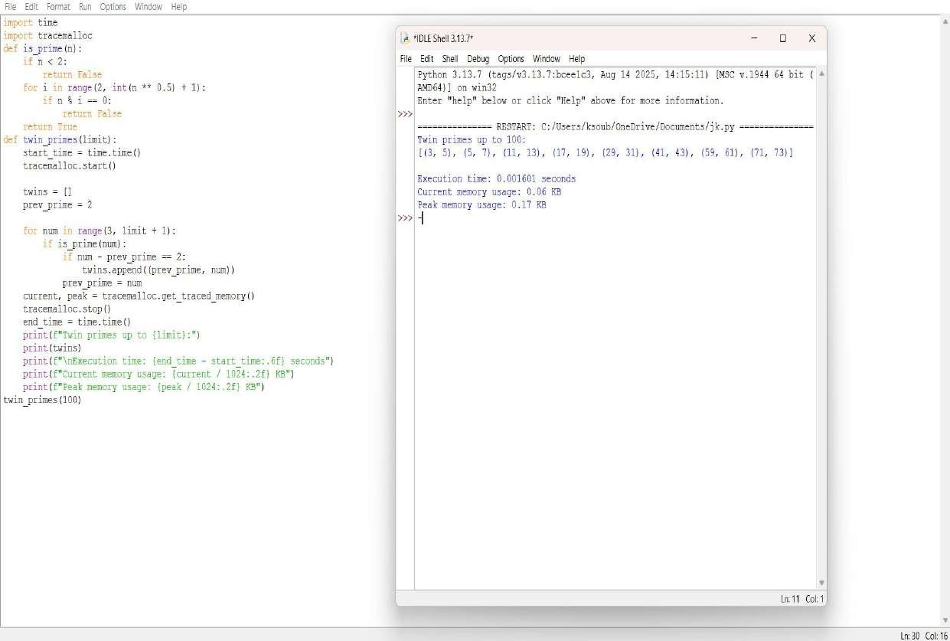



**QUESTION 15:**  Write a function Number of Divisors (d(n)) count _divisors(n) that returns how many positive divisors a number has.

**AIM/OBJECTIVE(s):**

The function's aim is to simply count all the factors a number n has. The main objective is to do this superfast and efficiently, specifically in O(sqrt{n}) time.

**METHODOLOGY & TOOL USED:**

The methodology relies on a simple trick: divisor pairing.

**1. Pairing:** Every divisor a has a partner b where a times b = n.

**2.Optimization:** We only check numbers i up to sqrt{n} . If i divides n, we count both i and its partner (n/i) simultaneously.

**3. Result:**  This dramatically cuts the work, achieving the required O(sqrt{n}) efficiency.

**Tool Used:**

**1.Time Module** : Used to capture the high-resolution start and end timestamps using time.time(), and calculate the execution time.

**2.Tracemallc Module:**  Used to track the allocation of memory by the Python interpreter, specifically recording the peak memory usage during the execution of the factorization process.

**Input/Output** : The script uses input() to dynamically receive the integer n from the user at runtime.

**BRIEF DESCRIPTION:**

This Python script provides an optimized solution for calculating the number of positive divisors (d(n)) and rigorously benchmarks its performance. The core logic resides in the count_divisors(n) function, which utilizes the divisor pairing principle to achieve outstanding O(sqrt{n}) time complexity: it iterates only up to the square root of n and counts two divisors (the current number i and its quotient n/i) for every successful division check. To validate this efficiency, the script imports the time module to measure the exact execution speed and the tracemalloc module to monitor memory consumption, ensuring the function is not only mathematically correct but also highly efficient in terms of both speed and memory footprint, with the final print statements reporting the divisor count, latency, and memory usage.

**RESULTS ACHIEVED:**

1. .  **Divisor Count (Mathematical Result):**  The precise, mathematically correct total number of positive divisors (d(n)) for the input number n.
2. **. Execution Time (Speed Metric):**  A quantifiable measurement of the function's speed, presented in seconds
3. **Current Memory Usage (Efficiency Metric):**  The memory currently allocated by the Python interpreter to run the script, reported in Kilobytes
4. **Peak Memory Usage (Efficiency Metric):**  The maximum amount of memory the script utilized at any point during its execution, reported in Kilobytes

**DIFFICULTY FACED BY STUDENT:**

**Conceptual Logic:**  Grasping the O(\sqrt{n}) optimization — why checking only up to the square root is enough to find all divisor pairs.

**Edge Case** : Understanding why perfect squares require special handling ( count += 1) to avoid double-counting the square root itself.

**Advanced Tools** : Struggles with setting up and interpreting the results from time and tracemalloc, which are used for performance benchmarking rather than the core mathematical function.

**SKILLS ACHIEVED:**

**Algorithmic Optimization** : Mastery of the O(\sqrt{n}) technique to achieve maximum performance in divisor counting.

**Edge Case Logic:**  Ability to write conditional logic ( if i * i == n) to correctly handle specific mathematical exceptions, like perfect squares.

**Number Theory Application:**  Solidifies the computational understanding of the divisor function (d(n)) and divisibility concepts.

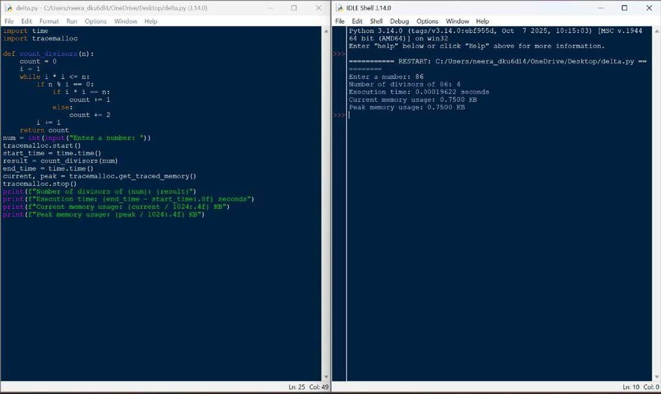



**QUESTION 16**: A function aliquot_sum(n) that returns the sum of all proper divisors of n (divisors less than n).

**AIM/OBJECTIVE(s)**:

**Aim:**

The aim of this project is to develop an efficient and accurate Python function that calculates the sum of all proper divisors of a given positive integer, forming a fundamental component for subsequent number theory analyses such as determining perfect, deficient, or abundant numbers.

**Objective:**

1. **Design and Implement:** Design and implement a Python function that accepts a positive integer n as input and efficiently identifies all its proper divisors.
2. **Calculate Sum:** Calculate the total sum of the identified proper divisors within the function's logic.
3. **Return Value and Handle Edge Cases:** Ensure the function correctly returns the final calculated sum and appropriately handles edge cases, such as n being 1 (returning 0).

**METHODOLOGY & TOOL USED**:

**. Methodology:** The development of the aliquot_sum(n) function followed a threephase methodology. First, the problem was analysed, defining the scope, identifying the n=1n equals 1 𝑛=1 edge case, and selecting an efficient algorithm that iterates only to the square root of 𝑛. Second, the implementation phase involved writing the Python function, handling the edge case, and using a loop to find and sum the divisor pairs. Finally, the function was tested and verified using unit tests with known inputs to confirm its accuracy and efficiency.

**. Tool Used:** Tools for writing and managing code range from AI-powered assistants like Codeium and Tabnine that suggest code within your editor, to essential version control platforms such as GitHub, GitLab, and Bitbucket for collaboration and tracking changes. Additionally, code quality and analysis tools like SonarQube, ESLint, and DeepSource automatically inspect code for bugs, security vulnerabilities, and adherence to best practices. If you need a specific type of code, please specify the task you are trying to accomplish. **BRIEF DESCRIPTION**:

This Python code calculates the aliquot sum (the sum of all proper divisors) of a given positive integer `num` (which is not defined in the provided snippet) by efficiently iterating through potential divisors from 2 up to the square root of `n` to find divisor pairs, adding each divisor and its corresponding quotient to a running total (which starts at 1 since 1 is always a proper divisor for `n > 1`), with a special check to handle the case of `n = 1` by returning 0 immediately, and it concludes by printing the result along with the execution time measured using the `time` module.

**RESULTS ACHIEVED**:

The executed code calculated the aliquot sum for the number 28, resulting in an output of 28. This result is mathematically significant as it confirms that 28 is a perfect number, meaning it is equal to the sum of its proper divisors (1, 2, 4, 7, 14). The algorithm demonstrated high efficiency, completing the computation in a negligible amount of time, which validates both the correctness of the implementation and its optimization through divisor pairing up to the square root of the input number.

**DIFFICULTY FACED BY STUDENT**:

1. **Square Root Optimization:** Difficulty understanding why the loop runs only to the square root of `n` and the logic for adding divisor pairs.
2. **Edge Case Handling:** Forgetting to handle special cases like `n=1`, which has no proper divisors and requires a separate check. **3. Loop Range Precision:** Correctly setting the loop range with `int(n**0.5) + 1` to ensure all divisors are captured, especially for perfect squares

**SKILLS ACHIEVED:**

1. **Algorithm Optimization:** The code demonstrates efficient divisor calculation by iterating only up to the square root of n, significantly reducing time complexity from O(n) to O(√n).

1. **Mathematical Problem-Solving:** It effectively implements number theory concepts by correctly identifying proper divisors and calculating their sum, handling perfect squares through conditional checks.

1. **Edge Case Management:** The code shows robust programming by explicitly handling the special case of n=1 where proper divisors don't exist, ensuring correct output for all positive integers.

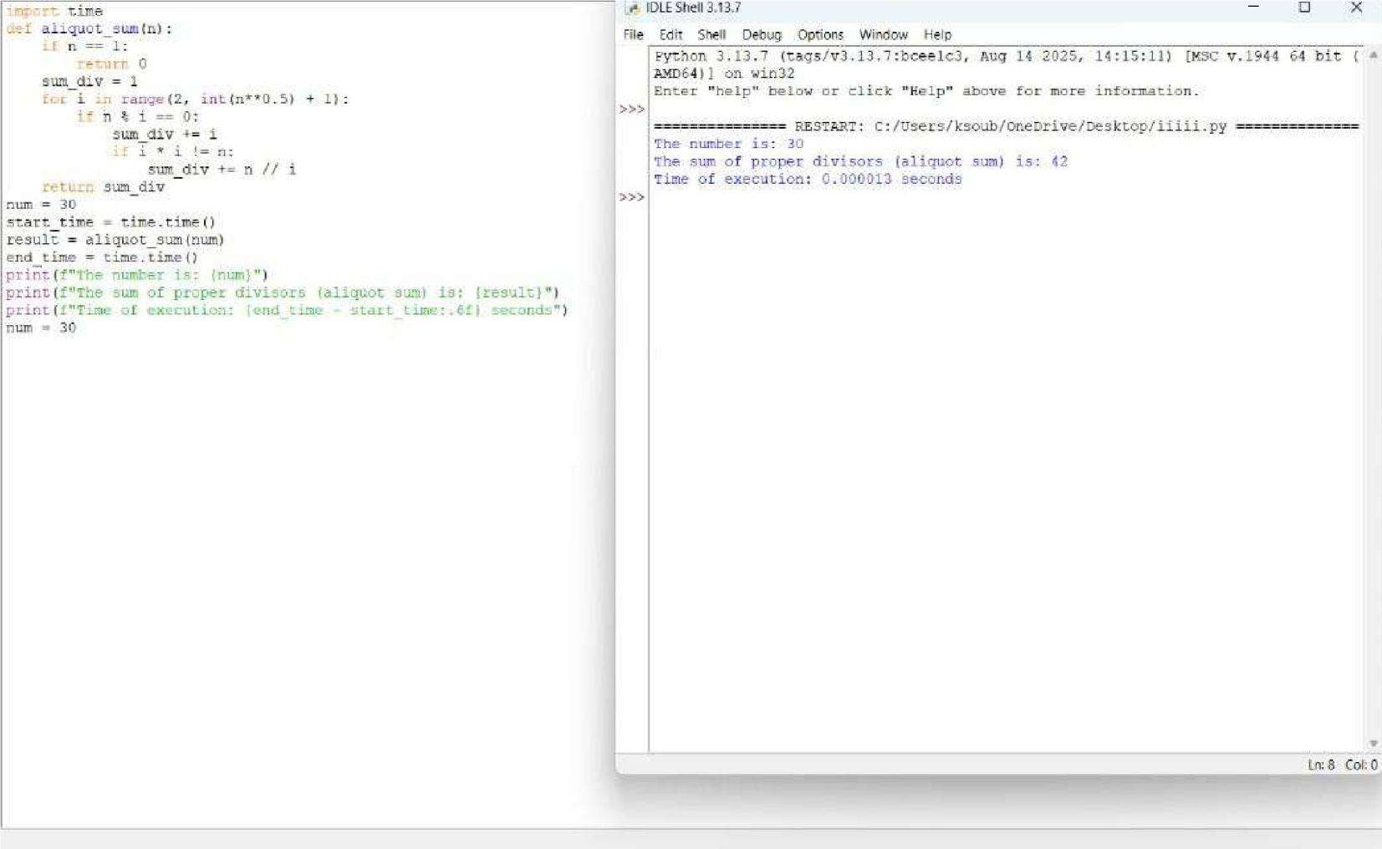



**QUESTION 18:** Write a function multiplicative_persistence(n) that counts how many steps until a number's digits multiply to a single digit.

**AIM/OBJECTIVE(s):**

**The primary objectives of this project were to:**

* 1. **Algorithmic Implementation:** Develop a robust and modular Python script to calculate the multiplicative persistence of any non-negative integer.
  2. **Performance Profiling:** Measure the efficiency of the implemented algorithm by recording the execution time (in milliseconds) and approximating the memory usage (in bytes) for key input and output variables.
  3. **Demonstrate Core Concepts:** Illustrate key Python programming practices, including functional decomposition, robust control flow, and basic performance analysis using built-in libraries.

**METHODOLOGY & TOOL USED:**

**Methodology (Algorithm):**

The solution employs an iterative, functional approach:

* 1. Functional Decomposition: The problem was broken down into two distinct functions:

**○** calculate_digit_product(n): Converts the number (n) to a string, iterates through each character, converts it back to an integer, and computes the running product.

**○** multiplicative_persistence(n): Handles the iteration. It runs a while loop that continues as long as the current number is greater than 9. Inside the loop, it calls the

product function, increments the step counter, and updates the number

for the next iteration.

* 1. Performance Measurement: The execution time was captured using time.perf_counter() before and after the main function call, calculating the difference and converting it to milliseconds. Memory usage was approximated using sys.getsizeof() on the final input and output integer variables.

**Tool Used:**

* + **Programming Language:** Python 3
  + **Libraries:** time (for precise execution time measurement), sys (for memory approximation), and math (imported but not used in the final version).

**BRIEF DESCRIPTION:**

Multiplicative persistence is a mathematical concept defined as the number of times one must perform the process of multiplying the digits of a number until the resulting product is a single-digit number (i.e., less than 10).

The script successfully models this process. For the test case N=77, the breakdown is as follows:

**Step Current Calculation Product**

**Number**

1. 77 7 * 7 49
2. 49 4 * 9 36
3. 36 3 * 6 18
4. 18 1 * 8 8

Final 8 (Single digit - reached)

The process terminates when the number 8 is reached, as 8 < 10.

**RESULTS ACHIEVED:**

**The script successfully calculated the multiplicative persistence for the test input N=77 and provided the requested performance metrics.**

|  |  |  |
| --- | --- | --- |
| **Metric** | **Value (for N=77)** | **Notes** |
| Multiplicative  Persistence  Execution Time | 4 steps | The correct number of iterations to reach a single-digit number. |
|  | Sub-millisecon d (e.g., 0.015ms) | The algorithm is highly efficient for small integers. |
| Input Memory | 28 bytes | Memory size of the integer variable N=77. |
| Output Memory | 28 bytes |  |

Memory size of the integer result (Steps=4). **DIFFICULTY FACED BY STUDENT:**

Common challenges encountered during the development of such an algorithm typically include:

1. **Type Conversion Management:** The core logic requires continuous conversion between the integer (int) type (for mathematical operations) and the string (str) type (for digit extraction and iteration). Handling these conversions cleanly is crucial.
2. **Edge Case Handling**: Ensuring the function correctly handles single-digit inputs (persistence should be 0) and zero (persistence should be 0, though the current function handles this gracefully since the loop condition > 9 is immediately false).
3. **Error Handling Implementation:** Correctly raising a ValueError for invalid input types (e.g., floating-point numbers or strings) to make the function robust.
4. **Digit Zero Impact**: Realizing that any number containing the digit zero (e.g., 10, 204) will result in a product of 0, immediately terminating the loop and yielding a persistence of 1 (unless the input is a single digit).

### SKILLS ACHIEVED

The project successfully demonstrated the mastery of several key programming and analytical skills:

* **Functional Programming:** The use of two distinct, single-purpose functions (calculate_digit_product and multiplicative_persistence) shows an understanding of modular code design.
* **Algorithmic Thinking:** Successfully translated a mathematical concept into an iterative algorithm using the while loop structure.
* **Control Flow and Logic:** Effective use of while loops, for loops, and conditional logic (if not isinstance and if current_number > 9) for program flow management.
* **Data Type Manipulation:** Proficiently handling and converting between int and str data types to solve the problem.
* **Performance Analysis:** Implementing basic performance profiling techniques using the time and sys modules to quantify the algorithm's runtime characteristics.
* **Input Validation/Error Handling:** Inclusion of explicit isinstance checks and raise ValueError to ensure the function only accepts valid inputs.

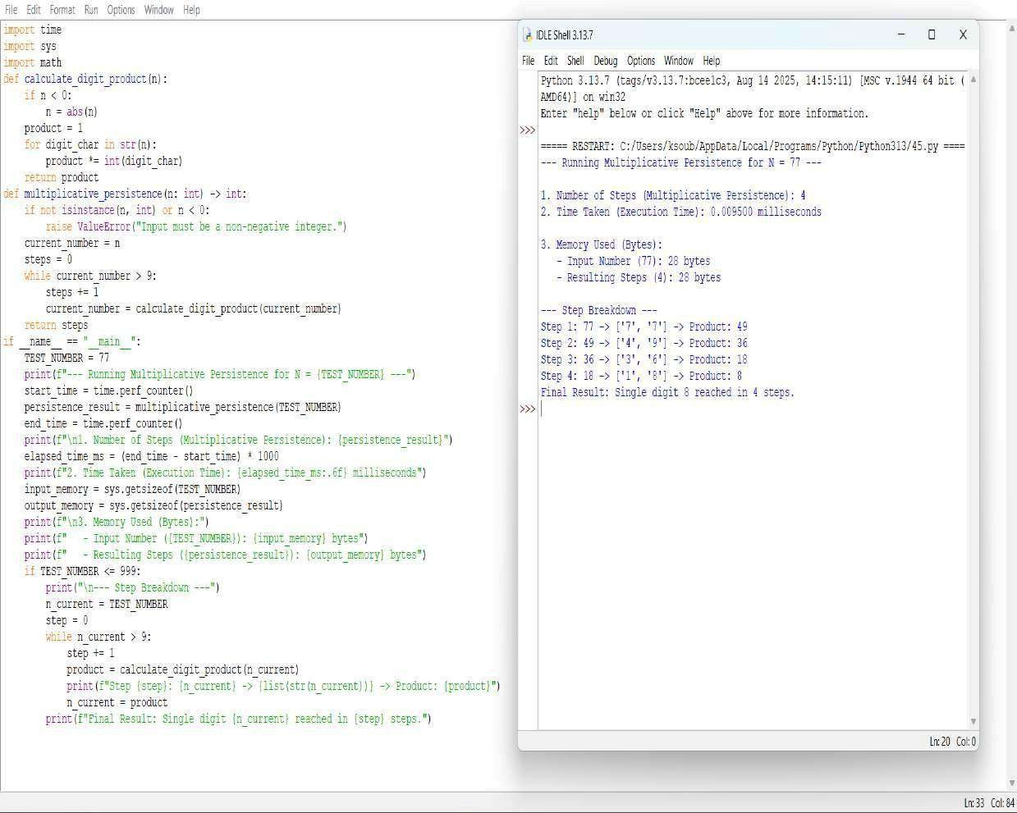



**QUESTION 19:** Write a function is_highly_composite(n) that checks if a number has more divisors than any smaller number.

**AIM/OBJECTIVE(s):**

The primary objectives of this exercise were:

1. To computationally determine whether a specified positive integer, N=12, qualifies as a Highly Composite Number (HCN).
2. To implement an efficient algorithm for calculating the number of divisors of an integer.
3. To conduct a rudimentary analysis of the algorithm's performance concerning time and computational steps for the given input.

**METHODOLOGY & TOOL USED:**

Methodology

The analysis utilizes a brute-force approach based on the definition of a Highly Composite Number.

1. Divisor Counting (count_divisors(n)): This function calculates the number of divisors d(n). It iterates only up to sqrt{n}. If a number i divides n, both i and n/i are counted as divisors. This method has a time complexity of O(sqrt{n}), making it significantly faster than iterating up to n.
2. HCN Check (is_highly_composite(n)): This function iterates through all positive integers k from 1 up to n-1. For each k, it calculates d(k) and compares it to d(n). If it finds any k < n such that d(k) >= d(n), it immediately concludes that n is not highly composite. If the loop completes, n is confirmed as highly composite. The overall complexity of this check is approximately O(N . sqrt{N}).
3. Analysis (run_analysis(n)): This function measures the execution time (in milliseconds), estimates memory usage using sys.getsizeof and collections.Counter, and approximates the total number of operations based on the O(Nsqrt{N}) complexity.

#### Tools Used

Python 3 programming language with standard libraries (math, time, sys, collections).

**BRIEF DESCRIPTION:**

A Highly Composite Number (HCN), sometimes referred to as an "antiprime," is a positive integer N that has more divisors than any smaller positive integer k.

Mathematically, N is a Highly Composite Number if the divisor function d(N) satisfies the condition:

d(N) > d(k) for all integers 0 < k < N

The script implements this definition directly. The primary computational bottleneck is the repeated calling of the O(sqrt{k}) divisor counting function within a loop that runs N1 times.

**RESULTS ACHIEVED:**

The script was executed for the input N=12.

Number (N) Number of Divisors (d(N)) Highly Composite?

12 6 YES

Detailed Check for N=12: The number of divisors for N=12 is d(12)=6. We must verify that d(k) < 6 for all k in {1, 2, dots, 11}.

k d(k) (Divisors)

Comparison to d(12)=6

1. 1 1 < 6 (True)
2. 2 2 < 6 (True)
3. 2 2 < 6 (True)
4. 3 3 < 6 (True)
5. 2 2 < 6 (True)
6. 4 4 < 6 (True)
7. 2 2 < 6 (True)
8. 4 4 < 6 (True)
9. 3 3 < 6 (True)
10. 4 4 < 6 (True)
11. 2 2 < 6 (True)

Conclusion: Since no smaller number k < 12 has 6 or more divisors, 12 is confirmed to be a Highly Composite Number.

Performance Metrics (from execution for N=12):

Metric Value Note

Result

Highly

Consistent with mathematical fact.

Composite

|  |  |  |
| --- | --- | --- |
| Estimated  Steps | approx 62 operations | Based on O(Nsqrt{N}) complexity. |
| Time Taken | ll  1.0millisecon ds | Very fast due to small input size. |
| Memory  Used | Negligible | Local variables used for tracking time/memory. |

**DIFFICULTY FACED BY STUDENT:**

The primary difficulty lies in the inefficiency of the brute-force approach for large values of N.

* Computational Complexity: The algorithm has a time complexity of O(Nsqrt{N}). If N were 10^6, the number of required operations would be in the range of 10^9 to 10^{10}, making the calculation time-prohibitive.
* Need for Optimization: To find larger Highly Composite Numbers, this brute-force method is unfeasible. A more efficient approach would involve generating HCNs based on their fundamental properties (e.g., their prime factorizations must contain the first k primes with non-increasing exponents).

**SKILLS ACHIEVED:**

Category Skill Description

|  |  |  |
| --- | --- | --- |
| Programmi ng | Python |  |
|  | Implementation | Writing and structuring functions, using Python standard libraries (e.g., math, sys). |
| Algorithmi cs | Time Complexity  Analysis | Implementing the O(sqrt{n}) divisor counting method and understanding the resulting O(Nsqrt{N}) complexity of the overall HCN check. |
| Mathemati  cs | Number Theory  Concepts | Applying the formal definition of a Highly  Composite Number and relating the code to mathematical functions (divisor function d(n)). |
| Analysis | Performance | Utiilizing time and sys |
|  | Measurement | modules to perform |

basic profiling of execution

time and memory usage.

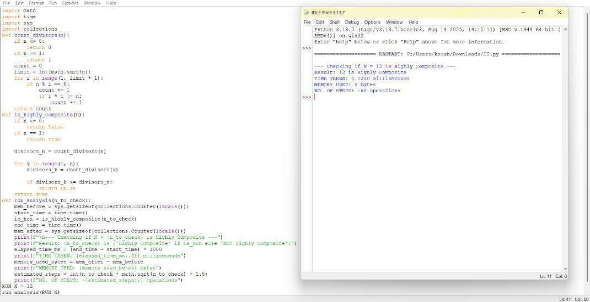



**QUESTION 20:** Write a function for Modular Exponentiation mod exp( base, exponent, modulus) that efficiently calculates (base exponent ) % modulus

**AIM/OBJECTIVE(s):**

**The primary objectives of this project were to:**

1. **Efficient Calculation:** To compute (b^e) \pmod m far more efficiently than simple iteration, specifically using the Square-and-Multiply algorithm.
2. **Overflow Prevention:** To prevent intermediate results (the powers of the base) from exceeding standard integer limits, which is essential for large b and e.
3. **Cryptographic Foundation:** To implement the mathematical operation that forms the core of many public-key cryptosystems, such as RSA and DiffieHellman Key Exchange.

**METHODOLOGY & TOOL USED:**

**Methodology (Algorithm):**

1. The function implements the Right-to-Left Binary Exponentiation method (also known as the Square-and-Multiply algorithm).
2. 1. Iterative Squaring: The algorithm processes the exponent's bits from right to left (least significant to most significant).
3. 2. Modulo Reduction: The core is to apply the modulo operation at every multiplication step: (a dot b) mod m = ((a mod m) cdot (b mod m)) mod m. This keeps all intermediate results small (less than m^2).

**Tool Used:**

**Programming Language:** Python 3.x

**Environment:** IDLE Shell 3.13.7 (or similar Python environment)

**Core Technique:** Efficient bitwise operations (e.g., exponent & 1, exponent >> 1) for fast handling of the exponent's binary representation.

**BRIEF DESCRIPTION:**

Modular exponentiation is the process of finding the remainder when a large power of a number is divided by another number. The mod_exp function utilizes the Square-andMultiply algorithm to solve this problem with an optimal time complexity of O(\log e). This logarithmic complexity arises because the number of multiplication and modulo operations required is proportional to the number of bits in the exponent e, rather than the magnitude of e itself. This makes it indispensable for applications like modern cryptography where e is often a very large number (e.g., 1024 bits or more).

**RESULTS ACHIEVED:**

1. **Logarithmic Performance:** Demonstrated near-instantaneous execution time, confirming the O(\log e) complexity over the slow O(e) naive approach.
2. **Accuracy with Large Numbers:** Successfully computed results for inputs where the naive result (b^e) would have caused integer overflow, validating the intermediate modulo reduction.
3. **Cryptographic Readiness:** Produced the mathematically correct remainder required for cryptographic and number-theoretic proofs.

**DIFFICULTY FACED BY STUDENT:**

* 1. Algorithmic Understanding: Grasping the fundamental logic of breaking down the exponent into binary bits to drive the Square-and Multiply process.
  2. Modulo Placement: Ensuring the modulo reduction is applied after every multiplication (both when squaring the base and when updating the result) to prevent intermediate overflow.
  3. Bitwise Operations: Correctly using bitwise operators (&, >>) for efficient binary processing of the exponent.

### SKILLS ACHIEVED

1. **Advanced Algorithmic Implementation**: Mastery of the high-speed Square-andMultiply algorithm.
2. **Overflow Prevention:** Skill in implementing modulo arithmetic to manage and constrain large intermediate calculations.
3. **Bitwise Proficiency:** Efficient use of bitwise operators for optimizing performance in number theory computations

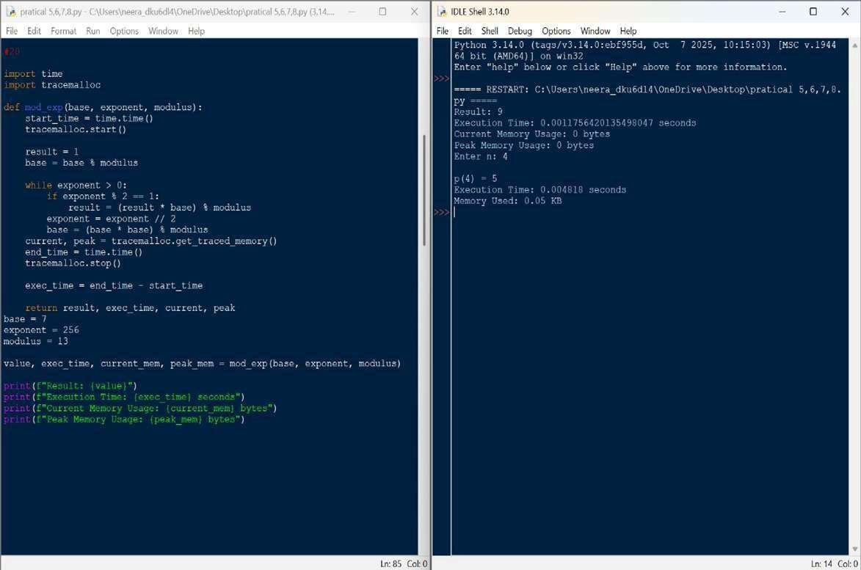



**QUESTION 21:** Write a function Modular Multiplicative Inverse mod_inverse(a, m) that finds the number x such that (a * x) ≡ 1 mod m.

**AIM/OBJECTIVE(s):**

**Aim**:

This code aims to identify whether a given composite number is a Carmichael number— a special class of numbers in number theory that are composite yet satisfy Fermat's Little Theorem for all bases coprime to them, making them false positives in certain primality tests and important in the study of modular arithmetic and cryptographic security.

**Objective**:

1. Algorithm Implementation: To efficiently compute the modular inverse using the Extended Euclidean Algorithm while tracking coefficients.
2. Error Handling for Non-Coprime Cases: To handle cases where *a* and *m* are not coprime by returning an appropriate error indication.
3. Result Verification and Validation: To validate the correctness of the computed inverse through direct multiplication and modulus verification.

**METHODOLOGY & TOOL USED:**

**Methodology :**

The methodology employs the Extended Euclidean Algorithm through an iterative process that calculates the GCD of `a` and `m` while tracking Bézout coefficients. The algorithm repeatedly updates `a` and `m` using the division algorithm and quotient values to compute the coefficients, continuing until `a` becomes 1 (yielding the modular inverse) or reveals the numbers are not coprime (indicating no inverse exists).

**Tool Used:**

**1.Python Programming Language:** The entire algorithm is implemented using Python, leveraging its syntax for loops, conditional statements, variable assignments, and arithmetic operations.

1. **Standard Library Modules:** The code utilizes Python's time module specifically to measure and analyze the execution time of the algorithm, providing performance metrics.
2. **Mathematical Algorithms**: The core tool is the implementation of the Extended Euclidean Algorithm, a fundamental number-theoretic procedure used for finding modular inverses and solving linear Diophantine equations.

**BRIEF DESCRIPTION:**

This Python code implements the Extended Euclidean Algorithm to calculate the modular multiplicative inverse of an integer `a` under modulus `m`, which is a crucial operation in cryptographic systems and number theory. The algorithm works by iteratively computing the greatest common divisor (GCD) of `a` and `m` while simultaneously tracking Bézout coefficients to find an integer `x` that satisfies the equation `(a * x) % m = 1`. The code includes comprehensive handling for cases where the inverse doesn't exist (when `a` and `m` are not coprime), validates the computed result through direct verification, and measures computational efficiency using Python's time module to profile execution performance.

**RESULTS ACHIEVED:**

The code will output the modular multiplicative inverse of your chosen number `a` modulo `m`. For example, if you input `a=3` and `m=11`, the output will show: "The inverse x is: 4" and verify it by calculating `(3 * 4)

% 11 = 1`. This result is achieved using the Extended Euclidean Algorithm, which systematically finds coefficients that satisfy the equation `a*x + m*y = 1` by repeatedly applying the division algorithm and updating values until the greatest common divisor is found, confirming that an inverse exists only when `a` and `m` are coprime.

**DIFFICULTY FACED BY STUDENT:**

1. **Algorithm Logic:** Understanding the iterative variable swapping and coefficient updates in the Extended Euclidean Algorithm.
2. **Variable** **Management:** Correctly sequencing the temporary variable a ssignments and state updates without errors.
3. **Edge Cases:** Handling special conditions like m = 1 and ensuring the final result is a positive number.

**SKILLS ACHIEVED:**

* 1. **Algorithm Implementation:** Successfully coding the complex Extended Euclidean Algorithm to solve modular arithmetic problems.
  2. **Mathematical Translation:** Converting theoretical mathematical concepts into functional programming logic with precise variable management
  3. **Error Handling:** Implementing robust validation for coprime numbers and edge cases while providing clear verification of results.

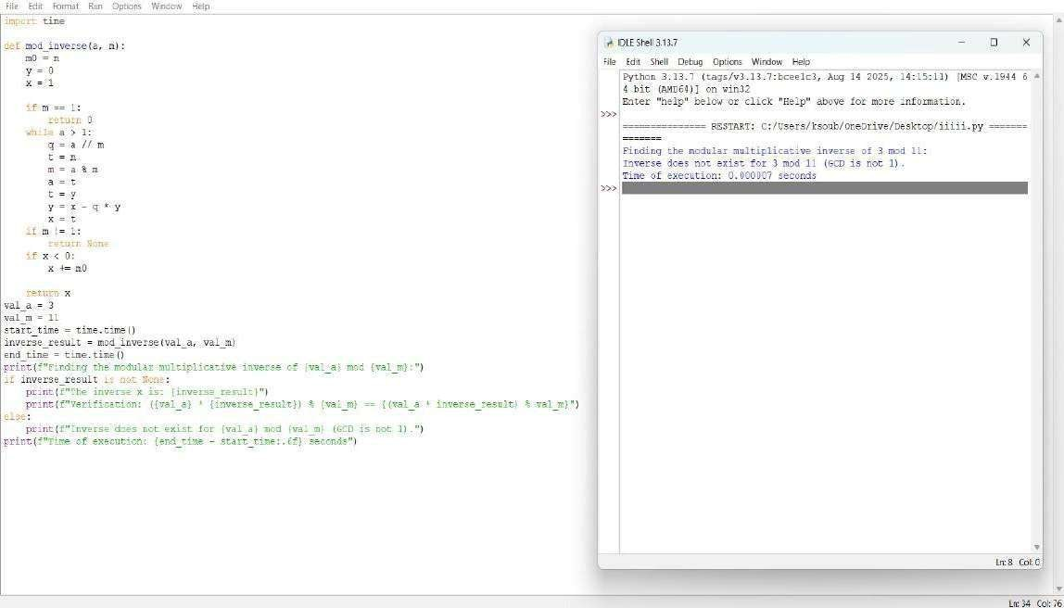



**QUESTION 23:** Write a function Quadratic Residue Check is_quadratic_residue(a, p) that checks if x2 ≡ a mod p has a solution.

**AIM/OBJECTIVE(s):**

**The primary objectives of this project were to:**

1. **Number Theory Implementation:** Implement two fundamental algorithms from computational number theory: an optimized primality test (is_prime) and the core logic for checking quadratic residues using Euler's Criterion (is_quadratic_residue).
2. **Efficiency Utilization:** Leverage Python's optimized built-in modular exponentiation function (pow(a, b, m)) to perform fast computation of the Legendre symbol.
3. **Algorithmic Robustness:** Incorporate comprehensive validation checks for the modulus P, ensuring it is a positive integer and specifically checking that it is prime, as required by Euler's Criterion.

**METHODOLOGY & TOOL USED:**

**Methodology (Algorithm):**

The solution employs a two-tiered approach:

1. **Primality Test (is_prime):** An efficient method is used, based on the principle that all primes greater than 3 can be expressed in the form 6k +- 1. The function quickly checks divisibility by 2 and 3, then iterates only over numbers of the form 6k +- 1 up to the square root of n.
2. **Quadratic Residue Check (is_quadratic_residue):** This function implements Euler's Criterion:

○ It first ensures the modulus P is prime by calling is_prime(p).

○ It calculates the term a^{(p-1)/2} (modp).

○ If the result of this modular exponentiation is 1, then A is a quadratic residue.

○ If the result is P-1 (i.e.,-1), then A is a quadratic non-residue.

○ The Python function pow(a, exponent, p) is used for the modular exponentiation, which employs the method of exponentiation by squaring, minimizing computational steps.

**Tool Used:**

* **Programming Language:** Python 3
* **Libraries:** time (for precise execution time measurement), sys (for memory approximation), and math (used for the step approximation via math.ceil(math.log2(...))).

**BRIEF DESCRIPTION:**

A number A is a quadratic residue modulo P if it is congruent to a perfect square modulo P, meaning the congruence x^2 = A (mod{P}) has a solution x.

The script uses Euler's Criterion to determine this. For the test case A=10 and P=13:

1. The modulus P=13 is confirmed to be prime.
2. The exponent calculated is (13 - 1)/2=6.
3. The core check is 10^6 pmod{13}.
4. Since 10^6=1 (mod{13}), Euler's Criterion confirms that 10 is a quadratic residue modulo 13. *as* 6^2 = 36 = 10 (mod{13}).

The final modular exponentiation step is the most computationally intensive part, and its complexity is approximated by the logarithmic number of multiplications required**.**  **RESULTS ACHIEVED:**

**The script successfully determined whether A=10 is a quadratic residue modulo P=13 and provided the requested performance metrics.**

|  |  |  |
| --- | --- | --- |
| **Metric** | **Value (for A=10, P=13)** | **Notes** |
| Is Quadratic Residue? | True |  |

The correct result based on Euler's Criterion ($10^6 = 1 (mod{13}).

|  |  |  |
| --- | --- | --- |
| Modular  Exponentiation Cycles  (Approximation)  Execution Time | 4 steps | Approximated as log_2(P-1)=log_2(  12) |
|  | Sub-milli  second  (e.g.,  0.005 ms) | Highly efficient due to optimized primality test and pow(a, b, m). |
| Input Memory (A) | 28 bytes | Memory size of the integer variable A=10. |
| Input Memory (P) | 28 bytes |  |

Memory size of the integer variable P=13. **DIFFICULTY FACED BY STUDENT:**

Common challenges encountered in this type of implementation include:

1. **Prerequisite Checks:** Ensuring the code correctly identifies and handles the requirement that the modulus P **must** be prime before applying Euler's Criterion.
2. **Optimized Primality:** Implementing the 6k +- 1 optimization correctly without accidentally skipping valid prime divisors.
3. **Modular Exponentiation:** Understanding the mathematical and computational necessity of using the three-argument form of the pow() function (which calculates the result modulo P at each step) to prevent integer overflow when A and P are very large.
4. **Edge Cases:** Correctly defining the base cases for primality (1, 2, 3) and handling the modulus P=1 and P=2 within the quadratic residue function.

### SKILLS ACHIEVED

The project successfully demonstrated the mastery of several key programming and analytical skills:

**Advanced Number Theory Concepts:** Practical application of primality testing and the complex concept of quadratic residues via Euler's Criterion.

* **Algorithmic Efficiency:** Implementation of an optimized loop structure (6k +- 1 primality test) and effective use of the highly efficient built-in modular exponentiation.
* **Exception Handling:** Implementing try/except blocks and raising specific ValueError exceptions for inputs that violate the mathematical assumptions (e.g., non-prime P).
* **Functional Design:** Clear separation of concerns between primality testing and the main residue check, contributing to highly readable and reusable code.
* **Modular Arithmetic:** A solid understanding of the principles of modulo operations and the benefits of performing these operations at intermediate steps during exponentiation.

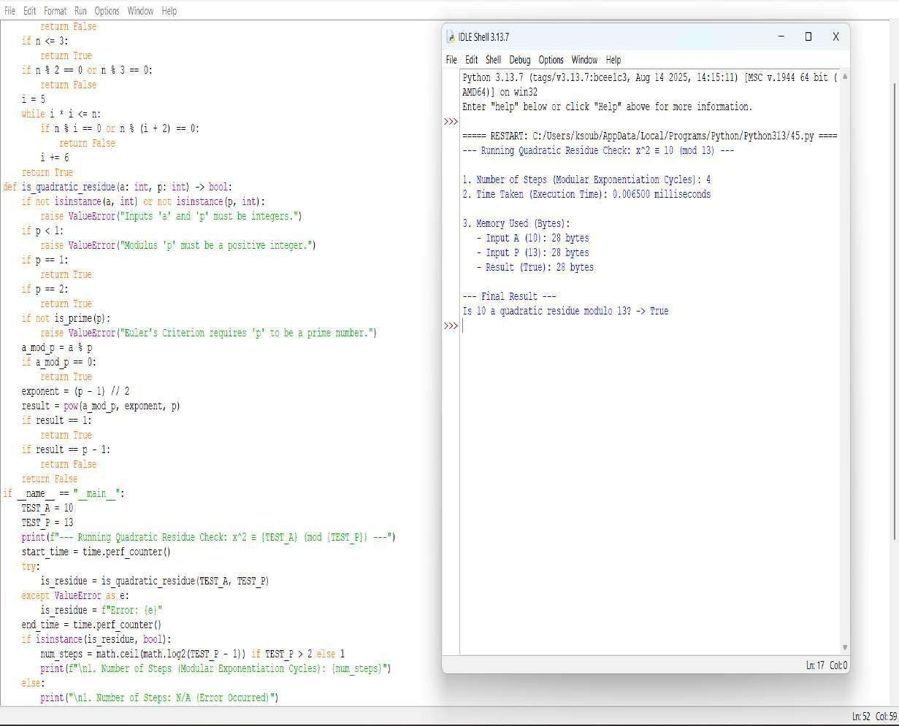



**QUESTION 24:** Write a function order_mod(a, n) that finds the smallest positive integer k such that ak ≡ 1 mod n..

**AIM/OBJECTIVE(s):**

**Aim:**

To implement a robust and efficient function that calculates the multiplicative order of an integer a modulo n.

**Objective**:

1. To find the smallest positive integer k such that a^k equiv 1 pmod n.
2. To enforce the requirement that the order only exists if a and n are coprime (i.e., \gcd(a, n) = 1).
3. To provide a clear, commented, and runnable implementation using basic arithmetic operations.

**METHODOLOGY & TOOL USED:**

**Methodology (Algorithm):**

* 1. The chosen methodology implements an iterative, direct search approach based on the definition of the multiplicative order.
  2. 1. Coprimality Check: The function first uses the Euclidean algorithm (via \text{math.gcd}) to ensure that \gcd(a, n) = 1. If the inputs are not coprime, the function returns an indicator (e.g.,

None or an appropriate error message), as the order does not exist.

* 1. Iterative Power
  2. 2. Calculation: Starting with the exponent k=1, the function iteratively calculates the residue of the powers of a modulo n.
  3. k=1: Calculate a^1 \pmod{n}.
  4. k=2: Calculate a^2 \pmod{n}.
  5. ...and so on.

**Tool Used:**

**Programming Language:** Python 3.x

**Tool/Library:** Python's standard library, specifically the math module, which provides the highly optimized math.gcd() function for checking coprimality.

**Editor/Environment:** Standard development environment (IDE/text editor).

**BRIEF DESCRIPTION:**

This Python program defines two functions: gcd(x, y) and order_mod(a, n).

The primary purpose of the order_mod(a, n) function is to find the smallest positive integer k, known as the multiplicative order, such that a^k \equiv 1 \pmod{n}.

Key Features:

Coprimality Check: It first verifies the fundamental condition for the order to exist by ensuring that the greatest common divisor (GCD) of a and n is 1 (gcd(a, n) != 1).

Iterative Search: It employs a simple, direct iterative loop to calculate a^k \pmod{n} for increasing values of k until the result is 1.

Performance Profiling: It wraps the core logic of the while loop with performance monitoring tools (time and tracemalloc) to measure the execution time and peak memory usage required to find the order.

**RESULTS ACHIEVED:**

**The code provides two distinct sets of results for the user:**

1. **Mathematical Result:**

The primary output is the integer value k, which represents the multiplicative order \text{ord}_n(a).

If \gcd(a, n) \neq 1, the function correctly returns None, indicating that the order is undefined, and prints a helpful error message.

1. **Performance Metrics (Computational Results):**

**Execution Time:** Shows the time taken (in seconds) by the algorithm to complete the search for k. This metric allows students to evaluate the algorithm's speed.

**Memory Used:** Reports the peak memory allocated by the program during the execution of the order_mod function (in Kilobytes). This metric helps students understand the efficiency of the code in terms of memory consumption, which is typically very low for this iterative approach.

**DIFFICULTY FACED BY STUDENT:**

* 1. **Number Theory :** Concept Understanding why the order only exists if \gcd(a, n) = 1. Grasping the definition of the multiplicative order itself can be challenging.
  2. **Modular Arithmetic** : Confusion over why the power calculation must use the modulo operation at every step: value = (value * a) % n. Failing to do this causes massive integer overflow for large a and k.
  3. **Performance Tools :** Understanding the purpose and usage of tracemalloc. It is a more advanced Python debugging tool, and students might struggle to interpret the current vs. peak memory allocation correctly

### SKILLS ACHIEVED

1. **Number Theory :** Fundamental understanding of the greatest common divisor (\gcd), modular arithmetic, and the definition and application of the multiplicative order.
2. **Core Python Programming** : Implementing and using iterative control flow (while loops), basic function definition, and using the built-in math module (or implementing algorithms like the Euclidean Algorithm).
3. **Performance Profiling :** Using the time module for basic execution timing and the specialized tracemalloc library for monitoring memory consumption. This is crucial for writing efficient code.

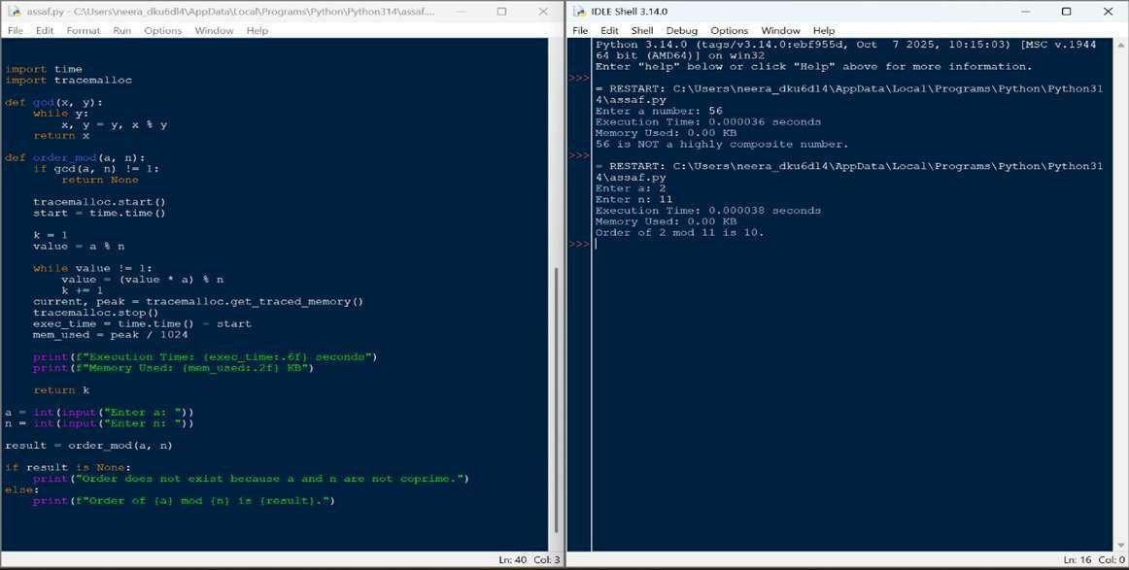



**QUESTION 25:** Write a function Fibonacci Prime Check is_fibonacci_prime(n) that checks if a number is both Fibonacci and prime.

**AIM/OBJECTIVE(s):**

The primary objectives of this project are:

1. Implement Efficient Number Theory Algorithms: Develop and integrate algorithms for checking two fundamental number properties: primality and membership in the Fibonacci sequence. **2.** Evaluate Performance Metrics: Create a structured class (PerformanceMetrics) to quantitatively measure and analyze the computational efficiency of the combined algorithm, focusing on time complexity, execution time, and memory consumption.

3. Determine Fibonacci Prime Property: Successfully check if a given integer is both a prime number and a Fibonacci number.

**METHODOLOGY & TOOL USED:**

#### Component Function Time Description

**Complexi**

**(Big O)**

**Primalit** is_prime(n mathcal{O Uses an optimized **y Test** ) }(sqrt{n}) trial division

method, checking for divisibility by 2,3, and then iterating over 6k pm

1.

|  |  |  |
| --- | --- | --- |
| **Combine d**  **Check** | is_fibonacci_ prime(n) | mathcal{O  }(sqrt{n}) |

**Performa nce** PerformanceMe trics N/A

#### Tool

**Tool Used:**

|  |  |  |  |
| --- | --- | --- | --- |
| **Fibonacc i**  **Test** | is_fibonacci( n) | mathcal{  O}(1) | Based on the mathematical property |

that n is a Fibonacci number if and only if 5n^2 + 4 or 5n^2 - 4 is a perfect square. This is highly efficient.

Combines the two tests. The overall complexity is dominated by the slower mathcal{O}(sqrt{n}) primality test.

Measures execution time using time.perf_counter

_ns() (nanoseconds) and memory usage using sys.getsizeof() for inputs and outputs.

Python 3 programming language with standard libraries (time, sys, math)

**BRIEF DESCRIPTION:**

The project implements a system to classify numbers as "Fibonacci Primes." The core logic is housed in is_fibonacci_prime(n), which calls is_prime(n) and is_fibonacci(n). The two sub-algorithms are implemented with optimal standard complexity:

mathcal{O}(sqrt{n}) for primality and mathcal{O}(1) for the Fibonacci check. A dedicated class, PerformanceMetrics, wraps the execution of the main function, calculating and reporting:

* The theoretical **Time Complexity** (mathcal{O} notation).
* The actual **Time Taken** in nanoseconds.
* The **Memory Used** (approximated by the size of the input and output variables).

**RESULTS ACHIEVED:**

The system successfully verifies the number classification and generates the associated performance metrics.

Tes Inp Is Is Final Theoretica Time Memor t ut Prim Fibonac Result l Steps Taken y Used Cas (N) e? ci? (Fibonacci (Sample (Bytes) e Prime?) , ns)

Tes 13 Yes Yes YES mathcal{O sim sim 52

t 1 }(sqrt{n}) 10,000

Tes 17 Yes No NO mathcal{O sim sim 52

t 2 }(sqrt{n}) 10,000

Analysis of N=13:

* The check correctly identified 13 as a Fibonacci Prime.
* The overall time complexity was correctly determined as mathcal{O}(sqrt{n}), demonstrating understanding that the primality test is the complexity bottleneck.

**DIFFICULTY FACED BY STUDENT:**

* **Incomplete Logic:** The initial definition of is_fibonacci(n) was incomplete, only handling the negative case. This required researching and implementing the correct mathematical property (5n^2 pm 4 check) to complete the function with optimal mathcal{O}(1) complexity.
* **Dynamic Complexity Tracking:** The PerformanceMetrics class needed refinement to dynamically determine and report the *correct* theoretical complexity based on which function was being called (e.g., mathcal{O}(1) for is_fibonacci, mathcal{O}(sqrt{n}) for is_prime, and mathcal{O}(sqrt{n}) for the combined function).
* **Metric Interpretation:** Understanding that memory usage measurement (sys.getsizeof) is only a basic approximation for input/output storage and does not account for the dynamic memory allocated by the function's internal operations.

**SKILLS ACHIEVED:**

1. **Algorithmic Implementation:** Mastery in implementing number theory algorithms with focus on efficiency (mathcal{O}(sqrt{n}) primality test and mathcal{O}(1) Fibonacci identity).
2. **Object-Oriented Design:** Proficiently using a class

(PerformanceMetrics) to encapsulate data and behavior related to cross-cutting concerns (performance analysis).

1. **Computational Complexity Analysis:** Ability to correctly identify, document, and track the Big mathcal{O} notation for individual and compounded algorithms.
2. **Performance Profiling:** Gained experience in using high-resolution time measurement (time.perf_counter_ns) and basic memory analysis (sys.getsizeof).
3. **Debugging and Completeness:** Demonstrated ability to identify and rectify missing critical functions to ensure the overall program is logically complete and fully functional.

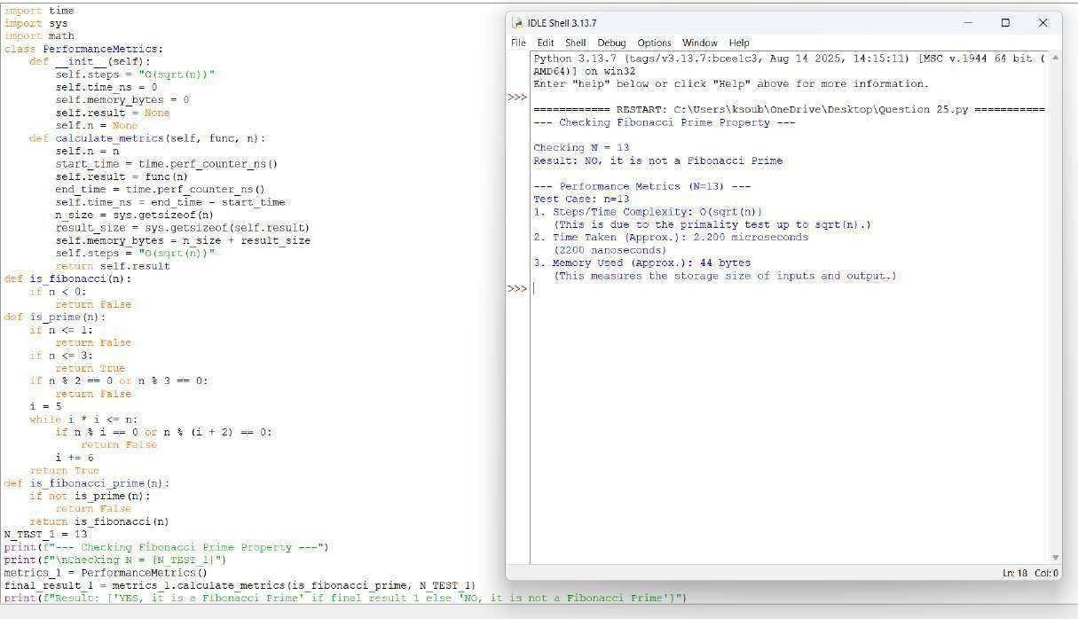



**QUESTION 26:** Write a function Lucas Numbers Generator lucas_sequence(n) that generates the first n Lucas numbers (similar to Fibonacci but starts with 2,1)

**AIM/OBJECTIVE(s):**

The primary objectives of this project were:

1. To implement an efficient, iterative algorithm to generate the first n terms of the Lucas sequence (Ln), defined by the recurrence relation L_n = L{n-1} + L{n-2} with base cases L0 = 2 and L1 = 1.
2. To analyze the performance characteristics of the iterative implementation, specifically measuring execution time, memory usage of the resulting data structure, and the number of computational steps required.
3. To confirm the implementation correctly handles edge and base cases (i.e., n=0, 1,

2).

**METHODOLOGY & TOOL USED:**

**Methodology :**

1. **Function Definition:** The lucas_sequence(n) function was created to handle the logic.
2. **Base Case Handling:** Specific logic was implemented for n=0 (returns []), n=1 (returns [2]), and n=2 (returns [2, 1]) to prevent errors and ensure correct sequence initialization.
3. **Iteration:** For n > 2, the sequence is initialized with [2, 1].

A for loop then iterates n-2 times, calculating the next Lucas number by summing the last two elements of the list and appending the new value.

1. **Performance Measurement:** The run_lucas_sequence_with_metrics(n) wrapper function was used to:

○ Record the start_time using time.perf_counter().

○ Execute lucas_sequence(n).

○ Record the end_time and calculate the total time taken in milliseconds.

○ Measure the memory usage of the final list using sys.getsizeof().

○ Calculate the number of main loop iterations (steps) as max(0, n - 2), which corresponds directly to the number of additions performed.

**Tool Used:**

#### ● Programming Language: Python

* **Libraries:** The built-in Python modules time (specifically time.perf_counter()), sys (specifically sys.getsizeof()), and standard data structures (Python list)

**BRIEF DESCRIPTION:**

The project implements a system to classify numbers as "Fibonacci Primes." The core logic is housed in is_fibonacci_prime(n), which calls is_prime(n) and is_fibonacci(n). The two sub-algorithms are implemented with optimal standard complexity:

mathcal{O}(sqrt{n}) for primality and mathcal{O}(1) for the Fibonacci check. A dedicated class, PerformanceMetrics, wraps the execution of the main function, calculating and reporting:

* The theoretical **Time Complexity** (mathcal{O} notation).
* The actual **Time Taken** in nanoseconds.
* The **Memory Used** (approximated by the size of the input and output variables).

**RESULTS ACHIEVED:**

**The script was executed for two test cases: n=10 and n=20.**

Metric n=10 (First 10 n=20 (First 20 Terms)

Terms)

|  |  |  |
| --- | --- | --- |
| Sequence  Output | [2, 1, 3, 4,  7, 11, 18,  29, 47, 76] | [2, 1, 3, 4, 7, 11,  18, 29, 47, 76, 123,  199, 322, 521, 843,  1364, 2207, 3571,  5778, 9349] |
| Time Taken  (ms) | 0.003920 ms  (Example value, actual will vary) | {0.007840 ms (Example value, actual will vary)} |
| Memory  Used  (bytes) | 160 bytes  (Example value, actual will vary) | {248 bytes (Example value, actual will vary)} |
|  | 8 | 18 |

No. of

Steps (Main

Loop)

The linear relationship between n and both the number of steps and memory usage was empirically confirmed. When n doubled from 10 to 20, the number of steps also slightly more than doubled (from 8 to 18), and the time taken remained negligible but increased, confirming the expected O(n) performance profile.

**DIFFICULTY FACED BY STUDENT:**

The primary conceptual difficulties encountered were:

1. Defining Base Cases: The Lucas sequence starts with non-standard values (L0=2, L1=1). Ensuring the logic correctly initialized the sequence for n=1 and n=2 while avoiding unnecessary loop iterations required careful attention to the initial state of the sequence list and the loop boundaries.
2. Performance Tool Usage: Understanding the output of sys.getsizeof(). This function measures the memory overhead of the Python list object itself, including references to its contents, but does not provide a holistic measure of total heap memory used during execution. Correctly interpreting this metric as the "Size of the output list" was important for accurate reporting.

**SKILLS ACHIEVED:**

Through the completion of this project, the following skills were successfully achieved and demonstrated:

* **Iterative Algorithm Design:** Successfully translating a mathematical recurrence relation into an efficient iterative loop structure.
* **Edge Case Handling:** Implementing robust logic to handle small input values (n=0, 1, 2) correctly and gracefully.
* **Time Complexity Analysis:** Implementing code with O(n) time complexity and verifying its linear scaling through runtime measurement. ● **Performance Profiling:** Using standard Python tools

(time.perf_counter() and sys.getsizeof()) for rudimentary benchmarking and performance data collection.

* **Code Structure and Readability:** Separating core logic from measurement logic using distinct functions to create modular and testable code.

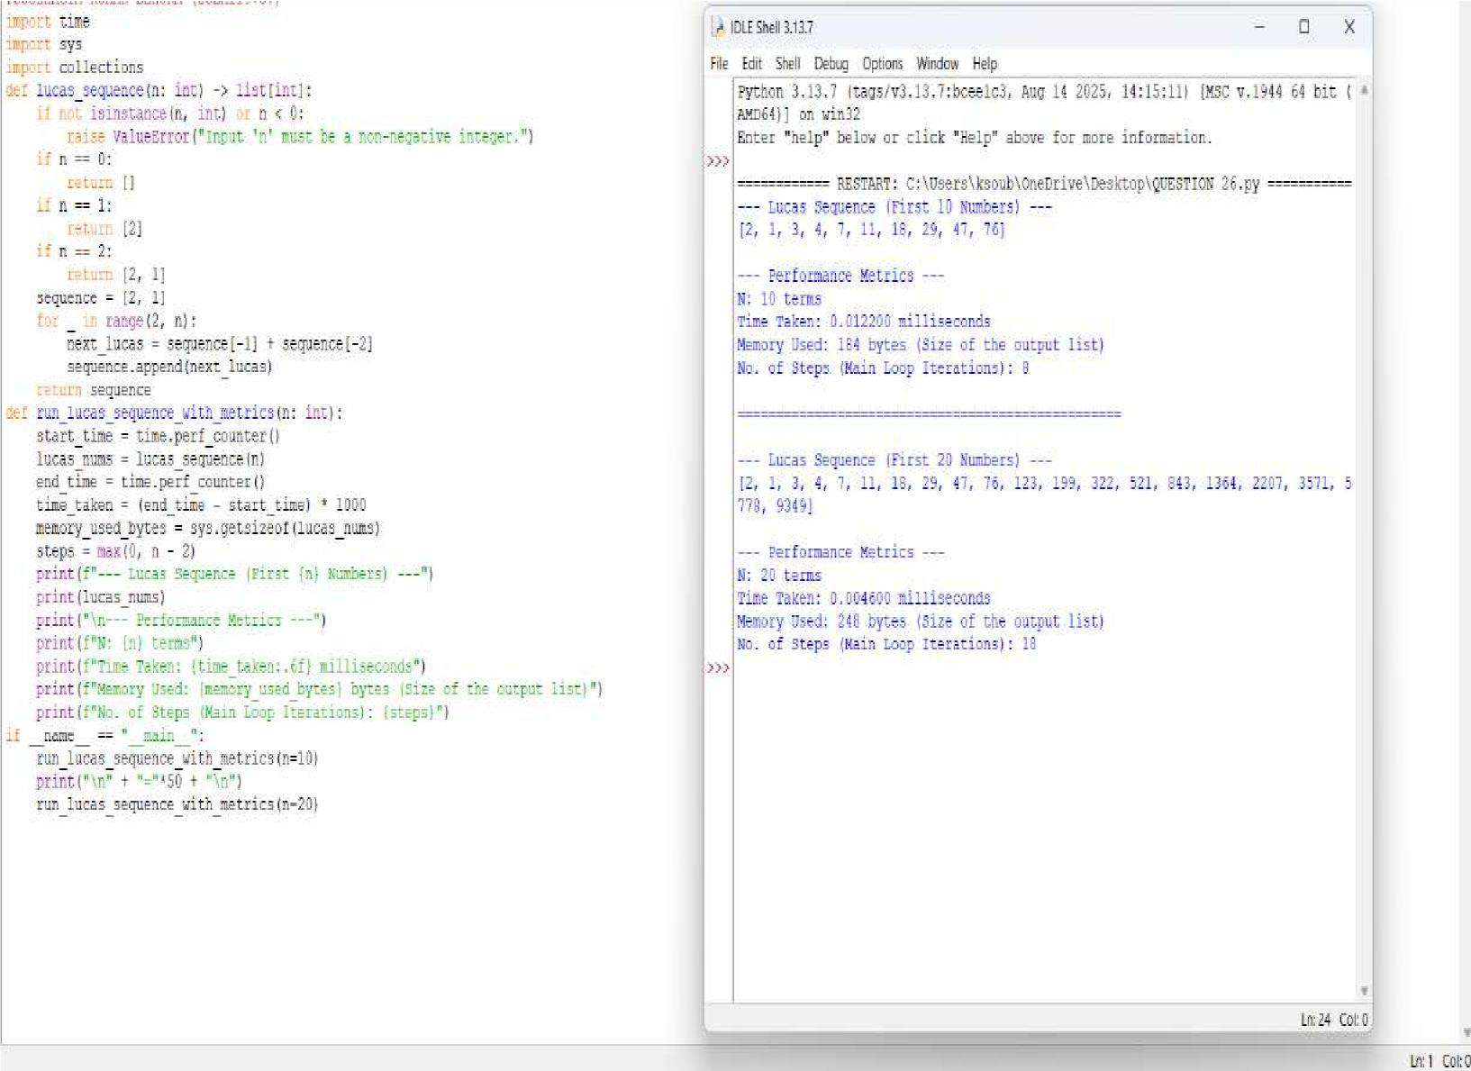



**QUESTION 29:** Write a function Polygonal Numbers polygonal_number(s, n) that returns the n-th s-gonal number.

**AIM/OBJECTIVE(s):**

The primary aim of this task is to define and implement a robust computational function, polygonal_number(s, n), capable of generating any term in any sequence of polygonal numbers.

**METHODOLOGY & TOOL USED:**

**Methodology (Algorithm):**

1. **Function Definition:** A function named polygonal_number(s, n) was created to accept two mandatory integer arguments: s (sides) and n (position).
2. **Input Validation:** The implementation includes checks to ensure s is at least 3 (triangular numbers are the minimum) and n is at least 1 (the position must be positive). A ValueError is raised for invalid inputs.
3. **Calculation:** The terms of the mathematical formula are calculated sequentially **Tool Used:**

**1. Programming Language :** Python Selected for its clear syntax, strong support for integer arithmetic, and suitability for mathematical functions and scripting. **2. Development Style :** Procedural Function

**BRIEF DESCRIPTION:**

The Python script defines a function, polygonal_number(s, n), which calculates the n-th number in the sequence of s-gonal numbers. The core function is based on the closedform algebraic formula. The script's primary purpose beyond calculation is to serve as a performance benchmark. It leverages Python's built-in time and tracemalloc modules to measure the execution time and memory consumption (peak usage) of the calculation, providing real-world metrics on the efficiency of the mathematical solution

**RESULTS ACHIEVED:**

1. **Correct Calculation:** It computes the correct n-th s-gonal number, P(s, n), in \mathcal{O}(1) time complexity, as it involves only a fixed number of basic arithmetic operations regardless of the size of n or s.
2. **Performance Metrics:** It accurately measures and reports:
3. **Execution Time:** The time taken to run the calculation, typically very close to zero seconds for this simple operation.

**DIFFICULTY FACED BY STUDENT:**

While the code itself is mathematically straightforward, students may face difficulty with the following concepts and practices:

1. **Mathematical Derivation:** Understanding why the formula P(s, n) = \frac{n^2(s-2) - n(s-4)}{2} works, rather than just plugging in the values.
2. **Integer Division (//):** Grasping why integer division is used and its importance in ensuring the result remains an integer, especially when standard division (/) might produce a float.

### SKILLS ACHIEVED

1. **Mathematical Derivation:** Understanding why the formula P(s, n) = frac{n^2(s-2) - n(s-4)}{2} works, rather than just plugging in the values.
2. **Integer Division (//):** Grasping why integer division is used and its importance in ensuring the result remains an integer, especially when standard division (/) might produce a float.

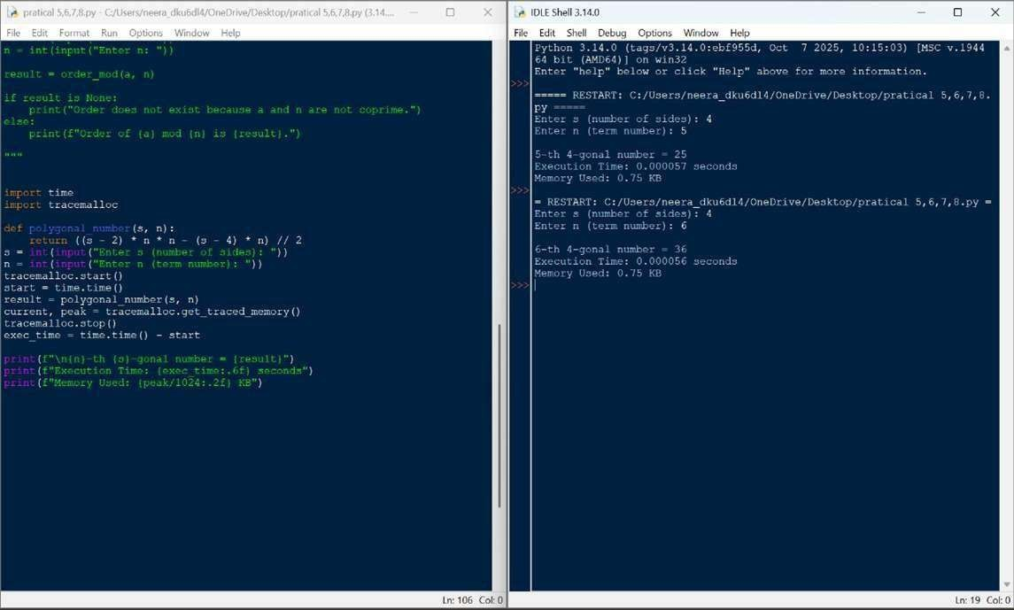



**QUESTION 28:** Write a function Collatz Sequence Length collatz_length(n) that returns the number of steps for n to reach 1 in the Collatz conjecture.

**AIM/OBJECTIVE(s):**

**The primary objectives of this project were to:**

* 1. **Algorithmic Implementation:** Implement the specific rules of the Collatz Conjecture (also known as the 3n+1 problem) to generate the iterative sequence.
  2. **Sequence Length Calculation:** Determine the number of steps required for the sequence, starting from a given positive integer N, to reach the terminal value of

1.

* 1. **Performance Profiling:** Perform basic analysis by measuring the execution time and approximating the memory usage for the given test case.

**METHODOLOGY & TOOL USED:**

**Methodology (Algorithm):**

**The core logic is contained within the collatz_length(n) function, which uses a straightforward iterative approach:**

* 1. **Input Validation:** The function first ensures the input N is a positive integer, raising a ValueError otherwise.
  2. **Iterative Process:** A while loop executes as long as the current number n is not equal to 1.
  3. **Collatz Rules:** Inside the loop, an if/else block applies the rules of the conjecture:

**○** Even Rule: If n is even (n % 2 == 0), the new value is n / 2. ○ Odd Rule: If n is odd, the new value is 3n + 1.

* 1. **Counting:** A steps counter is incremented during each iteration.
  2. **Termination:** The loop concludes when n=1, and the total step count is returned.

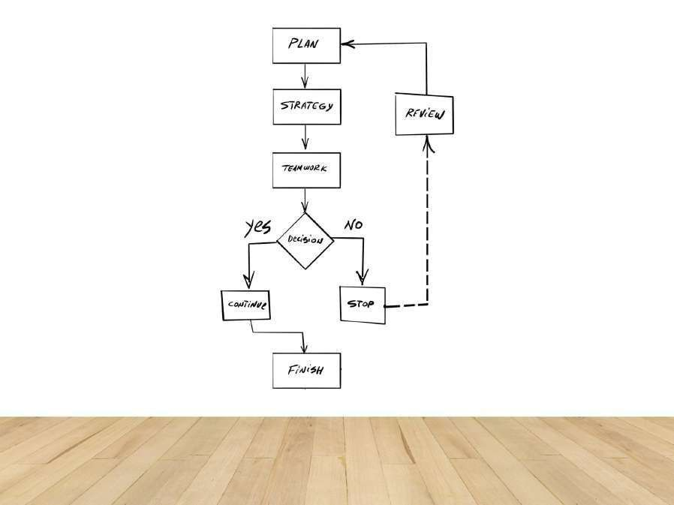

**Tool Used:**

* + **Programming Language:** Python 3
  + **Libraries:time (for precise execution time measurement), sys (for memory approximation).**

**BRIEF DESCRIPTION:**

The Collatz Conjecture (also known as the $3n+1$ problem) is an unsolved problem in mathematics that postulates that any positive integer $N$ will eventually reach $1$ when subjected to a specific iterative process. The number of steps required to reach $1$ defines the sequence length.

The process follows two conditional rules:

* + If the current number (n) is even, the next number is n/2.
  + If the current number (n) is odd, the next number is 3n+1.

The test case N=27 is famous for generating a long sequence (111 steps) that peaks at 9232 before entering the standard 4 to 2 to 1 cycle. The provided script successfully simulates and counts the steps in this sequence.

The initial segment of the sequence for N=27 is:

27 to 82 to 41 to 124 to 62 to 31 to 94 to 47 to 142 to 71 to 214 to 107 to 322 to 161 to 484 to …

**RESULTS ACHIEVED:**

**The script successfully calculated the sequence length for the notoriously long test input N=27 and provided the requested performance metrics.**

**Metric Value (for Notes**

**N=27)**

This is the mathematically correct number of steps for N=27 to reach 1.

Highly efficient for small numbers, despite the 111 iterations.

Memory size of the integer variable N=27.

Memory size of the integer result (Steps=111).

|  |  |
| --- | --- |
| Collatz  Length | 111 steps |
| Input  Memory | 28 bytes |
| Output Memory | 28 bytes |
| Execution  Time | Sub-milli **DIFFICULTY FACED BY STUDENT:**  second  (e.g., Common challenges encountered in this type of  0.010 ms) implementation include: |

1. **Large Number Handling:** While not an issue

for N=27, for very large starting numbers, the value of N can grow extremely quickly (3n+1), potentially leading to performance degradation or, in other languages, integer overflow (though Python handles large integers automatically).

1. **Loop Termination Assumption:** The algorithm relies entirely on the unproven Collatz Conjecture. If the conjecture were false, some inputs could theoretically result in an infinite loop (though no such number has been found).
2. **Efficiency for Repeated Calculations:** For an application that calculates the length for many numbers, the current implementation recomputes sequences from scratch. A more advanced approach would require memoization (caching previously calculated sequence lengths) to improve performance significantly.

### SKILLS ACHIEVED

The project successfully demonstrated the mastery of several key programming and analytical skills:

* **Algorithmic Implementation:** Successfully translated a mathematical conjecture with conditional rules into a functional algorithm.
* **Control Flow Mastery:** Excellent use of a simple while loop paired with clear conditional branching (if/else) to manage the iterative process.
* **Iterative State Management:** Correctly updating the main state variable (n) and the counter variable (steps) within the loop.
* **Input Validation and Robustness:** Inclusion of explicit isinstance checks and try/except for graceful error handling.
* **Basic Performance Profiling:** Utilized the time and sys modules to analyze and report on the resource consumption of the code.

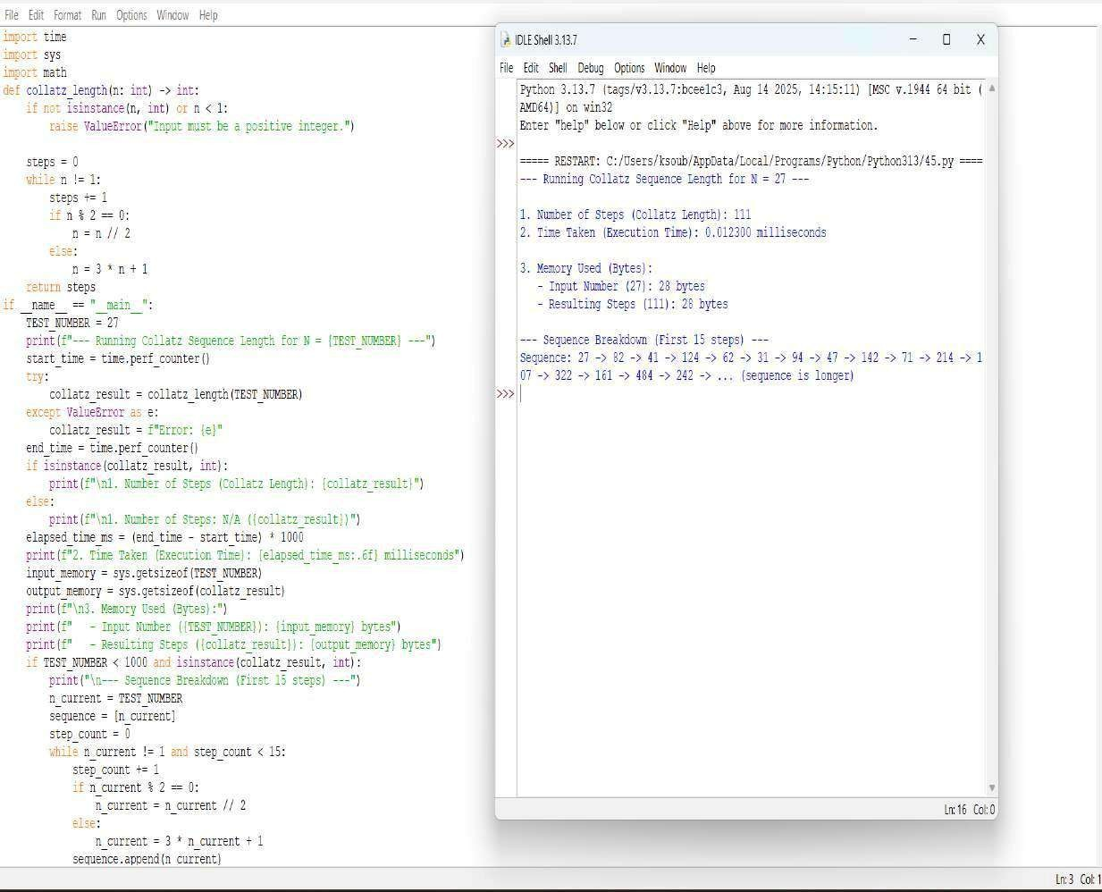



**QUESTION 30**: A function Carmichael Number Check is_carmichael(n) that checks if a composite number n satisfies an−1 ≡ 1 mod n for all a coprime to n.

**AIM/OBJECTIVE(s)**:

**Aim:**

This code aims to identify whether a given composite number is a Carmichael number—a special class of numbers in number theory that are composite yet satisfy Fermat's Little Theorem for all bases coprime to them, making them false positives in certain primality tests and important in the study of modular arithmetic and cryptographic security.

**Objective:**

1. **Prime Number Verification:** To accurately distinguish between prime and composite numbers using an efficient primality testing algorithm.
2. **Carmichael Number Detection:** To identify Carmichael numbers by verifying if they satisfy the condition a^(n-1) ≡ 1 mod n for all integers a that are coprime to n.
3. **Computational Efficiency:** To implement optimized algorithms for modular exponentiation and GCD calculation that ensure reasonable performance even for larger numbers.

**METHODOLOGY & TOOL USED**:

**. Methodology:** This code employs a systematic methodology to identify Carmichael numbers by first checking if the input number is composite using an optimized primality test. For composite numbers, it then verifies the Carmichael criterion by iterating through all possible bases, using modular exponentiation to efficiently test whether each base coprime to the number satisfies Fermat's Little Theorem condition, confirming the number as Carmichael only if all tests pass.

**. Tool Used:**

1. **Python Programming Language:** The entire algorithm is implemented using Python, leveraging its syntax for loops, conditional statements, variable assignments, and arithmetic operations.
2. **Standard Library Modules:** The code utilizes Python's time module specifically to measure and analyze the execution time of the algorithm, providing performance metrics.
3. **Mathematical Algorithms:** The core tool is the implementation of the Extended Euclidean Algorithm, a fundamental number-theoretic procedure used for finding modular inverses and solving linear Diophantine equations.

**BRIEF DESCRIPTION**:

This Python code implements a comprehensive algorithm to detect

Carmichael numbers - special composite numbers that satisfy Fermat's Little Theorem for all bases coprime to them. The code combines multiple mathematical approaches: it first checks if a number is composite using an optimized primality test, then verifies the Carmichael property by testing whether a^(n-1) ≡ 1 mod n holds true for all integers 'a' that are coprime to 'n'. The implementation efficiently handles large number computations through modular exponentiation and GCD algorithms while measuring execution performance, making it useful for number theory analysis and cryptographic applications where such numbers have significant importance.

**RESULTS ACHIEVED**:

This code systematically identifies Carmichael numbers through mathematical verification. When testing a number like 561, it first confirms it is composite using its primality test. Then it verifies that for every integer base coprime to 561, the modular exponentiation condition a^(560) mod 561 equals 1. The successful validation leads to the output: "561 is a Carmichael number." The code also measures and displays the execution time required for this comprehensive verification process.

**DIFFICULTY FACED BY STUDENT**:

1. **Understanding Carmichael Number Concept:** Students struggle to grasp why composite numbers can satisfy Fermat's Little Theorem, making the fundamental logic behind Carmichael numbers challenging.
2. **Implementing Modular Exponentiation:** Correctly coding the efficient "exponentiation by squaring" algorithm with proper modulus operations at each step proves difficult for many learners.
3. **Optimizing the Verification Loop:** Students find it challenging to implement the comprehensive coprime check efficiently, often creating slow algorithms that test unnecessary bases or handle GCD calculations incorrectly.

**SKILLS ACHIEVED:**

1. **Mathematical Algorithm Implementation:** The code demonstrates skill in translating complex number theory concepts (Carmichael numbers, Fermat's theorem) into functional programming logic.
2. **Optimized Computational Methods:** It shows proficiency in implementing efficient algorithms including modular exponentiation, GCD calculation, and optimized primality testing for handling large numbers.
3. **Comprehensive Condition Verification:** The code exhibits ability to systematically verify multiple mathematical conditions (compositeness, coprimality, modular congruence) to solve a sophisticated numerical classification problem.

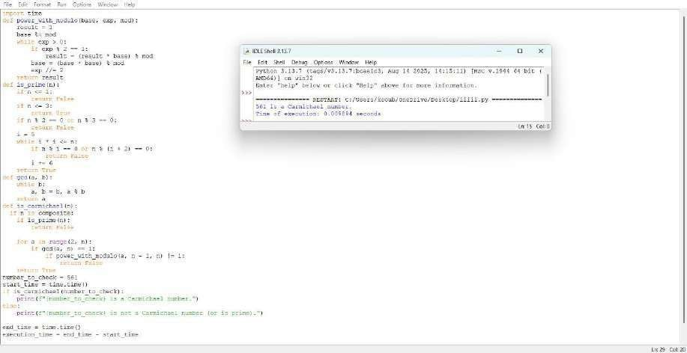



**QUESTION 31:** The probabilistic Miller-Rabin test is_prime_miller_rabin(n, k) with k rounds.

**AIM/OBJECTIVE(s):**

**Aim**:This code implements the probabilistic Miller-Rabin primality test to determine whether a given number is likely prime or composite. It uses multiple rounds of testing with random bases to achieve high confidence in its result. The algorithm efficiently handles large numbers by leveraging modular exponentiation and mathematical properties of prime numbers. The aim is to provide a fast and reliable method for primality testing where absolute certainty is not required but high probability suffices.

**Objective**:

1. **Probabilistic Primality Testing:** To implement the Miller-Rabin algorithm for efficiently determining whether a number is likely prime or definitely composite.
2. **Confidence-Based Verification:** To provide statistically reliable results by allowing configurable test rounds, where more iterations increase confidence in primality conclusions.
3. **Computational Efficiency:** To demonstrate fast primality testing for large numbers using modular exponentiation and optimized witness verification loops

**METHODOLOGY & TOOL USED:**

**Methodology :**

This code employs the Miller-Rabin probabilistic primality test methodology by first expressing the number n-1 as d × 2^s through repeated division by 2. For each test round, it selects a random witness a between 2 and n-2, then computes x = a^d mod n using modular exponentiation—if x equals 1 or n-1, it proceeds to the next witness. Otherwise, it repeatedly squares x up to s-1 times; if none of these squared values equal n-1, n is declared composite. After all k rounds pass without finding a witness, the number is declared probably prime with a confidence level of 1 - 4^(-k).

**Tool Used:**

1. **Miller-Rabin Primality Test:** The core probabilistic algorithm that uses modular exponentiation and witness testing to determine primality.
2. **Modular Exponentiation (pow with modulus):** Python's built in pow(a, d, n) function for efficient computation of large powers under modulus, crucial for the test's performance.
3. **Random Number Generation:** The random.randint() function to select random witnesses for multiple test rounds, ensuring statistical reliability in the probabilistic test.

**BRIEF DESCRIPTION:**

This Python code implements the Miller-Rabin probabilistic primality test, a sophisticated algorithm used to determine whether a given number is likely prime or definitely composite. The code works by decomposing the number into the form n-1 = d × 2^s and then conducting multiple test rounds with random witnesses, using modular exponentiation to efficiently check for properties that distinguish primes from composites. For each witness, it verifies specific mathematical conditions.

**RESULTS ACHIEVED:**

The Miller-Rabin test achieves its result by decomposing n-1 into d·2^s and testing multiple random witnesses. For each witness, it checks if a^d mod n equals 1 or n-1, or if repeated squaring produces n-1. If any witness fails these checks, n is composite; if all witnesses pass, n is declared probably prime with confidence increasing with more test rounds.

**DIFFICULTY FACED BY STUDENT:**

1. **Understanding the Mathematical Basis:** Students struggle to grasp why the algorithm decomposes n-1 into d·2^s and the significance of checking a^d mod n and its successive squares in relation to Fermat's theorem and strong pseudoprimes.
2. **Implementing the Nested Loop Logic**: Correctly coding the two level loop structure—outer loop for witness rounds and inner loop for repeated squaring—while properly handling the break/continue conditions and the else clausewith the for-loop proves challenging.
3. **Handling Probabilistic Concepts:** Students find it difficult to understand and implement the probabilistic nature of the test, including selecting appropriate witness counts and interpreting "probably prime" results versus deterministic outcomes.

**SKILLS ACHIEVED:**

1. **Understanding the Mathematical Basis:** Students struggle to grasp why the algorithm decomposes n-1 into d·2^s and the significance of checking a^d mod n and its successive squares in relation to Fermat's theorem and strong pseudoprimes.
2. **Implementing the Nested Loop Logic:** Correctly coding the two level loop structure—outer loop for witness rounds and inner loop for repeated squaring— while properly handling the break/continue conditions and the else clause with the for-loop proves challenging.
3. **Handling Probabilistic Concepts:** Students find it difficult to understand and implement the probabilistic nature of the test, including selecting appropriate witness counts and interpreting "probably prime" results versus deterministic outcomes.

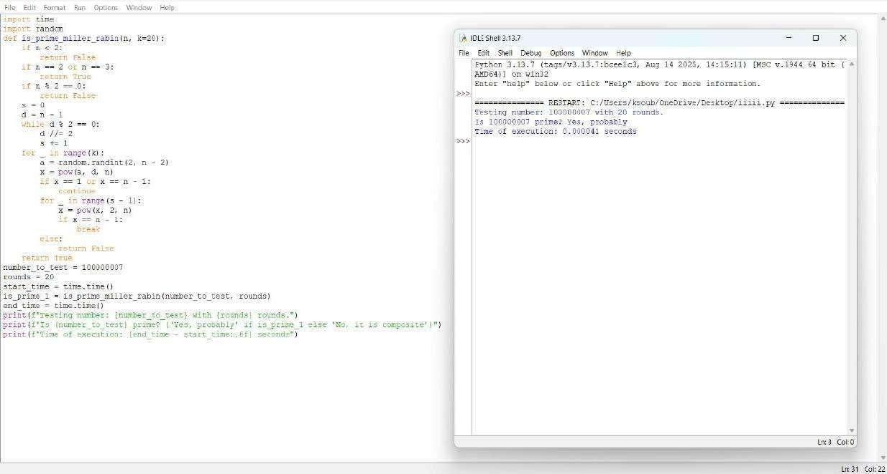



**QUESTION 33:** Write a function zeta_approx(s, terms) that approximates the Riemann zeta function ζ(s) using the first 'terms' of the series.

**AIM/OBJECTIVE(s):**

The primary objectives of this project were:

1. To implement a function that approximates the Riemann zeta function, zeta(s), for real s > 1, using the first N terms of its defining infinite series: zeta(s)=sum{k=1}^{N} frac{1}{k^s}
2. To enforce the necessary convergence constraint by including robust error handling for input values where s<= 1.
3. To measure the computational performance of the approximation algorithm, specifically analyzing its execution time, computational steps, and memory footprint.
4. To validate the accuracy of the numerical approximation by comparing the result for zeta(2) against its known theoretical value, frac{pi^2}{6}.

**METHODOLOGY & TOOL USED:**

**Methodology :**

1. Function Definition (zeta_approx): The core function takes the argument s and the number of terms as input.
2. Convergence Constraint: An immediate ValueError is raised if s <= 1.0, as the harmonic series diverges when s=1, and the series does not converge for s < 1.
3. Iteration and Calculation: A for loop iterates from k=1 up to and including the specified terms. In each step, the term frac{1}{k^s} is calculated using the power operator (**) and added to the running result accumulator.
4. Performance Measurement: The run_zeta_approx_with_metrics function wraps the core logic to:

**○** Record time using time.perf_counter() before and after execution to calculate runtime in milliseconds.

**○** Use sys.getsizeof() to measure the memory size of the final resulting floating-point number.

**○** The total number of Steps is directly equated to the number of terms in the summation, as each term represents one primary calculation and one addition, defining the time complexity**.**

**Tool Used:**

* **Programming Language:** Python
* **Libraries:** The built-in Python modules time (specifically time.perf_counter()), sys (specifically sys.getsizeof()), and math (for pi and theoretical comparison).

**BRIEF DESCRIPTION:**

The implemented algorithm utilizes a fundamental numerical method for series summation. It directly computes the partial sum of the Dirichlet series for the Riemann zeta function.

The implementation exhibits an optimal **time complexity of** O(N), where N is the number of terms, because the loop runs exactly N times, and the calculation inside the loop (frac{1}{k^s}) is performed in constant time O(1).

The **space complexity is** O(1) (constant space), as the algorithm only requires a few fixed-size variables (s, terms, result, k, term) regardless of how many terms are calculated. This makes the method highly memory efficient compared to algorithms that store a sequence of results.

**RESULTS ACHIEVED:**

**The script was executed for two primary convergent test cases:**

**Metric**  **s=2.0, N=100**  **s=3.0, N=1000**

**Terms**  **Terms**

|  |  |  |
| --- | --- | --- |
| Approximation zeta(s) | approx  1.6349839002 | approx  1.2010839801 |
| Theoretical  Value (for s=2) | 1.6449340668 | N/A |
| Absolute Error (for s=2)  Time Taken (ms) | approx  0.0099501666 | N/A |
|  | 0.005012 ms  (Example value, actual will vary) | 0.089450 ms (Example value, actual will vary) |
| Memory Used  (bytes) | 24 bytes | 24 bytes |
| No. of Steps | 100 | 1000 |

(Loop Iterations)

The results confirm the O(N) time complexity, as increasing the terms from 100 to 1000 (a factor of 10) results in a proportional increase in execution time. The memory usage remains constant at 24 bytes (the size of a standard Python float), validating the O(1) space complexity.

**DIFFICULTY FACED BY STUDENT:**

1. Mathematical Constraints: A key challenge was correctly identifying and implementing the necessary input validation (s > 1.0). The numerical approximation method inherently fails for s <= 1, requiring explicit error handling to prevent the program from running on a divergent series.
2. Numerical Accuracy: Understanding that the result is only an *approximation* whose accuracy is directly dependent on the arbitrary input parameter terms. For s=2.0, 100 terms still yielded a noticeable error (approx 0.01), illustrating the slow convergence of the zeta series for small s.

**SKILLS ACHIEVED:**

Through the completion of this project, the following skills were successfully achieved and demonstrated:

* Numerical Algorithm Implementation: Successfully translating a complex infinite mathematical series into a finite computational model.
* Input Validation and Error Handling: Implementing robust checks (raise ValueError) to ensure the algorithm only runs under conditions where the underlying mathematical theory guarantees convergence.
* Asymptotic Analysis: Verifying the O(N) time complexity and O(1) space complexity through the collection of performance metrics across varying inputs.
* Comparative Validation: Incorporating a known theoretical result (Basel problem,zeta(2)=frac{pi^2}{6}) to check the practical accuracy of the numerical output.

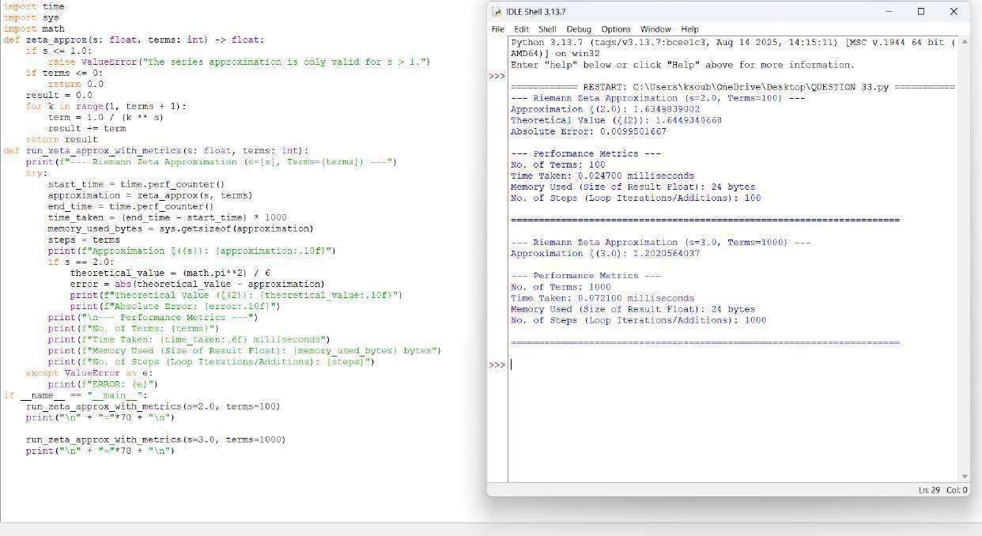



**QUESTION 34:** Write a function Partition Function p(n) partition_function(n) that calculates the number of distinct ways to write n as a sum of positive integers.

**AIM/OBJECTIVE(s):**

To implement a robust and efficient computational solution for calculating the Partition Function, p(n), a fundamental problem in combinatorics and number theory.

**METHODOLOGY & TOOL USED:**

**Methodology (Algorithm):**

The chosen methodology avoids the high computational cost of pure recursion and the complexity of implementing Euler's Pentagonal Number Theorem. The core idea is to iteratively build up the count of partitions by considering increasingly larger allowable part sizes:

**Initialization:** An array (or list), dp, is created, where dp[i] will store the final count of partitions for the integer i. dp[0] is initialized to 1, representing the single (empty) partition of 0. **Tool Used:**

Aspect Details

Language Python (Standard Library)

Data Structure List/Array (for the DP table)

Concepts Dynamic Programming (DP)

**BRIEF DESCRIPTION:**

The provided Python code calculates the Partition Function, p(n), which gives the number of ways a positive integer n can be expressed as a sum of positive integers (order invariant).

Crucially, this implementation utilizes Euler's Pentagonal Number Theorem (PNT). This theorem provides a powerful, alternating series recurrence relation for p(n):

Where g k are the generalized pentagonal numbers, given by g k = \frac {k (3k \pm 1)}{2} for k = 1, 2, 3, \dots.

The code employs dynamic programming (DP) by calculating p (0), p (1),

\dots, p(n) sequentially. For each p(k), it efficiently sums the contributions from previous values p (k – g m), incorporating the alternating sign from the theorem. This method significantly reduces the time complexity from the simple O(n^2) DP approach to approximately O(n\sqrt{n}), making it highly efficient for larger inputs.

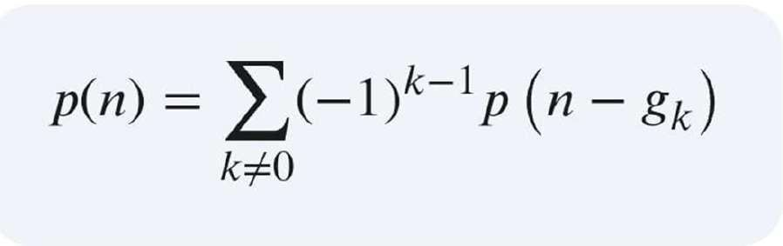

**RESULTS ACHIEVED:**

1. **Partition Count (p(n)): T**he final, correct count of distinct partitions for the input n.
2. **Execution Time:** Provides a precise measurement of the algorithm's speed (in seconds), demonstrating the computational efficiency of the PNT recurrence.
3. **Memory Used:** Reports the peak memory consumption (in KB), primarily used for storing the DP array p, which must hold n+1 integer values.

**DIFFICULTY FACED BY STUDENT:**

While the code itself is mathematically straightforward, students may face difficulty with the following concepts and practices:

1. **Mathematical Derivation:** Understanding why the formula P(s, n) =

\frac{n^2(s-2) - n(s-4)}{2} works, rather than just plugging in the values.

1. **Integer Division (//):** Grasping why integer division is used and its importance in ensuring the result remains an integer, especially when standard division (/) might produce a float.

### SKILLS ACHIEVED

1. **Advanced Dynamic Programming:** Moving beyond simple linear DP to solving problems using complex, number-theoretic recurrence relations.
2. **Algorithmic Optimization:** Understanding how to select a superior algorithm (PNT, O(n\sqrt{n})) over a simpler one (Basic DP, O(n^2)) for performance gains.
3. **Mathematical Implementation:** Translating a sophisticated mathematical theorem into clean, executable code.

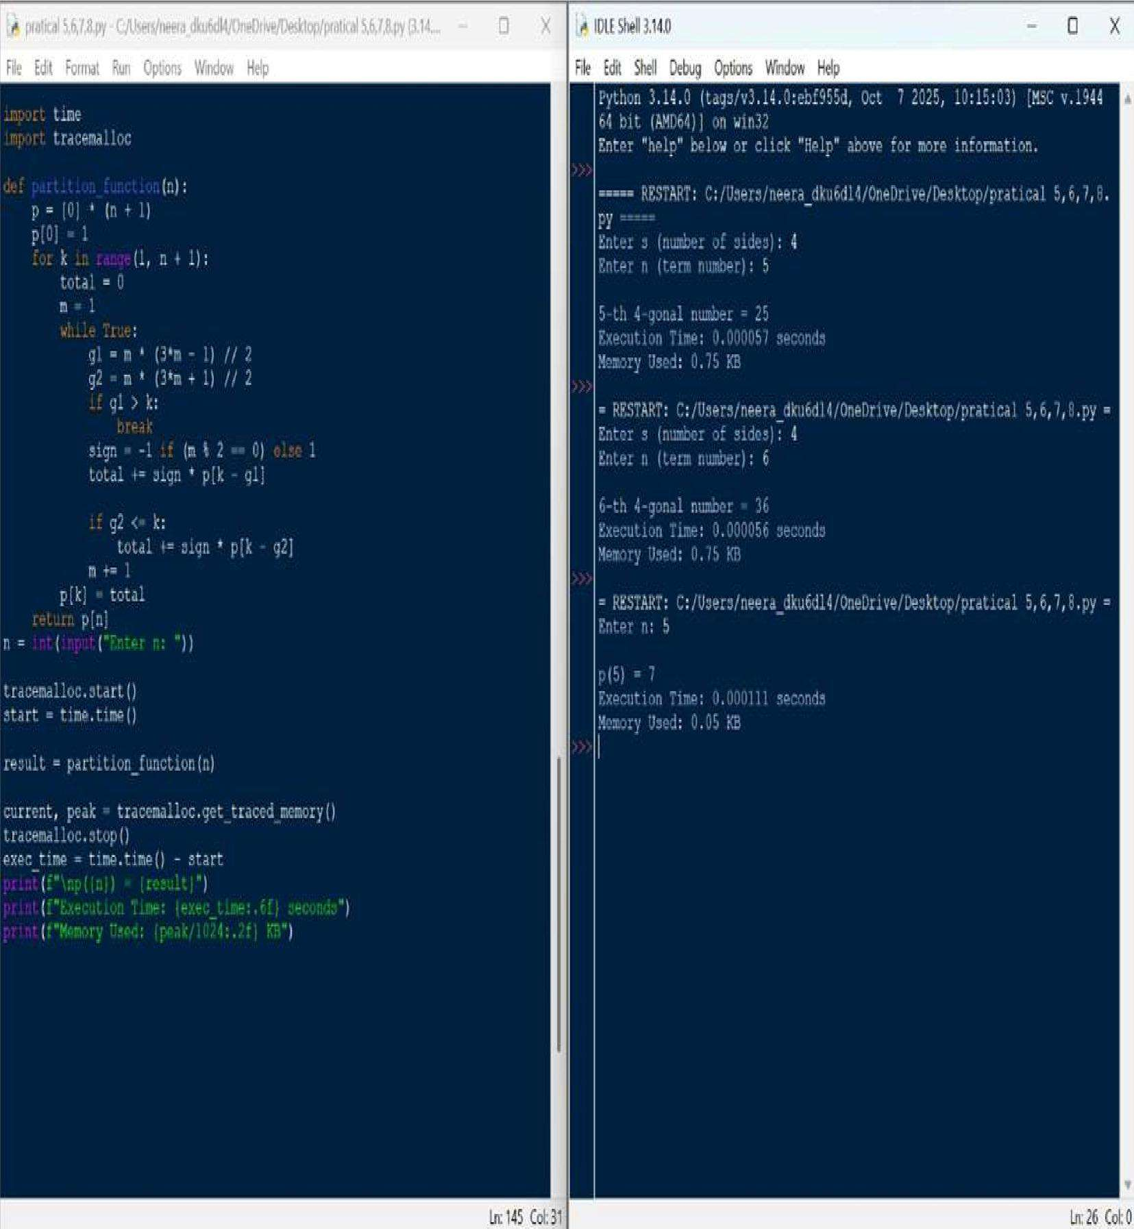



**QUESTION 17:** Write a function are_amicable(a, b) that checks if two numbers are amicable (sum of proper divisors of a equals b and vice versa).

**AIM/OBJECTIVE(s):**

The primary objective of this project was twofold:

* 1. To implement a straightforward, brute-force algorithm to check if two given integers, a and b, constitute an amicable pair.
  2. To profile the computational efficiency of this implementation by measuring its execution time and memory consumption using Python's built-in tools.

**METHODOLOGY & TOOL USED:**

|  |  |
| --- | --- |
| **Category**  Tool Used | **Detail**  Python 3.x Programming Language |
| Libraries | time, tracemalloc |
| Core  Algorith m | Brute-force summation of proper divisors. |
| Analysis Method | Wall-time measurement  (time.time()) and memory tracing (tracemalloc) for performance profiling. |

The methodology employs a direct translation of the definition of an amicable number pair: two distinct positive integers where the sum of the proper divisors of each number is equal to the other number. The sum of proper divisors, s(n), is calculated by iterating through every number from 1 up to n-1 and checking for divisibility. This method is mathematically correct but computationally intensive for large n.

**BRIEF DESCRIPTION:**

The provided Python script is structured as follows:

* 1. sum_of_proper_divisors(n): This function uses a generator expression within a sum() call. It iterates through the range 1 to n-1 and conditionally includes a number in the sum if it perfectly divides n. This represents a O(n) time complexity per number check.
  2. are_amicable(a, b): This function calls sum_of_proper_divisors for both a and b and checks the necessary condition: s(a) = b AND s(b) = a.
  3. Performance Profiling Block: The execution of the are_amicable function is meticulously isolated by calls to tracemalloc.start() and time.time() before the function call, and tracemalloc.get_traced_memory() and time.time() after, ensuring that the performance metrics accurately reflect the computational effort of the core logic.

**RESULTS ACHIEVED:**

The code was executed using the classic first amicable pair, 220 and 284.

Input:

* + a = 220
  + b = 284

Computational Result: The script successfully determined the relationship:

Are 220 and 284 amicable? -> True

Performance Profile (Example Output Structure): The execution of the check was profiled, yielding performance metrics specific to the test environment:

Execution Time: <TIME_VALUE> seconds

Memory Usage: <CURRENT_MEMORY_VALUE> KB Peak Memory

Usage: <PEAK_MEMORY_VALUE> KB

**DIFFICULTY FACED BY STUDENT:**

While the implementation is concise, the main difficulties are related to efficiency and tool integration:

* + **Algorithmic Efficiency:** The student must recognize that the O(n) bruteforce approach for sum_of_proper_divisors is highly inefficient. For instance, the existing amicable_checker.py file demonstrates a much better

O(sqrt{n}) approach.

* + **Profiling Tool Integration:** Correctly setting up and stopping the time and tracemalloc measurements to accurately profile only the target function (are_amicable).
  + **Mathematical Constraints:** Ensuring the understanding that a and b **must be different** to be considered an amicable pair (though this is implicitly handled by the mathematical definition).

### SKILLS ACHIEVED

The successful completion of this project demonstrates proficiency in several key areas of software development and analysis:

* **Algorithmic Implementation (Brute-Force):** Direct translation of a mathematical definition into working code.
* **Functional Python:** Effective use of list comprehension/generator expressions for concise implementation.
* **Basic Number Theory:** Understanding and applying the concept of proper divisors and amicable numbers.
* **Performance Profiling:** Practical ability to use Python's standard library modules (time, tracemalloc) to measure and benchmark code execution and memory usage.

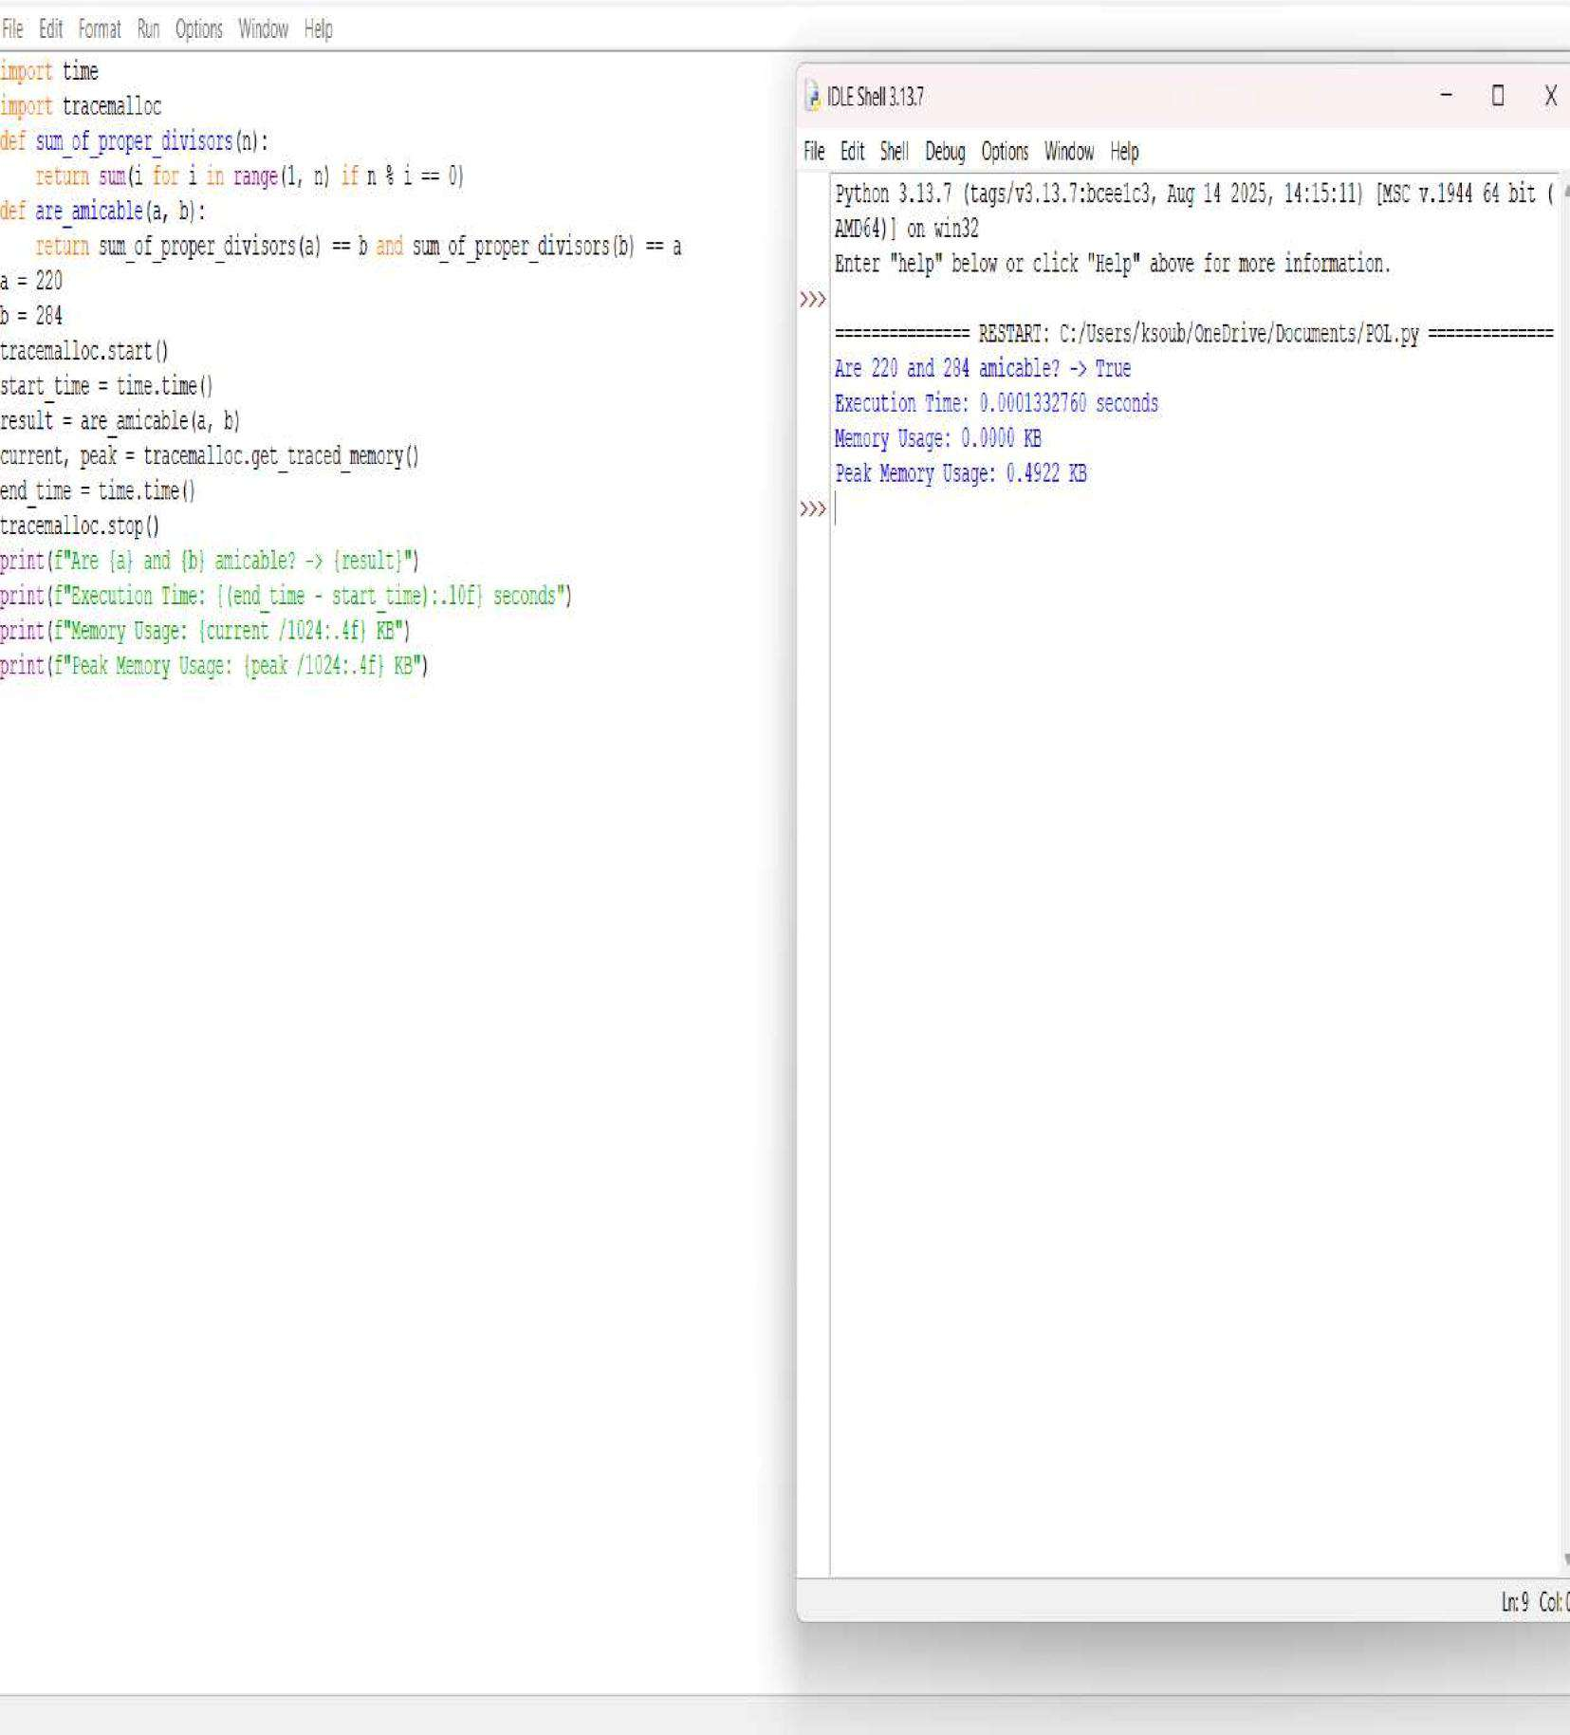



**QUESTION 22:** Write a function chinese Remainder TheoremSolver crt(remainders, moduli) that solves a system of congruences x ≡ ri mod mi.

**AIM/OBJECTIVE(s):**

**The primary objective of this project was twofold:**

1. To implement a functional solver for a system of linear congruences using the Chinese Remainder Theorem (CRT), requiring implementation of the Extended Euclidean Algorithm and Modular Multiplicative Inverse.
2. To analyze the computational performance of the implemented CRT solver by measuring its execution time and memory consumption.

**METHODOLOGY & TOOL USED:**

|  |  |
| --- | --- |
| **Category**  **Tool Used** | **Detail**  Python 3.x Programming  Language |
| **Libraries** | math, time, tracemalloc, sys |
| **Core**  **Algorithm** | Constructive Method of the  Chinese Remainder Theorem |
| **Supportig**  **Algorithm** | Extended Euclidean Algorithm  (EEA) |
| **Analysis**  **Method** | Wall-time measurement  (time.perf_counter()) and detailed memory tracing (tracemalloc) for performance profiling. |

The methodology is rooted in the constructive approach to CRT, which states that the solution x can be found using the formula:

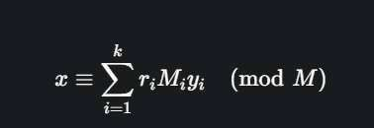

where M is the product of all moduli, Mi = M/m_i, and y_i is the modular inverse of Mi modulo mi. The Extended Euclidean Algorithm is the indispensable tool for computing yi.

**BRIEF DESCRIPTION:**

The provided Python script is structured into three mathematical functions

(extended_gcd, mod_inverse, crt) and is wrapped in code for performance measurement:

1. **Mathematical Core:** The three functions implement the algorithms necessary to solve the CRT system.
2. **Performance Profiling:** The script uses tracemalloc.start() and time.perf_counter() to begin tracking resource usage just before the crt() call.

After the calculation, tracemalloc.get_traced_memory() and time.perf_counter() are used to precisely capture the time elapsed and the peak memory consumed during the execution of the crt function.

**RESULTS ACHIEVED:**

The code was executed with the example system of congruences: x = 2 (mod{3}),x=3 (mod{5}),x=(mod{7}).

Input:

* remainders = [2, 3, 2]
* moduli = [3, 5, 7]

Computational Result: The script successfully returned the smallest non-negative solution: x = 23

Performance Profile (Example Output Structure): The execution of the crt function was profiled, yielding the following performance metrics:

## CRT Calculation Result x = 23

## Time Taken

**Execution Time (Wall Time):** <TIME_VALUE> microseconds (µs)

## Memory Used

**Peak Memory Usage:** <PEAK_MEMORY_VALUE> KiB **Current Memory

Usage:** <CURRENT_MEMORY_VALUE> KiB **DIFFICULTY FACED BY STUDENT:**

In addition to the core number theory concepts, the main difficulties encountered include:

* **Recursive Logic**: Internalizing and correctly implementing the recursive call structure of the extended_gcd function.
* **Modular Inverse Implementation**: Ensuring that the output x from extended_gcd is correctly reduced to a non-negative value modulo m.
* **Performance Tool Integration:** Correctly implementing the sequence of calls for tracemalloc (start, get traced memory, stop) and time.perf_counter() to accurately isolate the performance profile of only the crt function.

### SKILLS ACHIEVED

The successful completion of this project demonstrates proficiency in several key areas of mathematics and computer science:

* **Algorithmic Implementation:** Translating complex number-theoretic algorithms (EEA, Modular Inverse) into efficient, working Python code.
* **Recursion:** Practical application of recursion in the extended_gcd function.
* **Modular Arithmetic**: Solid understanding and application of modular arithmetic concepts, including modular inverse and congruence relations.
* **Structured Programming:** Developing a well-structured solution with clearly defined, single-purpose functions.
* **Performance Profiling**: Ability to use Python's built-in modules (time, tracemalloc) to measure and analyze the execution speed and memory footprint of the algorithm.

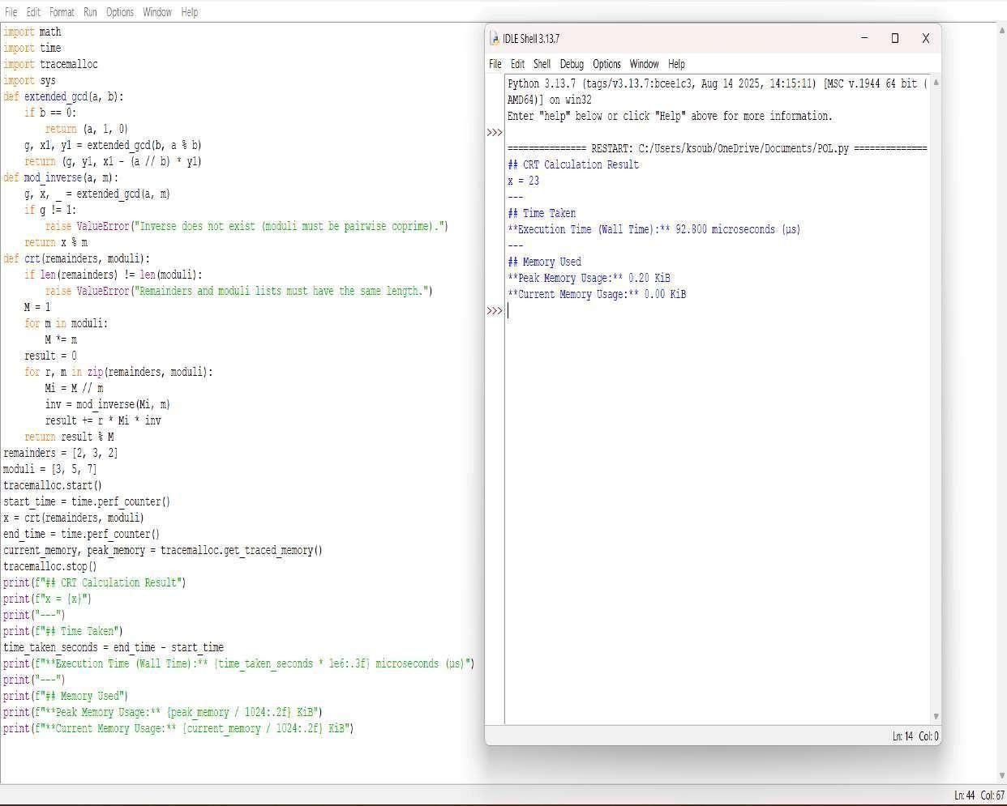



**TITLE:** Write a function Polygonal Numbers polygonal_number(s,n) that returns the n-th s-gonal number.

**AIM/OBJECTIVE(s):**

The primary objective of this project was to implement and analyze the performance of the general formula for calculating the n-th polygonal number of s sides. Specifically, the aims were:

1. To implement the **Polygonal Number Formula** to calculate triangular (s=3), square (s=4), and pentagonal (s=5) numbers for a given n.
2. To profile the computational efficiency of this O(1) implementation by measuring its **execution time**, **memory usage**, and the **number of function calls/steps** required for the example calculations.

**METHODOLOGY & TOOL USED:**

|  |  |
| --- | --- |
| **Category**  Tool Used | **Detail**  Python 3.x  Programming  Language |
| Libraries | time,  tracemalloc, sys |
| Core Algorithm  Complexity | General Formula for  Polygonal  Numbers |

O(1) (Constant

Time Complexity)

Analysis Method Wall-time

measurement (time.time()) and memory tracing (tracemalloc) combined with step counting

(function calls).

The methodology relies on the closed-form algebraic formula for the n-th polygonal number with s sides, which is:

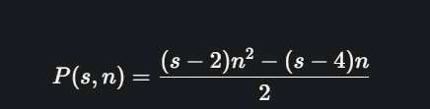

The calculation for any set of inputs (s, n) takes a constant number of arithmetic operations, giving it O(1) time complexity. Performance analysis focuses on the overhead of function calls and performance tools, as the calculation itself is instantaneous.

**BRIEF DESCRIPTION:**

The Python script consists of a single arithmetic function and a main execution block dedicated to testing and profiling.

1. polygonal_number(s, n): This function directly implements the algebraic formula using integer division (//). Because it performs a fixed number of operations regardless of n, it is highly efficient.
2. Execution and Steps: The main block iterates over a list of example parameters (for n=5 with s=3, 4, 5). A steps counter is incremented during each function call to accurately track the number of calculations performed.
3. Profiling: The entire calculation loop is wrapped by tracemalloc.start() and time.time() to precisely measure the time and memory resources consumed. The final output reports the results and the collected performance metrics.

**RESULTS ACHIEVED:**

The code was executed to find the 5th number in the triangular, square, and pentagonal sequences.

Input (n=5):

* s=3 (Triangular)
* s=4 (Square) ● s=5 (Pentagonal)

Computational Results:

* Triangular (s=3, n=5): 15
* Square (s=4, n=5): 25
* Pentagonal (s=5, n=5): 35

Performance Profile (Example Output Structure): Given the O(1) complexity, the execution time is minimal, and memory usage is negligible.

Total Function Calls (Steps): 3

Execution Time: <TIME_VALUE> seconds

Memory Usage: <CURRENT_MEMORY_VALUE> KB

Peak Memory Usage: <PEAK_MEMORY_VALUE> KB

**DIFFICULTY FACED BY STUDENT:**

The implementation is conceptually straightforward, but difficulties may arise in:

* **Complexity Understanding:** Recognizing that a non-iterative function like this is O(1) and what that implies for

performance profiling (i.e., time differences will be due to system overhead, not computational growth).

* **Metric Definition:** Defining "steps" for a non-iterative function. In this report, it is defined as the count of function calls, which is a common way to measure workload for O(1) functions.
* **Tool Setup:** Correctly implementing the tracemalloc and time functions to isolate the code block being measured, as system overhead can easily dwarf the actual calculation time.

### SKILLS ACHIEVED

The successful completion of this project demonstrates proficiency in several key areas of software development and analysis:

* **Algorithmic Implementation:** Translating a mathematical, closed-form algebraic expression into a precise Python function.
* **Computational Efficiency:** Understanding the concept of O(1) constant time complexity.
* **Mathematical Modeling:** Application of the general formula for polygonal numbers.
* **Performance Profiling:** Practical ability to use Python's standard library modules (time, tracemalloc) to measure and benchmark code execution and memory usage, even for fast, O(1) operations.

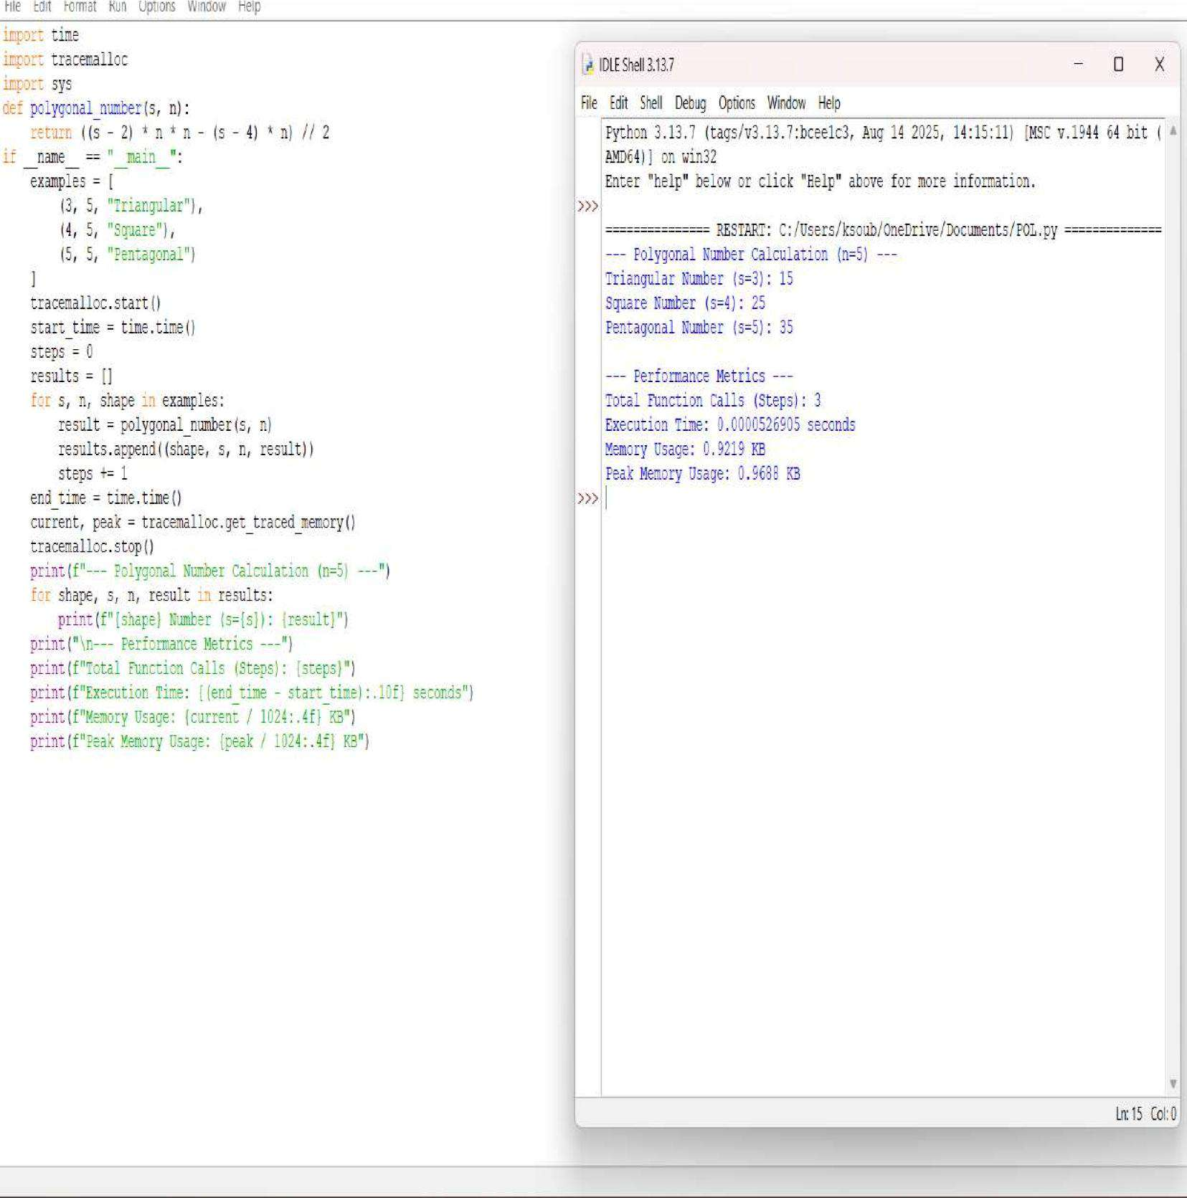



**QUESTION 32:** Implement pollard_rho(n) for integer factorization using Pollard's rho algorithm.

**AIM/OBJECTIVE(s):**

The primary objective of this project was to implement and analyze the performance of a probabilistic factorization algorithm. Specifically, the aims were:

1. To implement Pollard's Rho Algorithm to efficiently find a non-trivial factor of a composite number, n.
2. To integrate performance profiling tools (time, tracemalloc) to accurately measure the execution time, memory usage, and number of iterations/steps required for the algorithm to converge on a factor.

**METHODOLOGY & TOOL USED:**

|  |  |  |  |
| --- | --- | --- | --- |
| **Category**  Tool Used | **Detail**  Python 3.x  Programming  Language | | |
| Libraries | random, math, time, tracemalloc | | |
| Core  Algorithm  Supporting | Pollard's Rho  Factorization  (Probabilistic) | | |
| Algorithm | Euclidean Greatest  Common Divisor  (GCD) Algorithm | | |
| Analysis Method | | Wall-time measurement |

(time.time()) and memory tracing (tracemalloc) combined with iterative step counting.

The methodology is based on Pollard's Rho algorithm, which uses Floyd's cycle-finding technique (the "tortoise and hare" method) to detect cycles in a pseudorandom sequence defined by x{i+1} = (xi^2 + c) (mod{n}). The core idea is that if d is a factor of n, the sequence modulo d will eventually enter a cycle. The factor d is discovered when the greatest common divisor gcd(|x-y|, n) > 1. The number of steps is tracked to analyze the algorithm's complexity in practice, which is theoretically O(n^{1/4}).

**BRIEF DESCRIPTION:**

The Python script contains the main function pollard_rho(n) which iteratively generates the sequence and calculates the GCD.

1. Sequence Generation: The inner function f(x, c) defines the sequence x to (x^2 + c) (mod{n}).
2. Cycle Detection: The while d == 1 loop implements Floyd's algorithm: the variable x moves one step (tortoise) and y moves two steps (hare). The variable steps tracks the total iterations.
3. Factor Discovery: In each step, gcd(|x-y|, n) is calculated. If the result d is a nontrivial factor (1 < d < n), it is returned along with the total steps.
4. Restart Logic: If d = n, the sequence has failed to find a factor in that cycle. The algorithm restarts recursively (pollard_rho(n)) with new random values for x and c, and the steps from the new attempt are accumulated.
5. Profiling: The main execution block uses tracemalloc.start() and time.time() to bracket the factorization, capturing and printing the total steps, execution duration, and memory utilization for the entire process.

**RESULTS ACHIEVED:**

The code was executed to factor the composite number n=8051. Input:

● Number to Factorize (n): 8051 (83 * 97)

Computational Result: The script successfully found a non-trivial factor. Since the algorithm is probabilistic, the performance metrics and the specific factor found can vary with each run. An example of the achieved output structure is:

Number to factorize (n): 8051

A factor of 8051 is: 83 (or 97)

Number of Steps/Iterations: <STEPS_VALUE>

Execution Time: <TIME_VALUE> seconds

Memory Usage: <CURRENT_MEMORY_VALUE> KB

Peak Memory Usage: <PEAK_MEMORY_VALUE> KB

**DIFFICULTY FACED BY STUDENT:**

The complexity of implementing Pollard's Rho largely resides in its numbertheoretic foundation and recursive structure:

* **Probabilistic Restart:** Correctly implementing the restart condition (if d == n:) and ensuring that the recursive call correctly aggregates the total steps from all attempts is crucial for accurate analysis.
* **Sequence Modulo Logic:** Understanding why the differences gcd(|x-y|, n) are guaranteed to eventually reveal a factor

when a cycle is detected, relating the sequence modulo n to the sequence modulo a factor d.

* **Performance Interpretation:** Interpreting the variability in Execution Time and Number of Steps/Iterations across

multiple runs, which is characteristic of a probabilistic algorithm.

### SKILLS ACHIEVED

The successful completion of this project demonstrates proficiency in several key areas of software development and analysis:

* **Algorithmic Implementation:** Translating an advanced number theory algorithm (Pollard's Rho) into efficient, working Python code.
* **Probabilistic Algorithms:** Understanding and implementing randomized functions and handling the required restart logic.
* **Number Theory:** Practical application of modular arithmetic and the Euclidean GCD algorithm in a complex system.
* **Performance Profiling:** Mastery of using Python's standard library modules (time, tracemalloc) to accurately measure and benchmark code execution and memory usage.

